NCSES-CNSTAT Workshop on Advancing Concepts and Models of Innovative
Activity and STI Indicator Systems

Workshop Summary

1. Introduction
1.1. Workshop Goals
1.2. Background
1.3. Themes and Synthesis
2. Assessing Innovation Measurement—How Accurately Measured are Innovation Processes and the Resultant Outcomes Delivered to Society and the Economy?
3. Innovation Beyond R&D and Other Conventional Input Measures
4. The Role of Individuals (and Networks of Individuals) in Innovation
5. Measuring Public Sector Innovation and Social Progress
6. Regional Innovation Models and Data Needs
7. Innovation Measurement Agendas of the Future

References
Appendixes
A. Workshop Agenda
B. Workshop Participants

1. INTRODUCTION

1.1. Workshop Goals

In May 2016, at the request of NSF's National Center for Science and Engineering Statistics (NCSES), the Committee on National Statistics (CNSTAT) of the National Academies of Sciences, Engineering, and Medicine convened a workshop—bringing together academic researchers, private and public sector experts, and public policy agencies—to develop strategies for broadening and modernizing innovation information systems. The workshop was organized to assist NCSES in refining and prioritizing its work on innovation metrics to maximize the relevance and utility of its data collection programs and statistical products to users. The focus was on conceptualizing innovation—its inputs, outputs and consequences—in a way that reveals elements that are being measured well and those that are being measured inaccurately or not at all. Presenters and discussants were asked to take into account the role of innovation not just as it affects economic growth and productivity, but also as a mechanism for creating greater public good and meeting social challenges that are often nonmarket in nature. Workshop participants were also asked to consider how new kinds of data can be used to complement more traditional survey and administrative sources in the construction of innovation metrics. Throughout the discussion, one objective was to identify questions that cannot be answered now but could be with additional data that have a reasonable chance of being collected.

During his introductory comments, workshop chair Scott Stern (MIT) outlined why the meeting was convened and why the topical coverage is timely. He pointed out that the term “innovation” is meant to identify phenomena that are themselves important, but that are often elusive. Nonetheless, in the context of the measurement of science and technology indicators, there is a growing consensus among practitioners and researchers who gather the data and report their results that innovation—both its inputs and potentially various elements of its outputs—is measurable and central to economic and social progress. This, Stern added, is a particularly important contention in an era when the United States and other countries are living in times beset by relatively low rates of productivity growth and periods of greater economic fluctuation. One purpose of the workshop was to bring together communities to talk about the linkage between measurement and policies that might help promote economic and social progress.

Stern identified the three major communities represented at the workshop: (1) government agencies and policy analysists who—in addition to developing large-scale statistical programs to measure various parts of the economy and society, including science and technology—are increasingly and intently focused on the measurement of the causes, consequences, and phenomena of innovation; (2) academic researchers who have developed conceptual frameworks and metrics that advance understanding of innovation; and (3) practitioners, the people who are actually doing the innovating. Future measurement projects need to increase involvement of the third group (who are of course at the forefront of the process). One consequence of the presence of three distinct communities is that people often use the word innovation to mean very different things which can lead to an inability to establish standards that allow for clear and transparent communication. Innovation may be a complex phenomenon, and many statistics may be needed to capture its multiple dimensions, but it should be clear that if communities are talking past each other it becomes difficult for policymakers, practitioners, and researchers to take advantage of findings that are emerging.

Stern also noted that the workshop summarized in this report was timely. In addition to their long-range goals, NCSES is about to embark on a “medium term” goal to influence the revision process by the OECD and Eurostat of the Oslo Manual (described below) and to provide input to the OECD Blue Sky Forum in the Fall of 2016. These activities are committed to advancing and modernizing innovation statistical programs and setting a measurement agenda for the coming decade. The workshop was intended to synthesize broader lessons that may enhance the capabilities of NSF and the statistical agencies to continue on their path of developing a robust innovation measurement program.

Speaking on behalf of NCSES, John Gawalt (NSF) emphasized the goals of the workshop. NCSES engages in a range of activities that relate to innovation measurement: It conducts and supports large-scale surveys on (1) science and engineering and education, focusing on graduate level education, and (2) R&D funding and performance across all sectors of the economy—business, academia and, in the near future, on the nonprofit sector; the agency also collects analogous information on the federal and state governments. NCSES publishes information about the academic research infrastructure and about public understanding and attitudes toward science. Under the guidance of the National Science Board, the agency produces a biennial report to Congress, Science and Engineering Indicators, the volume of record for presenting high quality data on the science and engineering enterprise overall, where possible in an international context.

Gawalt noted that the agency’s history of collaboration with CNSTAT has allowed it to address challenges associated with its mandate to cover a number of topics—to date, most of these have been within the confines of the business sector and the nonprofit sector. Most recently, the 2014 report Capturing Change in Science, Technology, and Innovation: Improving Indicators to Inform Policy (NRC, 2014) covered a broad spectrum of topics that fall within the purview of NCSES responsibilities. Chapter four of that report provided guidance specifically about the measurement of innovation, and was shaped by key policy questions and concerns raised by users of science, technology, and innovation indicators. The workshop summarized in this report was planned as a direct follow-up to the Capturing Change report, and Chapter 4 in particular. In commissioning the workshop, NCSES sought to tap into the collective expertise of participants’ in order to inform its data collection activities and to refine and prioritize its plan to improve the breadth of innovation measures. With input from the workshop and elsewhere, the agency hopes to shape its innovation measurement agenda for the future in a way that will benefit the user community.

1.2. Background

Defining and Measuring Innovation

Because of the role of innovation as a driver of economic productivity and growth and as a mechanism for improving people’s well-being in other ways, understanding the nature, determinants, and impacts of innovation has become increasingly important to policy makers. To be effective, investment in innovation requires this understanding, which, in turn, requires measurement of the underlying inputs and subsequent outcomes of innovation processes.

The Oslo Manual (OECD-Eurostat, 2005, p. 46) defines innovation as “. . . the implementation of a new or significantly improved product (good or service), or process, a new marketing method, or a new organizational method in business practices, workplace organization or external relations.” Implementation is defined as follows …. [See para 150 where implementation is defined and without that definition, there is no definition of innovation]

Inputs to innovation such as R&D, capital expenditures, and training are defined by the Manual as innovation activities which, in principle, are: “all scientific, technological, organizational, financial and commercial steps which actually, or are intended to, lead to the implementation of innovations. Some of these activities are themselves innovative, while others are not novel but play a role in the implementation of innovations” (p. 18).

Definitions in the Oslo Manual are oriented toward measurement of innovation by business enterprises at the firm level and in a way that facilitates international comparability. In examining the purpose of innovation measurement, Robbins (2016, p. 2) raises a set of questions suggesting that the OECD definition, and in turn the scope of data collection objectives, may usefully be revisited and possibly broadened:

- What concepts identify incidence of innovation (the incidence of innovation can be understood as an output of an innovation process, resulting from the activities of actors interacting with other inputs in a particular environment)?
- What concepts explain the effect of different kinds of innovation over time, as with incremental innovation and more transformative or disruptive innovation, such as general purpose technologies?
- What concepts for innovation output explain industry and technology variations?
- What measures of innovation reflect the broader impact of innovation on economic growth and social outcomes?

Indicative of the appeal of greater conceptual flexibility, some researchers (see OECD, 2011) have brought into scope how the successful exploitation of ideas affects the well-being of society more broadly, beyond the contribution to efficiency, effectiveness, or quality in the production of market goods and services. Knowledge creation has the capacity to influence non-market outcomes in areas such as health, environmental sustainability, and education. Similarly, while advocating for measurement of the transmission mechanisms of new knowledge and its impacts on economic development, OECD (2010) has also highlighted questions of how innovation affects the workplace, communities, and social habits. One conclusion of the OECD report is that “the current measurement framework, with its focus on the role of innovation in economic performance, falls short in terms of measuring the social impacts of innovation.”

Regardless of scope, measurement of innovation is difficult. Many kinds of innovations occur, which means that a simple aggregation of cases cannot be expected to be very useful for assessing (or predicting) impacts on economic growth or on other outcomes. Some innovations have a huge impact, while others are useful but minor. Additionally, not all innovation inputs and outputs can be easily quantified. Sources such as NCSES human resource data provide information necessary to measure “education, skills, and other dimensions of human capital that are used in the process of innovation” (Robbins, 2016). However, the process of R&D, for example, also involves a continuous flow of idea creation and, as such, is not well suited to measurement by a binary innovation indicator. Connecting measures of innovation to economic and social outcomes is even more challenging than quantifying innovation or its inputs.

NCSES and CNSTAT Initiatives

As part of its mission to conduct data collections related to U.S. competitiveness, the NCSES has a focused interest in innovation and, consequently, in collecting and reporting science, technology, and innovation (STI)-related information. As articulated in its mission statement, NCSES is responsible for statistical data on:

- Research and development
- The science and engineering workforce
- U.S. competitiveness in science, engineering, technology, and R&D
- The condition and progress of STEM education in the United States

To assist in this mandate, as noted above, NCSES commissioned CNSTAT to produce the Capturing Change report to provide an “assessment of the types of data, metrics, and indicators that would be particularly influential in evidentiary policy and decision making for the long term.” The panel was also charged with “recommending indicators that would reflect the fundamental and rapid changes in the global STI system while having practical resonance with a broad base of users in the near, medium, and long terms” (p. 7). An indicator is a set of facts or observations that tells us something meaningful about the underlying phenomenon of interest, in this case, science, technology, and innovation (Hall and Jaffe, 2012)—a “scaffolding of statistics” often used to “tell an end-to-end story on a policy-relevant topic” (NRC, 2014, p. ix).

Concurrent with the completion of the CNSTAT report, the agency organized a center-wide team to build on the report’s conclusions and recommendations (and on other NCSES activities) in order to develop and implement a common understanding of innovative activity and innovation systems. This project, intended to enhance NCSES’s role as a leading provider of policy relevant and policy neutral data on U.S. innovation, is charged with:

- developing a core set of key innovation-related concepts and models that allow NCSES’s programs, publications, and surveys to respond broadly to the needs of NCSES data users;
- creating an inventory of existing innovation data sources from NCSES and other statistical sources and identifying data development opportunities by matching the inventory to the concepts and models;
- collaborating with stakeholders to develop priorities that reflect both user value and feasibility; and
- developing new indicators following this prioritized plan by leveraging partnerships, collaborations, and supported research.

Although the four parts of the NCSES innovation project are closely interlinked, the focus of this workshop was on the component dealing with conceptual and organizing framework issues (the first bullet above). Naturally related issues, such as the opportunities and challenges created by the evolving data landscape, came into play.

Focus on Concepts and Frameworks

The emphasis for this workshop on conceptual bases for measuring innovation is motivated in part by a key message that emerged from the OECD Blue Sky Forum (2006) a decade ago: this was that research on innovation in the broad sense is highly fragmented, which undermines its effectiveness. This conclusion led to calls for development of general frameworks of analysis and greater coordination of research efforts with the goal of improving understanding of innovation, its inputs, and its economic and social impacts. To be useful, any framework would have to be capable of reflecting the complex and diverse processes and interactions inherent in innovation:

Science, technology, and innovation consist of a number of components linked by the knowledge and resources that flow among them. These components include governments, government research laboratories and extension services, the intellectual property system, higher education and research institutions, venture capital, and industrial research laboratories. Perhaps less obviously, they also include individuals across many economic sectors who are engaged in improving the efficiency of production, introducing new ideas and new products, or attempting to adopt new technologies or methods of organization. When the system works well, the interaction of these institutions and individuals [turning ideas into value] produces welfare-enhancing economic growth via the introduction of new and improved processes, products, and services (Hall and Jaffe, 2012).

Ideally, a measurement framework would specify a system of indicators that, taken together, are helpful in monitoring these processes and informing policies designed to foster, facilitate, and enhance them. The conceptual framework drives (implicitly or explicitly) data collection and data organization, as well as what measurements based on those data will be illuminating. Subsequently, when measurements are used in research, a feedback mechanism is created that further shapes the framework and helps to identify data and indicator gaps that, if filled, could help answer key questions about the pace, location, and nature of innovation activity (Hall and Jaffe, 2012, p. 34).

Though the idea of a single unified indicator framework has allure, it is not possible if the goal is to promote research on the many ways that innovation is fostered and impacts the economy and society. Multiple approaches are needed to serve the many kinds of users of innovation (and science and technology) indicators and to address the wide range of policy questions posed. Indeed, the panel that authored Capturing Change in Science, Technology, and Innovation “encountered several challenges in seeking a single framework or model for the STI system,” due in large part to the observation that such systems are shaped by users’ goals: “Economists, policy analysts, information scientists, material scientists, physicists, statisticians, and geographers (all represented on the panel) have different predilections for how to develop a representative model of the STI system” (NRC, 2014, pp. 12-13). This theme—that no one set or system of indicators will suit all monitoring, benchmarking, evaluating, and forecasting purposes—arose again and again during the workshop. There was wide agreement that a unified framework is probably not a realistic goal. The objectives of a range of stakeholders dictate that multiple approaches must be considered when designing data collection and indicator development programs.

This heterogeneity of uses in no way implies that frameworks for organizing data and monitoring outcomes are not useful; rather, they must be tailored to use. One framework that has proved useful is the intertemporal model of economic growth in which (typically) market output is a function of capital, labor, and knowledge assets (human capital) (Hall and Jaffe, 2012, p. 10). Likewise, economic accounting frameworks, such as the System of National Accounts, are essential for linking innovation and other nontangible asset inputs with outputs, measured as components of aggregate economic activity. It is important that, in these systems, flows (e.g., the rate at which advanced degrees are produced, resources are expended on R&D or on education of scientists and engineers) are distinguished from the resultant stocks (e.g., the total numbers of scientists, patents, etc.).

The limits of growth accounting or any other singular approach means that multiple indicator frameworks will continue to be demanded by researchers and policy makers. For example, as noted above, since some potential benefits of innovation—like better health, greater happiness, and improved environment—are not market-based, other concepts of output (and sets of indicators to capture their trends) are also needed. When R&D results in a greatly improved medical treatment, not all of the benefits from the innovation will register in economic statistics such as price indexes or GDP (national output); they may instead only be captured by health measures, either objective (life expectancy) or subjective (how people feel). Thus, one topic of general interest to several stakeholders represented at the workshop is broader concepts of innovation-driven outputs and outcomes.

Focus on Individuals in Addition to Organizations

In part due to the multiple objectives of innovation measurement, workshop participants discussed at length the activities of individuals as well as those of institutions and organizations. Firm-based innovation has been carefully defined in the Oslo Manual as “the interplay of institutions and the interactive processes at work in the creation of knowledge and in its diffusion and application.” Less attention has been given to the role of individuals in innovative processes. In his address to the 2006 Blue Sky II conference, John Marburger called for work on this comparatively neglected front: “We need models—economists would call them microeconomic models—that simulate social behaviors and that feed into macroeconomic models that we can exercise to make intelligent guesses at what we might expect the future to bring and how to prepare for it.” A full session of the workshop summarized in this report addressed the role of individuals, and networks of individuals, in innovation processes.

One concrete example of how innovation relates to individuals with direct and high profile policy content is in the area of immigration and human capital formation. NCSES-sponsored surveys and other sources allow tracking of foreign-born STEM-educated or foreign-trained individuals and the mobility of STEM labor between countries. A number of scholars—Hunt (2011); Chiswick and Taengnoi (2007); Peri and Sparber (2008)—have used such data as the National Survey of College Graduates to investigate how the foreign born have enhanced technological innovation as a result of their greater concentration than natives in science and engineering occupations.

1.3. Themes and Synthesis

Several clearly identifiable themes emerged from the Workshop on Advancing Concepts and Models of Innovative Activity and Indicator Systems. Scott Stern (the workshop chair) and Bronwyn Hall provided a synthesis of these themes at the conclusion of the program which provides something of a roadmap to readers navigating this report.

Three broad questions were addressed, in some cases directly and in others indirectly, through the presentations and open discussion that took place:

- What can be done to facilitate productive updating of the Oslo Manual, which defines innovation and prescribes an approach to its measurement, going forward?
- How should metrics be developed and modernized to capture the components of innovation—including its inputs, outputs, and dynamics over time—more accurately and more comprehensively?
- How are new (or revised) measures and datasets changing our understanding of innovation?

An objective of the workshop organizing committee was to envision how the range of measures could potentially be improved and expanded to more fully capture, on a reliable basis, aspects of innovation processes that are currently missed or undercounted. This goal requires first taking stock of the good work in this area that is already being done by the NSF and the statistical agencies. The value of their contributions, made possible by significant public investments, improve the understanding of innovation and advance its measurement and was clearly evident at many steps along the way during the proceedings. While highlighting the need for new kinds of data and new analytic constructs, workshop participants recognized the current apparatus—e.g., the Community Innovation Survey and the Business R&D and Innovation Survey (BRDIS)—as containing invaluable tools that benefit from a balance between standardization (across countries and time) and experimentation (to uncover new phenomena and local circumstance). Stern made the point that planners need to be explicit about what parts of the survey and resultant data products require standardization (because the capacity to make direct comparisons across countries and time has value) and what domains of the survey should be opened up to experimentation.

While progress in the field was acknowledged, workshop participants sought to identify what Ben Martin (Session 1) termed the “dark matter”—aspects of innovation that are not measured and, consequently, not well understood. Over the course of a day and a half of thoughtful presentations, it became clear that shedding light on this dark matter will entail individual and organizational initiatives on domains that are outside the current scope of the Oslo Manual and the Community Innovation Survey upon which it is based. In some cases the comparative advantage for advancing measurement will be beyond (or in collaboration with) the statistical agencies.

Regarding question (1) above, revision of the Oslo Manual, one theme running throughout the sessions was that the definition of innovation matters. Fred Gault (Session 1) commented that the definition is central because it is the anchor determining what is in scope and what is out of scope. Thus, to some extent, a narrow definition will confine inquiry and a broad definition will stimulate wider inquiry. The definition also needs to be widely accepted by practitioners working in the field.

A clear message that emerged from the workshop was that knowledge gains are there to be had from an accounting of innovation based on a broader range of sources and administrative units than what is currently the practice. As dissected during Sessions 3 and 4, innovation can be tracked at the industry and sectoral levels but, in principle, it can also be traced back to where it originates, which may be businesses, households, individual entrepreneurs, universities, non-profit organizations, or the public sector (or some combination of these). The Oslo Manual was created largely for the production of national-level and industry-level innovation statistics. Several presenters (see Session 5) demonstrated that measurement can be applied with illuminating effect at more localized levels—levels that are often more relevant in terms of understanding the sources of innovation (such as the human capital and geographic clustering of activities) and their impact on economic and social outcomes.

Additionally, measurement frameworks should reflect linkages in innovation processes so that flows of inputs, outcomes, and broader economic and societal impacts can be tracked. Charles Edquist (Session 4) noted the importance of distinguishing innovations from their determinants. He views entrepreneurship and research, for example, as drivers of innovation. These determinants need to be measured, as do the innovations themselves and the impact they have, in a detailed and coordinated way.

Regarding question (2) above, modernizing innovation measurement and metrics, it was recognized by participants that the scope of data collection must continue to broaden beyond R&D and patents. The modal notion is that R&D is undertaken in a company, which then leverages the knowledge generated to produce one or more innovations—suggesting an alignment between R&D as the input with the output being new or significantly changed goods and services produced by the company. This perception may have been sufficiently accurate at the time when a number of our key surveys were designed, but the interaction of different players is now more complex. To portray innovation fully, data systems should be capable of detecting knowledge linkages between people and companies—and business and household interactions generally—over time (Javier Miranda, Session 2); the division of labor, which means that people engaged in idea development (as measured in papers, patents, or information on new inventions) are often different than those commercializing the innovations (Cohen and Arora, Session 2); and the role of “non-traditional” but prominent aspects of value creation, such as design (Bruce Tether, Session 2), digitization, and robotics (Rob Seamans, Session 2) must also be considered. These complexities are only compounded by the changing innovation landscape which includes ever increasing internationalization, globalization, networking, and co-invention. As articulated by Robbins (2016, p. 11), “the increasingly open nature of innovation, including the role of suppliers, customers, licensed technology, and collaborations and joint projects suggest that the activities of firms need to be understood in the context of their relationships to other institutions, including other firms, universities, non-profits, and government entities.”

A comprehensive portrayal requires acknowledging that innovators (and not just the innovations they produce) matter—that is, a recognition that knowledge flows via individuals. Innovation is undertaken by a person or teams of persons, which makes maintaining individual identifiers in data sets crucial to tracking these linkages and for anticipating where action may occur. This point was made by Eric Von Hippel (session 4), Sallie Keller (session 6), and others: People are innovators. Scientists, engineers and designers, as well as people in the broader community can be identified as engaging in a distinctive human trait, which is making tools, using tools, problem solving, and developing novel creations. This notion of tracking innovators as well as innovations is important at both the level of measurement (e.g., suggesting a need for data on the migration of STEM graduates to firms) and at the level of the questions we ask.

Ben Martin (Session 1) reinforced discussion of the need to move beyond traditional indicators. In particular, he argued that indicators based on patent data are often only distant proxies for the true measurement objective—a point echoed by a number of presenters. Jeff Oldham (Session 6) also demonstrated that patent data sources could be used more effectively, by linking them to non-patent data, to shed light on the impact of patented ideas on sales, on quality of life, on educational effectiveness, and elsewhere. Several participants argued it was time to broaden sectoral coverage of innovation given that services (and experiences) increasing dominate value added and employment in the US and other advanced economies, but there is still a manufacturing orientation in most measures of innovation. It was noted, for example, that if more had been known about the characteristics of innovation in the financial sector, policy makers and researchers would have been better placed to anticipate the events leading to the 2007 crisis. This also highlights that not all innovation is socially desirable.

Comprehensive conceptualization and measurement of innovation also requires recognizing activities (and outcomes) that take place in households (Eric Von Hippel, Session 4), in the public and non-profit sectors (Kay Husbands Fealing, Session 4), and in communities (all presenters in Session 5). A goal for the future is to better capture—in both survey-based and administrative data sets as well as the broader programs of the National Science Foundation, OECD, and others—the scope of innovation in a way that integrates leading edge research findings (which breaks new ground) into the statistical machinery (which facilitates consensus and common understanding).

Including the public sector in “official” innovation measurement raises an important issue (which also applies to some other sectors), which is the dearth of data on outcomes. Measurement of outcomes for the public sector innovation requires thinking about how survey questions should be asked. The wording of survey instruments has to change not only for the public sector and not only for the innovation question, but possibly for other questions. Measurement of the innovation and public goods link (which may take place in the public or private sector) requires connecting indicators of the inputs (mainly dollars and human capital) all the way through to social outcomes in the ecosystems in which they take place. Much of the current focus is on economic outcomes or tangible outputs which leads to an overemphasis on patents and other readily available data; many of the useful innovations that bring high utility for the public good are not “patented ideas” (von Hippel).

The development of innovation measurement will, to a great degree, be driven by the availability of new kinds of data—where, as Stern phrased it, the administrative data revolution meets the digitization revolution. The administrative data revolution discussed by Javier Miranda (Session 2) reflects at least two developments. One is an increasing capacity at the statistical agencies and others to link different administrative and survey data sources; the work by Chetty et al. (2014) combining IRS earnings records and other sources to examine determinants of intergenerational economic mobility is one high profile example. Elsewhere, there is data on entrepreneurship, around health records, around studies of schools and teacher value added, and so on to be exploited. Alongside this there is a digitization revolution, which is allowing researchers to uncover new ways to understand what companies do, new products, and new services that reflect the process of innovation. Except for a few examples, these two developments have so far existed as separate tracks within the innovation community. Sallie Keller (Session 6) provided an overview of the role of non-survey data for statistical use, and of how statistical and data gathering techniques are already being used to advance research interests.

As articulated by Robbins (2016) in a background paper for the workshop, innovation-related data priorities for the statistical agencies can be informed by evaluating the needs of the data using community against three factors: 1) the data currently available from NCSES and other statistical agencies, 2) the increasing opportunities provided by non-survey data, and 3) opportunities for linking existing data sets. Further, capabilities of the data collecting agencies can be enhanced for these priorities by leveraging partnerships, collaborations, and supporting research. Enhancing the ability to link data across sources—from Census, to UMETRICs, to SED/SDR links to individual sources—was frequently identified during the workshop as a prerequisite to analytic and measurement progress. One example among the many kinds of new data that will aid a greater understanding of innovation are those tracking angel funding and crowd funding; currently, the data are still not sufficiently detailed and available to enable sustained high quality research on new age innovation funding.

Regarding question (3), what have we learned so far and what remains to be learned, Stern observed that researchers are able to measure some aspects of innovation extremely well. However, the share of what is being missed—the portion identified by Ben Martin’s dark matter analogy—is still largely unknown, except perhaps in a highly aggregated sense as reflected in productivity statistics (Sichel, Session 1) which is essentially a black box—a residual measure of what is not explained by changes in the levels of inputs of production. Even assessing the amount that is missed on the basis of productivity measures (without claiming to identify the sources) is controversial as it requires anchoring one’s belief that the input output relationships are captured accurately, which is not universally accepted.

Among the areas for future research identified by workshop participants as key to shedding light on some of the innovation “dark matter” were the following:

- The Division of Innovative Labor: Work by Wesley Cohen, Ashish Arora (Session 2) and others is demonstrating that a surprisingly high fraction of important innovations come from outside the firm, albeit sometimes cooperatively. The linkages among innovating individuals and organizations need to be better understood.
- Design, Digitization, Robotics, Household/Users and Entrepreneurship: Workshop discussions (specifically Bruce Tether, Session 2) convincingly made the point that aspects of innovation such as design could be systematized enough to be measured at the level of a “design index.” Rob Seaman’s presentation (Session 2) on innovations in the area of automation provocatively illustrated that there is not a single use data set that currently captures these job creating and job replacing phenomena adequately.
- The Centrality of the Regional Systems Approach. A considerable amount of new work is seeking to understand entrepreneurship and other innovative activities at the regional level. Practitioners and policy makers have become accustomed to the idea that innovation statistics are produced at the national level. Certainly in the 1990s, outside of a few state level aggregates, S&E indicators were based at the level of countries. In reality however—at least in a large country like the United States—many processes can be better understood at the regional level. Presentations by Feldman, Fazio, Ziedonis, and Smith (Session 5) made it clear that there is probably more to be learned at the subnational unit of analysis than at the national level, especially because both research communities and policy communities are often regional in character.
- Characterizing the Skewed Distributions of Discovery, Invention, Innovation, and Entrepreneurship: It is an empirical phenomenon that a large percentage of profoundly influential innovative activity—returns on IPOs, the impact of ideas on profits, product and job creation, etc.—occurs from a small proportion of the distribution. This means that, for some measurement purposes, detailed statistics based on one percent of activity (if it is the right one percent) are very useful, while information on the full distribution of total number of papers or patents or R&D that a country or a region produced is inefficient in producing insights. At an aggregate level, it may be more important to know if a country or a region is reliably producing innovations that appear in the top .5 percent of the distribution measured along dimension x than to know their totals. An important research priority for the near-term horizon is to evaluate what statistics can be produced at the nth percentile as part of the information infrastructure. The Census Bureau’s Business Dynamics Statistics group has done pioneering work to reveal the analogous skewedness of job creation and destruction, firm survival, and other areas. This work may provide something of a blueprint for further work on the topic. Just as, in the area of income, focusing on the top 1 percent changed the conversation of what people studied, focusing more centrally on these skewed distributions in areas related to innovation is important for advancing understanding of the relationship between innovation and its sources and outcomes. [[Gault: Please re-think this para. Innovation is pervasive and far more firms innovate than do R&D or hold patents. R&D is indeed highly concentrated and if the interest was in the aggregate figures, the top 100 firms would be all that mattered. However there is a big difference between the innovation distributions and the R&D definition. Large firms are another issue, they do everything, R&D, innovation, training, IPOs, patenting…. And they dominate the economy. That is a separate issue.]]

In covering these and other themes developed during the workshop, the rest of this report is organized around five topical questions:

- Assessing Innovation Measurement: How accurately are innovation processes and resultant societal and economic outcomes measured? (Session 2)
- What is the nature of innovation that takes place beyond R&D, and how well is it measured? (Session 3)
- What roles do individuals (and networks of individuals) play in innovation, and how well are they measured? (Session 4)
- What do regional innovation models tell us about innovation processes and what are the data needs for improving measurement of at the sub-national level? (Session 6)
- How best can innovation measurement agendas of the future be shaped? (Session 7)

Workshop session 5, on measuring public sector innovation and innovation resulting in social progress, included topics that span all the other sessions and is therefore summarized in those discussions.

2. Assessing Innovation Measurement

Much of the content of Day 1 of the workshop was intended to respond to the following set of overarching questions:

- Which aspects of the innovation processes are not well covered and increasing in importance?
- Among things that are currently not measured but could be, what are the top priorities? Where can funding for measurement be most productively directed?
- For what aspects of innovation measurement might conventional surveys not comprise the optimal data collection strategy? Where might administrative or big data become more prominent in meeting demand for new metrics?
- What is the path forward for measuring innovation (a difficult measurement process) in the case of public goods and social progress (a difficult to measure, largely nonmarket outcome).

Addressing these questions requires first assessing the adequacy of current measures of innovation (the topic of Session 2 of the workshop). The longstanding measurement paradigm in this field emphasizes collecting data on inputs and expenditures (e.g., investment in R&D). While this emphasis is driven largely by feasibility constraints, it means that the impact of innovation on economic outputs and other outcomes is only captured in a partial way at best. It may also lead to excessive attribution of returns to R&D (if complementary activities tend to correlate with R&D). This measurement gap has led for calls to collect new kinds of data and create new metrics. In this session, participants were asked to identify aspects of the innovation process and its impacts that are measured well and aspects that are being measured incorrectly, incompletely, or not at all. Such assessment encompasses inputs to innovation (R&D and other), outputs and outcomes of innovation (economic growth, better functioning society), and the utility of metrics to stakeholders ranging from government to researchers to businesses themselves. This discussion was intended help NSF assess the adequacy of current data collection programs and what additional kinds of information should be pursued.

The Purpose of Indicator Frameworks; Under-Measured Aspects of Innovation

Bronwyn Hall (UC Berkeley) began the session by reviewing desirable characteristics of innovation indicators in the context of how they are used for policy and other purposes; she also commented on existing data gaps. Drawing from Hall and Jaffe (2012), she pointed out that one important use of current indicators is for benchmarking. Since it is difficult to measure returns to innovation activities, organizations set goals of how to spend on a range of activities by benchmarking and performance assessments based on changes in these benchmarks. This requires data that are comparable across space and over time. Innovation indicators are also used for public policy questions, private sector decisions, and academic research; for the latter, micro level information and data matched to other sources (an area for which there has been recent progress) is desirable.

Hall pointed out that, until now, the dominant data collection methodology has been surveys—for example, asking companies how much they spend on research, or asking individuals about their education and career paths. However, due to falling survey response rates and increasing costs, there is a growing sense that some data might be better collected using administrative and other passive methodologies that utilize data created as a matter of course for operational or other (non-research) purposes. One example is accounting data maintained by firms and which are sometimes available publicly and sometimes not. The patent system also generates passive data and, again, there are public sources. One advantage of passive data is that if it is generated during the course of other activities, it lends itself less to gaming by respondents. The key issue to be addressed in using passively collected data to complement survey data is data quality; this is important for web scraping and other emerging methods). As noted in Hall and Jaffe (2012), for passive methods, “it may be much harder to assess reliability, precisely because the relationship between the captured data and the universe of underlying activity is not known” (p. 8). An additional issue to be addressed by statistical agencies, and which will systematically differ between survey and non-survey data and between publicly and privately generated data, is accessibility—an issue considered at various points throughout the workshop.

One approach used for measuring innovative activities is the growth accounting framework. This is used for measuring R&D, which is only a subset of innovative activities, in the National Income Accounts. The difference between the growth accounting exercise being done for the National Income and Product Accounts and what micro-econometricians do is that the former is basically an input cost approach. Normal rates of return are assumed, which may not be wholly appropriate for intangible inputs like R&D; and, from a welfare perspective, the value of unpriced output is omitted. Additionally, the aggregate accounting approach is something of a black box that obscures the functional relationships underlying the system. In contrast, the micro-econometric approach is used by researchers to actually try to find out how much innovative activities contribute to the value of output (whereas the growth accounting version assumes that the value of the contribution is equal to what is spent on it). For many questions, it is the value of the output of innovative activity that is what we would ideally like to measure.

Having more and better indicators creates opportunities to examine variables in models of innovation as well as feedback mechanisms that exist, such as the influence of ideas coming from users back to firms. The impacts of basic science discoveries that emerge from applied research are also important, but predicting the flow of information in this way is extremely difficult. Hall and Jaffe (2012) concluded that, at least for the U.S., indicators of resource flows—inputs to innovation—were fairly well covered, but that flows within government, industry, academic and household sectors are less well measured. And non-R&D inputs are typically not measured at all, at least in the U.S. This means that measures of innovation expenditures could be off by orders of magnitude if the goal is to measure all innovation. Human capital formation and knowledge output is measured fairly well, but the proxies that these provide are distant from the underlying concept of interest to researchers and policy makers. For example, counts of papers, degrees and patents are available, but the success or impact of them (e.g., the value of outputs linked to them) is less well measured.

Hall concluded that, to address gaps in data coverage, improving the ability to link sources, to generate timely data, and to produce information on capital for financing innovation (much of which is privately held) should be top priorities for the statistical agencies. Ben Martin (University of Sussex) observed that their challenge is to reduce the danger of innovation measurement failing to keep up with the changing world and the changing nature of innovation. NSF, OECD, and statistical offices play an important role in providing the empirical infrastructure for the field of science, technology, and innovation policy studies. The national and international research system—in which government actors, university researchers, and the private sector all play a part—must work together to meet this challenge.

Martin highlighted one area where innovative activities go largely unmeasured: the knowledge economy. While encouraged by emerging opportunities created by new kinds of data, Martin pointed to a number of challenges. Increasingly, the problems of interest—such as growing competition and increasing complexity of productive processes, which put a growing premium on innovation, science and technology —are global rather than national or regional. Innovation takes place in a vast range of sectors (not just in manufacturing, as was often implicitly assumed until the 1990s) and in different kinds of organizations (not just firms, again as was often assumed in the past). Additionally, innovation is not just technological; for example, it may be process oriented.

The rapidly changing environment motivated one central question addressed during the workshop: are current innovation indicators adequate? Citing Hall and Jaffe (2012), Martin prefaced his answer by noting that all indicators are partial. Especially in the world of social science and policy, indicators only capture certain aspects of a phenomenon or its characteristics, and then only to a limited extent. Sometimes we lose sight of such caveats assuming, for example, that patents measure innovation—which of course they do not. This approximation ignores the subtle distinction between innovation and invention, as well as the fact that patents are only used in certain sectors for certain technologies and for certain types of innovations.

For a given indicator, conceptual clarity is needed about what aspects of innovation are being captured and what aspects are being neglected. For example, bibliometric indicators relate to only one form of scientific output: publishing. But there is a whole range of other outputs from research which may be equally important, such as commercial applications. Likewise, citations relate to impact on academic peers rather than to quality or outcomes that affect the balance sheets of firms or the wellbeing of individuals.

Martin next observed that every indicator is based on assumptions, many of which are implicit and rarely subject to critical scrutiny. The validity of these assumptions varies with circumstances and over time. For these reasons, he characterized statistics and indicators as more of an art than a science. Reiterating a point made by Hall, he pointed out that outdated measures are often maintained due to the appeal to researchers of consistent time series. When, in the early 1990s, NSF redesigned the R&D survey such that it went out to a much larger group of firms, it required extra work to interpret trends spanning the pre- and post-change periods. However, dogmatically sticking with an outdated approach can be counterproductive when the nature of phenomena of interest changes (e.g., the types of individuals or organizations innovating) or the relevant population changes (e.g., a shift to embrace services as well as manufacturing firms). Sometimes maintaining a long time series comes at a cost in terms of growing distance from reality.

To the extent that innovation is conceptualized, defined, and measured in a way that reflects conditions when the field of innovation studies was being established—when most innovation was assumed to be technology based and conducted by private sector firms in the manufacturing sector, especially in high tech—today’s indicators are failing to keep up with the changing world. In the 1960s, ‘70s, ‘80s, (technological) innovation may have been better captured by indicators such as those for R&D spending (although R&D has never been a satisfactory proxy for all innovation), numbers of qualified scientists and engineers, patents and so on. But now a huge amount of innovative activity takes place that is not technological, not based on R&D, not reflected in patents, and not in the manufacturing sector. Citing one example, Martin observed that the innovations that had most impacted people’s lives in the first decade of this century were financial—mortgage backed securities, collateralized debt obligations, credit default swaps and the like. Neither these innovations nor their negative outcomes were captured by conventional indicators and, as a result, they were not investigated by the innovation studies community.

So—and this was the key theme of Martin’s presentation—a lot of innovative activity is largely invisible through the lens of current measures. Here, he drew an analogy with cosmology, and the fact that about 95 percent of the universe is invisible with current measuring techniques (telescopes). It takes the form of dark matter or dark energy. For this reason, he adopted the term dark innovation—i.e., that which is invisible with current metrics. And unmeasured innovation may be taking place disproportionately in places such as China, Vietnam, and Latin America that are producing a large percentage of goods consumed worldwide; and much of this is not being captured in any official statistics, which further distorts our perception of what is happening. During open discussion, Stern called for more evidence to assess whether the rate of dark innovation had been changing in recent years. If it has been increasing, that means that our measurement system has become more partial (or grown more outdated). As noted above, the initial measurement system, when set up, was perhaps well designed for the phenomena at that time. But since the phenomena have changed, we need evidence of that; there is currently little hard data on which to study this question.

Pointing to the challenges now being faced, Martin identified the need to conceptualize, define, and devise methods for measuring dark innovation. Some solutions may facilitated by opportunities created in an era of big data. He warned, however, that there are several dangers to be aware of. The first of these is characterized by the metaphor of the drunk looking for his keys under the lamp post. A temptation of indicator producers will be to focus on phenomenon and characteristics where the light is, which would lead to the neglect of less easily measured or indeed non-measurable aspects, even if they are equally or more important. This reality is the subject of the quote often attributed to Einstein (but actually introduced by William Bruce Cameron in Informal Sociology: A Casual Introduction to Sociological Thinking (1963)) that “not everything that counts can be counted, and not everything that can be counted counts.” This methodological tendency is also linked to the McNamara Fallacy: making the measurable important rather than attempting to make the important measurable.

A second danger, Goodhart’s Law, is that once a variable is adopted as a policy target, it rapidly loses its ability to capture the phenomenon or characteristics supposedly being measured. In the context here, once an indicator is adopted as part of policy it leads to changes in behavior—specifically, game playing may take place in response to perverse incentives, thereby creating unintended consequences. As an example of the law Martin cited the British Minister for Science talking about the number of spinoffs from universities. When he started talking about it, there were 70 spinoffs a year; the next year it was 200. Clearly the universities had not become three times better at this activity—they had just become better at playing the game.

The third danger facing innovation measurement has to do with costs and benefits. Indicator development entails setting them up and regular updating. In some cases, the costs—which may include distortions created by gaming the system—may come to exceed the benefits. Martin sees this as possibly being the case in the application of bibliometric indicators, where individuals pursing to score in this system have incentives that may lead to higher incidence of research misconduct.

Martin’s concluded that, in a knowledge intensive society, innovation becomes even more important than it has been in the past, but it takes on a growing variety of forms and geographic characteristics. Conventionally accepted indicators reflect primary forms of innovation of previous decades, which has left much current innovative activity invisible or dark. Thus, new indicators are needed. But, in an area of easily available big data, we must resist the temptation to search only “under the lamp-post.” We must be aware of the McNamara fallacy and of subsequent game-playing and unintended consequences, and, above all, that the benefits of indicator systems must be greater than their costs.

International Indicator Standards—The Oslo Manual and The Community Innovation Survey

Fred Gault (UNU-MERIT, Maastricht) spoke to a range of issues: developing new indicators to capture the changing nature of innovation; policy and other uses of innovation data and indicators; and international comparisons. His approach to the challenge posed by the workshop—to identify questions that cannot now be answered but could be with additional data that has a reasonable chance of being collected—was to compare what can be done within the existing definition of innovation in the Oslo Manual with what could be done if changes were made to the definition and new data sources were then developed. The current definition is:

An innovation is the implementation of a new or significantly improved product (good or service), or process, a new marketing method, or a new organisational method in business practices, workplace organisation or external relations (OECD/Eurostat 2005, para 146). . . . A common feature of an innovation is that it must have been implemented.

A new or improved product is implemented when it is introduced on the market. New processes, marketing methods or organizational methods are implemented when they are brought into actual use in the firm’s operations (OECD/Eurostat 2005, para 150). The new or improved product does not have to make money to be an innovation—it just has to be put on the market. And similarly, new processes, marketing methods, etc. are implemented when they are brought into actual use in firms’ operations.

Gault echoed comments by Hall and Martin that the world in which innovation occurs (and is measured) has changed enormously over the years. About half of the economy consisted of manufacturing or services related to the distribution and sale of goods (wholesale and retail trade, transportation and warehousing) in 1947 when the Bureau of Economic Analysis GDP series began. Today, service industry innovations in sectors such as financial services dominate in a similar fashion and have transformed our lives (though not always for the better, as the 2008 financial crisis made clear). In addition to the economy itself changing, the classification of industry for statistical purposes, as reflected in the North American Industry Classification, has likewise changed.

The Oslo Manual was first published in 1992, and drew on about 20 years of experimental surveys from the United States, Germany, Canada, Italy and the Nordic countries. The Manual was initially concerned with only manufacturing and technological innovation. In the second edition, published in 1997, coverage of the Manual was expanded to cover private sector services, but the emphasis remained on technological product and process innovation. In the third edition of the Manual, published in 2005, non-technological forms of innovation – especially organizational, marketing and strategic innovations – were recognized for the first time. Problems include that types of innovation are not exclusive. Not infrequently, product innovation involves process innovation, organizational change, and marketing. So an innovation can be distributed across a range of activities, and they overlap. A systems approach has been creeping gradually into the Manual which is essential for understanding a complex system. The idea is to better measure linkages and feedback of different kinds of innovation. Some of these ideas will appear in the forthcoming revision to be issued in 2017.

The Community Innovation Survey—a series of harmonized surveys based on the Oslo Manual and fielded by national statistical offices throughout the European Union—provides data on sources of information for innovation (and on collaboration for innovation). One thing that is missing, however, is data on sources of prototypes, such as the white water kayaker modifying his kayak in a way that feeds back into future design. Data could also be considered, either survey or administrative, on the size and age of firms. Sources such as business registers also provide data on firm entries and exits by size and by innovation status. Gault noted that all of this information can be and often is coordinated and overlaid with additional indicators based on analyses of sources of innovation, human resources, characteristics of innovators, and other factors. However, problems often exist with regard to the quality of matches across sources.

Another point raised by Gault and others is that innovation does not always relate to R&D. Arguably, one of the most significant findings of the CIS is the extent to which firms innovate without engaging in R&D. NSF data indicate that firms performing R&D have a substantially higher propensity to innovate; however, there are still over a million “non-R&D” firms in the U.S. economy reporting innovation, which raises a policy question that is not being addressed: how to prompt innovation—perhaps through state and municipal support—among non-R&D firms operating in different sectors. This relates to Ben Martin’s “dark matter” problem – if firms are not engaging in R&D, then how are they innovating?

Next, Gault speculated about how measurement might be broadened by extending the Olso Manual definition to cover innovation beyond the business sector, to the public (government) and household sectors, in a way that makes it possible to examine how innovation links together economy wide. The new definition might take the following form:

- An innovation is the implementation of a new or significantly changed product or process. A product is a good or a service. Process includes production or delivery, organisation, or marketing processes.
- A new or significantly changed product is implemented when it is made available to potential users. New or significantly changed processes are implemented when they are brought into actual use in the operation of the institutional unit, as part of making product available to potential users.

The main change proposed here involves generalizing the language so that “process” has three components that overlap; “improved” becomes “changed” to avoid normative statements; and “market” becomes “potential users.” In the new definition, implementation occurs when the product is made available to potential users, which also applies in the public sector as well as the business enterprise sector. And the process activities involve making the product available to potential users.

Hall commented about the importance of measuring whether anything actually happened once a new or improved product is on the market (say, the share of sales due to products introduced during the last three years). This is a question that many firms are able to answer, at least approximately. Survey developers, she argued, should continue to give thought to how questions might be developed in order to generate more useful variables about the impact of innovations, than the yes/no information concerning whether or not the organization introduced an innovation. Data on market outcomes is quantitative and more informative, especially when comparing firms of different sizes, in part because it is size normalized. Ben Martin commented that such a question brings time scales to the surface again, because when a firm is asked whether it has put products on the market, the firm is able to look back over, say, a three year reference period and report that new products that went on the market accounted for x percent of sales. There are analogous metrics for the public sector—e.g., for healthcare, perhaps decreased bed days or gains in quality adjusted life years created as a result of a new or significantly improved product or process. Surveys have to be customized to capture the value of innovation for services and for the public sector, which would make them very different from the CIS, which is the same, regardless of sector.

A final point made by Gault is that goal of policy makers is not just to talk about or measure innovation, but to nurture good innovation, green innovation, and sustainable innovation. He argued that current statistics are designed to count innovation, not to ask whether they are good or bad. In order to do that, agencies have to conduct surveys after the fact, which requires a long-term strategy for measurement and a commitment to understanding the system.

Fernando Galindo-Rueda (OECD), following up Gault’s discussion of the Oslo Manual revision, considered international standards for measuring and comparing innovation. As outlined by both Gault and Galindo-Rueda, the OECD/Eurostat Oslo Manual embodies, as the outcome of a global consensus building exercise, a number of measurement choices reflecting sectoral scope, perspective on the unit of interest, data sources, who is performing the measurement, and who benefits from the data. Galindo-Rueda’s presentation focused on the role of international standards for measuring innovation and the scope for extending those in order to facilitate the international benchmarking of US innovation performance - one of the potential NCSES requirements for data on innovation.

Standardization requires above all a community of practitioners with defined responsibilities and resources who have shared interests about what to measure and how to measure it. The Manual reflects the perspective of national statistical organizations, although many measurement systems involve partnerships with academic researchers, who carry out data collection, and with international organizations who themselves field surveys across the world. Finding a common denominator among stakeholders, Galindo-Rueda noted, is not trivial because quite often individual countries have idiosyncratic perspectives on why innovation is of interest and what aspects are worth measuring. In some cases, phenomena of interest are fairly universal, and perhaps this is increasingly becoming the case as the world becomes more global; but in other cases, where interests and practical constraints are location specific, it is more challenging to institute practices that can results in outputs that can be compared across countries.

The Oslo Manual provides guidelines oriented towards the measurement of innovation through statistical surveys based on self-reported measures from respondents (who are typically managers within firms); and it focuses on businesses, although there has been a struggle to reach to all activities (e.g., agriculture, knowledge providing services). A number of alternative perspectives could be adopted to measure innovation. In terms of sectoral scope, surveys of households, governments, and non-profit organizations could all be fruitful additions.

The perspective of the Oslo Manual is on measuring dimensions of innovation that are descriptive of the institutional units—i.e., firms—being covered. One advantage of this approach is that it creates the possibility of linking information on innovation at the level of the firm with information about firms’ economic outcomes. But there are alternatives, such as to focus on the actual innovations—the so called ‘object-based approach,’ which was prominent until the early 1980s, or on innovation projects or innovation related transactions, and perhaps inventions as a subset of that.

To date, statistically representative surveys have focused on eliciting information from management, but they could be reoriented toward capturing relevant insights from other perspectives such as the firm's workforce or from outsiders such as users of products and services. The methods prescribed by the Manual generate information about innovation as reported by a firm; but, perhaps, information is also needed from users to verify whether or not those self-assessments are sufficiently accurate and reliable.

Regarding data sources, the Manual could in principle expand beyond statistically representative surveys to cover use of administrative and commercial data, and new platforms that have the potential to be used by researchers to generate interesting insights. Also, specialized or nonspecialized media are potentially useful data sources. There is a history of research in the academic literature based on announcements in the media about new product launches and similar activities. One can envision new indicators based on data from the Kickstarter platform, for example, which may be used to identify what proportion of projects receive funding and how much. Some of these new data gathering and analysis activities will no doubt develop outside of the confines of the Oslo Manual. Some of these measurement avenues could be the object in the future of standardization, but it is important to note that not all areas are equally mature for that purpose, bearing in mind the OECD criteria for endorsing statistical guidelines. In considering new kinds of data and guideline development, OECD will no doubt demand quality assessment along the lines described by Hall and Jaffe (2012); NCSES may also play a similar role in the context of the U.S. for subject of high domestic relevance where no international consensus exists. Incorporating new kinds of data is also likely to require experimentation and building up different types of consortia that involve different actors that take advantage of specialization and comparative strengths.

Innovation and Productivity—Recent Puzzles

Dan Sichel (Wellesley College) discussed measurement of innovation within a macro-economic framework—specifically what national level and sectoral level productivity statistics tell us about innovation. A key question in this context is whether the productivity statistics currently being produced by statistical offices are credible and, in light of the answer, what might be the next steps forward.

National level data imply that the pace of innovation has been exceptionally slow in recent years. Sichel’s expressed the view that this conclusion is not credible, and identified some key areas in which data inaccuracies need addressing—most notably in price measurement. While acknowledging that the productivity framework takes on a black box characteristic, he argued that that the numbers that have emerged have affected the narrative in the popular and financial press about innovation, and affect what questions researchers focus on.

If done correctly the framework for measuring multifactor productivity, produces (at least indirect) estimates of rates of innovation or technical change, both for the overall economy and within key sectors. In the “primal approach” which begins with a production function and information about outputs and inputs, the part of growth that is not explained by changes in quantity of inputs is attributed to multifactor productivity growth which reflects productivity improvements. The approach can be used to decompose multifactor productivity growth by key sectors. An alternative way to measure multifactor productivity involves explaining price changes for an output in a particular sector, e.g., semiconductors. Price changes that are not explained by a weighted average of input costs also indicate multifactor productivity growth. The faster prices fall, the more rapid will be measured multifactor productivity growth.

The data that feed into these exercise are put together by BEA, BLS, and the Census Bureau; Table 2.1 presents estimates (from an upcoming paper) for the U.S., over selected periods, of growth rates of multifactor productivity

Table 2.1: Multifactor Productivity Growth for Selected Sectors
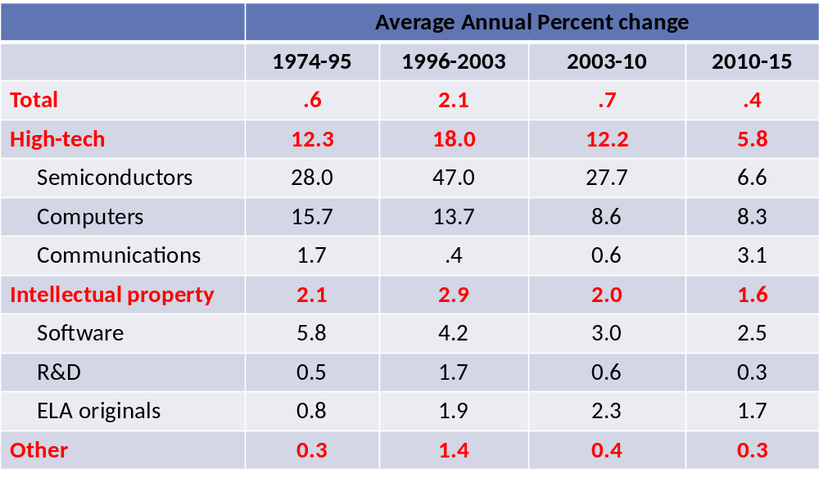
Source: Illustrative update of Byrne, Oliner, and Sichel (2013), using all official data.

If we believe that productivity figures provide reasonably good proxies for rates of innovation then, in these sectors, there is a clear pattern: a big step up in rates of productivity/innovation in the mid ‘90s through the mid-2000s (emergence of the internet, computerization and so on) to 2.1 percent, followed by a step down after that, and then an even further step-down since 2010. The same pattern observed for the high tech sectors is also present for intellectual property products and in other areas of the economy. Taken at face value, this means that rates of innovation in the U.S., particularly in the last five years, have been exceptionally slow. This observed trend has colored the narrative of what’s happening in the economy. Robert Gordon amongst macroeconomists has gotten quite a bit of traction with this narrative in his terrific economic history book. The slow pace of innovation is one of the factors he cites for why future prospects for improvements in productivity and living standards are so bleak in the US.

Sichel argued that this accounting is only credible if the data feeding into the national system for measuring productivity are accurate. If the rate of price decline of, say, semiconductors is understated, so too will be the rate of multifactor productivity growth since the rate of multifactor productivity growth is being inferred from rates of decline in prices of key products. And, if the rates of multifactor productivity growth are understated, the implicitly inferred rates of innovation in these sectors will be underestimated. Solow made a statement in the late 1980s about computers, paraphrasing: “we see innovation everywhere but in the productivity statistics.”

A lot of people have a sense that the productivity numbers derived from official statistics may not be up to the measurement task, and particularly that price measurement has not been able to keep up with rapidly changing goods and services. A set of papers convincingly documents the evidence, at least within the high tech area, and some intellectual property products. For example, research on semiconductors by Byrne et al. (2013) suggests that rates of price decline are understated by as much as 35 percentage points in recent years (see figure 2.1).

Figure 2.1: Price decline for semiconductors, based on two different price indexes
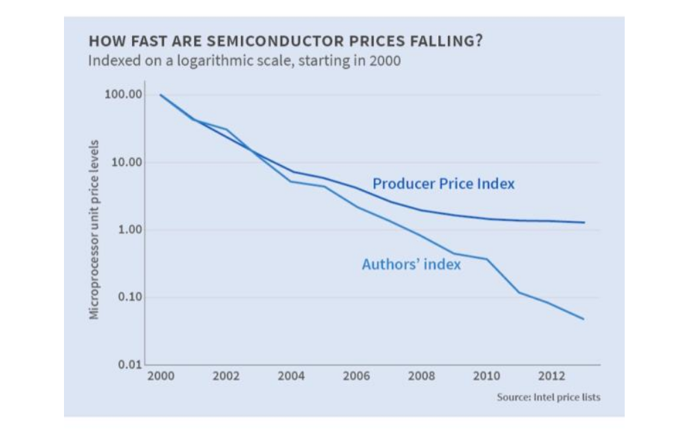
Source: NBER Digest, July 2015

Dramatic misstatement of rates of price decline would lead to incorrect inferences about innovation. Similar research has looked at communications equipment, personal computers, tablets, phones, data storage devices, and special purpose electronics. While not as convincing as in the case of intellectual property products, evidence of mismeasurement also exists for these other sectors.

Once one feeds the revised semiconductor price measure into the broad system of productivity measurement, the inferred rates of innovation change sharply. The blue bars in Figure 2.2 are rates of multifactor productivity growth within the semiconductor sector by period, using official price measures. These data indicate a sector that had its heyday in the mid-1990s. The red bars reflect the corrected price measures and, in turn, a quite different picture of what has happened with MFP (and, by extension, innovation) in this sector. Specifically, innovation in this sector has continued at a rapid pace—not quite as rapid as during the second half of the ‘90s, but nonetheless quite rapidly.

Figure 2.2. Dual MFP, Semiconductors (percent change over period shown)
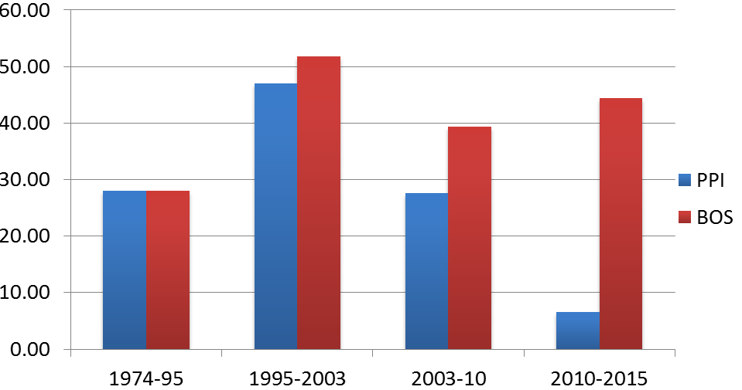

Source: Illustrative update of BOS (2013), using PPI index and Byrne, Oliner, Sichel (2015) index for semiconductor prices.

With fully corrected statistics, Sichel argued that researchers and policy makers might be having a different conversation and asking different questions. The conclusion that innovation in the economy is very sluggish raises one set of questions, for example about what to do about it while the conclusion that innovation actually has been quite rapid, but it is not appearing in broad economic statistics, raises a very different set of questions. They imply two very different lines of research and a different set of policy interventions would come from each. So, even though the broad analytical framework is a bit of a black box, it is important to try to make progress to improve the sort of inferences about innovation that we can make from that broad system.

He concluded that, to improve the accuracy of MFP measurement and, in turn, inferences about innovation in key sectors, (1) work on improving measures of prices within key sectors needs to continue and to be incorporated into the measurement programs that feed into official statistics; and (2) the measurement system needs to be expanded so as to better capture ongoing innovation activity.

Responding to Sichel’s presentation, Ashish Arora expressed concern about equating advances in productivity with advances in innovation. He pointed out that macroeconomic measurement is limited to revealing something about the rate at which inputs are being applied to economic production; this does not mean innovation in the conventional sense. Sichel responded that, in his research, John Fernald has been as careful as one can reasonably be with aggregate data to account for influences such as changes in utilization that might affect multifactor productivity and that are not associated with innovation—in other words, to construct a residual that is as close as one can get. He acknowledged that productivity is not a perfect measure of innovation, but that innovation is typically viewed as one of the key factors driving it. Sichel granted Arora’s point that innovation is not the same as advances in human knowledge and agreed that there are semantic issues to be worked out. Other factors that contribute to productivity change should also be looked at going forward by researchers. The advantage of MFP is that it offers a consistent framework within which one can make comparisons across sectors, across countries, and innovation is going to be one of the important factors driving those numbers.

Building on the exchange between Sichel and Aroroa, Wes Cohen pointed out that bridging the micro level view often used by innovation researchers with the MFP view of macroeconomists reveals a need to measure more multiple dimensions of productive processes. Technology and idea adoption, diffusion, imitation (which can also show up in the productivity numbers) all need to be measured since productivity gains from innovation can be generated through any of these avenues. Without this information, we remain largely in the “dark matter” world. National statistical agencies have occasionally taken on these tasks, but not necessarily in a systematic way.

3. Innovation Beyond R&D and conventional input measures
Data on specific aspects of innovation—such as R&D expenditures, patent applications, and citations—are often used to proxy levels of innovation activity within industries or countries. However, in the measurement community, it has long been understood that activities, both technical and non-technical, including those that are not a directly measureable function of R&D and science also play an important role in innovation.

The annual Business R&D and Innovation Survey (BRDIS)—conducted by the Census Bureau through an interagency agreement with NCSES—asks firms (in both manufacturing and service industries) for information about newly introduced or improved products and processes, and about purchased R&D inflows and outflows, revenue from the sale of patents and patent licensing, and a number of IP-related activities. Some questions about innovative activities can be adequately addressed with current data sources such as BRDIS and the Community Innovation Survey (CIS), while others may require new or different kinds of data. For example, less is known about how innovation that takes place in organizations that are not R&D active, as is often the case in the service sectors. Questions to be addressed during this session included: What models exist for assessing different kinds of (e.g., non R&D-based) innovation? What do we know about innovators acquiring inventions from external sources? How would better information about the division of innovative labor affect our understanding of the propensity to innovate? On the measurement front, participants considered how surveys and alternative data sources might be combined to improve the accuracy and interpretability of measures of different kinds and levels of innovation.

Expanding surveys to reveal additional information about innovation processes

Wesley Cohen (Duke University) discussed two prominent survey-based sources of innovation data—the Community Innovation Survey (CIS) and the “Division of Innovative Labor” (DoIL) survey, the latter of which he co-created with Ashish Arora and John Walsh. The DoIL survey was designed to shed new light on the key sources of innovation and competitive advantage of American companies. Cohen’s presentation included two parts: The first addressed the question, discussed earlier by Gault and others, what do we mean by innovation, and how should surveys be structured to measure it? The second reviewed substantive findings that have emerged from the DoIL survey.

The top level questions from the most recent CIS were “did your enterprise introduce a product innovation”, meaning one or more “new or significantly improved goods?”; and “were any of your product innovations “new to your market,” “only to your enterprise,” or a “first” in your country, Europe or the world?” The CIS frames questions about innovation at the firm level. For example, regarding revenues and innovation, it asks what percent of a firm’s total turnover in a given year was from new to the market innovations, new to the firm innovations and from significantly improved products during the three year reference period.

The CIS and DiOL surveys generated the following estimates of the share of manufacturing firms introducing innovations for the 2007-2009 period in selected European countries and the U.S.:

New-to-the-firm
- Germany: 49%
- UK: 34%
- France: 28%
- U.S.: 42%

New-to-the-market innovation
- Germany: 23%
- UK: 17%
- France: 19%
- U.S.:16%

A key concern with the above statistics is how to interpret what respondents mean by new or significantly improved goods? A “yes” answer to the above survey question could indicate something comparatively trivial such as a new color of toothpaste. Or it could be something major, such as the first 3D printer. What respondents have in mind when answering these questions needs to be well understood in order to attach meaning to the this kind of information.

Compared with the Community Innovation Survey, the DoIL is less broad in spirit. Its objective was to characterize the contours of what developers call innovative labor and to emphasize the distinction between invention and innovation. The questions at the core of the survey were intended to determine to what extent innovators—companies introducing something new to the market, or commercializing new products or significantly improved products—acquire inventions from external sources and channels. The framework allows researchers to estimate and compare the value of externally acquired inventions by source—buyers, suppliers, another firm in the industry, universities, and so on—and to identify which channels—licensing, contract, more informal, is it cooperative efforts, et cetera—were exploited.

In order to identify innovating firms, the survey asked:
“In 2009, have you earned revenue from any new or significantly improved goods or services in [INDUSTRY] introduced since 2007, where “new” means new to your firm?”
In order to focus on respondents’ most important innovations, the line of questioning continues with:
“Of all the new or significantly improved products or services you brought to market in [RESPONDENT INDUSTRY] during the three years, 2007-2009, think of the one that accounts for the most revenue.”
And, to identify respondents as “new to the market” (NTM) innovators:
“Did you introduce this innovation in your industry before any other company?”

This question structure builds directly on the definition of innovation from the Oslo Manual and from the Community Innovation Survey. The major advance created by DoIL is that it identifies a specific line of business for a given respondent. The survey is not for the firm as a whole—it is conducted at the business unit level.

In addition to “new to the market” innovators, DoIL enables identification of imitators—cases in which something new was introduced to the firm but which was not new to the industry. The question framing allows for calibration regarding what meets the threshold to classify as an innovation for a given purpose. Analysts can set the criteria—e.g., the introduction must account for X percent of sales—for what is considered important.

Summary statistics reveal a “new to market” innovation rate of about 16 percent for the 2007-2009 period across all manufacturing industries, with innovation occurring disproportionately among large firms (38% versus 23% and 13%, respectively, for medium and small firms). There was also a wide range of innovation rates by industry: at the top end were instruments and electronics, at 37% and 33%, respectively; at the low end (8-9 %) were wood, minerals and metals. About 27 percent of respondents reported imitating, and these rates were more stable across industries and firms size relative to the innovation rate. And the percent of sales from new to market innovations was also highly skewed by industry (e.g., 31% for medical equipment and 5% for metals). For NTM innovators, the most important new to market innovation accounts for the bulk of all new to firm sales (about 70%).

[Reproduce the table from Slide 12?]

Next, the survey asks respondents about the sources and channels from which the most important innovations (contributing to the overall design or the development of prototypes or conceptualizations of technology) originated. About 49% of respondents reported externally sourced inventions. The most pervasive source of innovations was customers; the most valuable ones originated from technology specialists, which include contractors, universities, and independent inventors. Innovations were acquired through market channels (e.g., licensing, contract, equity acquisition) and non-market channels. The latter accounted for almost two thirds of the cases, with cooperative efforts at 61%.

Returning to the question of where in the spectrum (from trivial to very important) a product innovation falls, Cohen suggested that surveys could do more to capture the relevant dimensions in ways that are measurable. Supplementary indicators of economic value and technical significance could be developed that permit assessment of the significance of innovations reported by respondents. DoIL indicators along these lines were constructed based on questions asking:
- The percentage of business unit sales due to the focal innovation;
- Whether, in order to commercialize a focal innovation, the innovator: (1) developed new sales and distribution channels, or (2) invested in new types of equipment or hired employees with skills different from existing employees; and
- Whether the focal innovation is patented by (1) the innovator or (2) an external source.
The last question is less a measure of economic value (since most patented inventions are not ever commercialized) and more as a measure of technical novelty.

Figure 3.1 presents findings about the percentage of business unit sales from focal innovation. The vertical axis is the percentage of innovating firms and the horizontal axis indicates the percentage of sales accounted for by that group of innovating firms. For example, looking at the second to last blue bar, for about eight percent of innovating firms, their most important new or significantly improved product accounted for more than 50 percent of sales.

Figure 3.1: Percentage of sales from focal innovation (all innovations), 2009
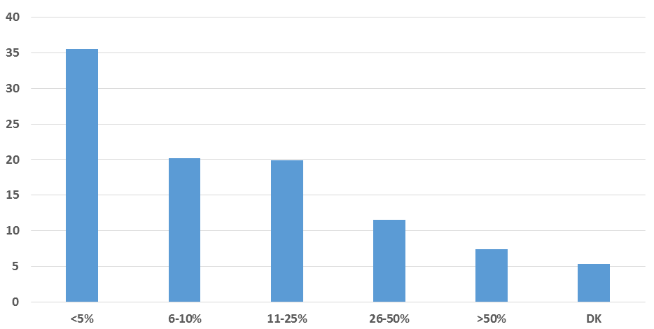
Note: N=1,062 NTM innovators.

Findings from the DoIL also indicate levels of investment in commercializing focal innovations (e.g., about 25 percent of respondents reported buying new equipment, hiring new personnel, and developing new distribution channels) as well and patent rates among NTM innovators (e.g., the rate is about 42% in manufacturing).

Cohen went on to discuss findings about the correspondence between the percentage of sales due to focal innovation and other indicators. As shown in Figure 3.2, the degree to which focal innovations accounted for sales (less than or more than 50 percent) tended to correlate with other metrics. For example, looking the fourth set of bars, among firms whose innovation accounted for more than 50 percent of sales, 44 percent also indicated that they developed new distribution channels and invested in new sales and equipment. These different kinds of innovation are interrelated.

Figure 3.2. Correspondence between percent of sales due to focal innovation and other indicators

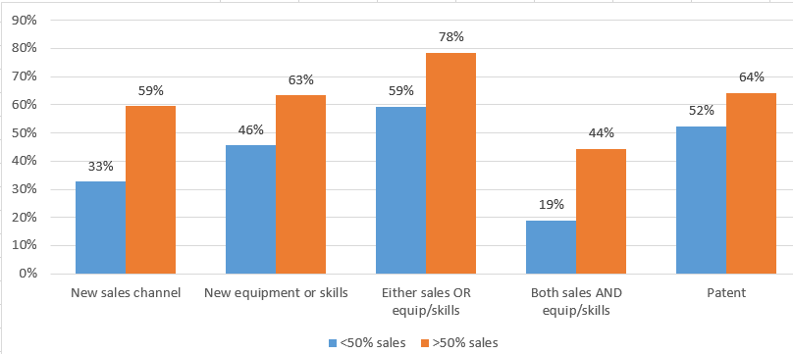
Cohen’s substantive conclusion was that the observed high reliance on external sources for invention suggests that, to understand drivers of innovation, researchers must consider the extent and implications of the “division of innovative labor. “It’s not just large firms, it’s not just startups, it is not just universities.” Measurement of the performance of the system as a whole must be focused on the relationships across them. His methodological conclusions were that (1) innovation measures focusing on a specific innovation offers accuracy and interpretability, and provides latitude and discretion to an analyst trying to understand various phenomena of interest; and (2) multiple measures tied to a specific innovation can reflect dimensions of economic and technical importance, mitigating ambiguity surrounding terms “innovation” and “new or significantly improved.”

Changing Divisions of Labor in Innovation

Ashish Arora’s (Duke University) presentation reinforced many of the points—such as that thinking about innovation purely from the point of view of the innovating firm is misleading—made by Cohen. Much of Arora’s presentation took Simon Kuznets’ premise—that the paramount feature distinguishing modern economic growth is the systematic application of scientific knowledge to the problem of human production—as a given.

Arora began by making the distinction between invention, innovation, and knowledge. Early in the country’s history, for example, innovators in the railroad industry, the technically most sophisticated enterprise of its time, did very little inventing on their own. For the most part they relied on outside sources, and independent invention by employees or contractors. Exemplifying the times, writing on the “duties of the patent department” at AT&T, T.D. Lockwood (1885) wrote:
"I am fully convinced that it has never, is not now, and never will pay commercially, to keep an establishment of professional inventors, or of men whose chief business it is to invent” … the duties of the patent department … (should be) … first and foremost on examining patents or inventions submitted by the public for consideration and second on examining descriptions of inventions forwarded by the company's employees.“

Lockwood’s inclinations notwithstanding, eventually “industrial research” did emerge, initially to deal with this problem of external invention. The country entered the golden age of American R&D during the 1950s through the 1970s; companies such as AT&T, Dow, DuPont, and IBM (and many others) worked on a path of innovation-led growth relying largely on internal invention. At about this same time, many statistical agencies began developing their models of innovation measurement which influenced methodological decisions.

Fast-forwarding to more recent years, data from NSF (Figure 3.3) shows a return to the pre-golden age trend, as the share of privately funded R&D taking place in the economy by large firms has declined.

Figure 3.3: Share of total privately funded R&D in the U.S. by firm size, 1984-2005
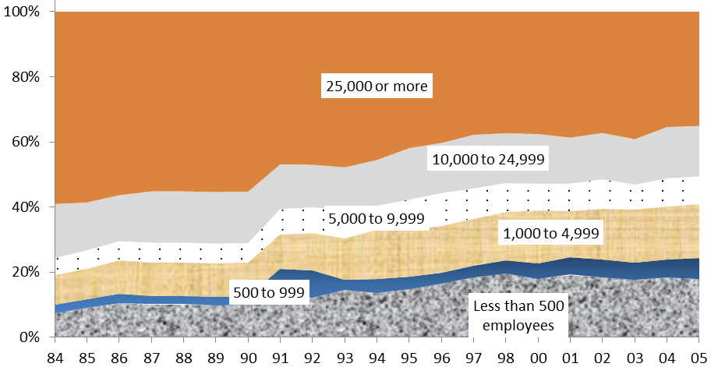

Other indicators, such as R&D award winners among fortune 500 companies, paint a similar picture: large firms—the innovators getting products into the market—are not inventing the inputs themselves at the same rates they were 30, 40 and 50 years ago.

An interrelated trend, shown in Figure 3.4, is that the share of basic and applied research as a percentage of total R&D has been in steady decline since the mid-1980s as companies move away from the generation of new knowledge. They are still in the business of using inventions to produce innovations but, Arora argued, these data indicate a growing separation between knowledge production and the use of that knowledge in invention and then innovation. Given the diminishing role of internal research in large private sector companies, understanding the mechanisms of external knowledge production and spillovers from universities, startups, and government sources—as well as non-US sources of both invention and knowledge—is becoming increasingly important.

Figure 3.4. U.S. business expenditure on basic and applied research, as share of total business funded R&D, 1980-2012
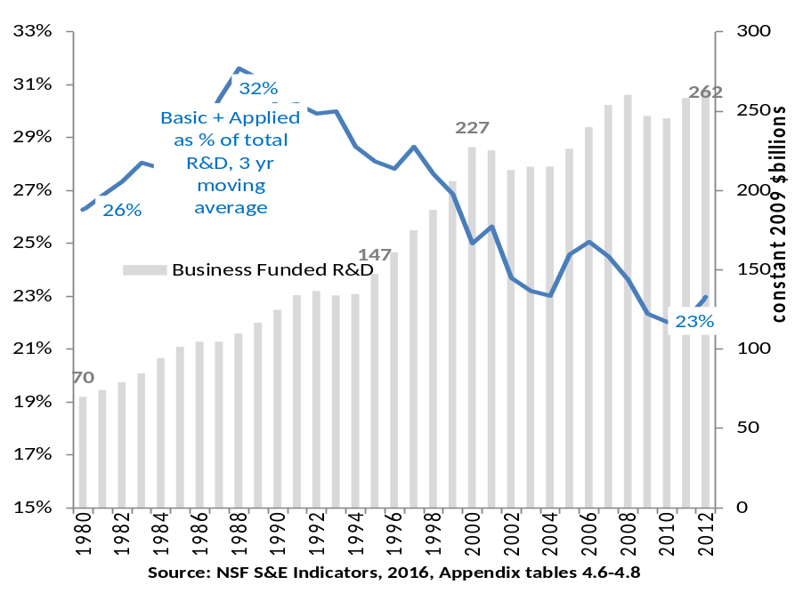
Source: NSF S&E Indicators, 2016, Appendix tables 4.6-4.8

Regarding the organizations doing the inventing, Cohen noted that in the U.S. roughly half come from sources—suppliers, customers, other firms, consultants, independent inventors, and universities—that are external to the manufactures who put them to use. The channels through which inventions flow to innovators are market based about one third of the time. The other two thirds flows through other informal means, which Arora speculated includes public domain, stealing, or some combination of these. Some are collaborative, cooperative joint ventures. Data produced by NSF Science and Engineering Indicators provides information about the extent to which invention originates from science—the percentage of patents citing science and engineering literature.

Commenting on external sources of inventions (and inventive labor), Alfonso Gambardella noted an important distinction between market and non-market mechanisms. Current data are geared to capturing the former, while researchers have to be more creative with the data to glean information on the latter. The non-market mediated mechanisms are still largely black matter in terms of our understanding of their role in economies. Cohen, agreed that non-market mechanisms are important noting that, for example, cooperative efforts in these sorts of relationships were shown to be extraordinarily high in the Cohen/Arora surveys. Co-invention, he said, probably accounts for the majority of invention, but we have little data on these arrangements. There is an enormous amount of literature on alliances in the strategy and management area, but really systematic data at an economy or sector wide level, and its role in innovative performance as well as adoption, diffusion, et cetera, is essentially lacking.

Citations by U.S. patents to science and engineering articles has been trending up from about 16 percent in the early 2000s to well over 20 percent in more recent years—so now almost a quarter of the patents cite science and engineering literature. Some indication, then that innovative activity is not getting separated from the scientific or technical base, as some have argued. This does not appear to be the case, as least as reflected by patents.

Arora’s conclusion was that currently collected data does tell us a lot about the division of labor in invention, adoption, and innovation. The data currently tell us how innovation systems are evolving in the American economy. Of course, more could be done, especially through data linkages used to measure more of the idea flows. This requires improved data on (1) the sources of invention—whether it is internal, through partnerships (with customers, suppliers), or other mechanisms (startups, universities); (2) the sources of knowledge (whether corporate, university, or otherwise based); and on (3) flows of external knowledge (e.g., citations, text matching) and external invention (e.g., licensing, contracts, mergers and acquistions, and collaborations).

Research using longitudinal business data and other statistical agency data that helps measure innovation

[It might make sense to move this discussion to immediately after summary of Sichel’s presentation.]

Javier Miranda (U.S. Census Bureau) presented work measuring the high tech sectors using administrative records at the Census Bureau. Picking up the discussion thread from Dan Sichel’s presentation, Miranda argued that, regardless of the productivity measurement issues, when other outcomes are examined different trends have emerged for the high tech sector after 2000. His research (with coauthors John Haltiwanger, Ron Jarmin and Ryan Decker) indicates a decline in the number of startups in the high tech sector and in the number of jobs that these startups are generating (Figure 3.5). Specifically, the number of these startups that become superstar firms, firms started by “transformational entrepreneurs” that generate a lot of jobs in the economy, has declined over the period.

Figure 3.5: Share of Employment in Young Firms in High Tech

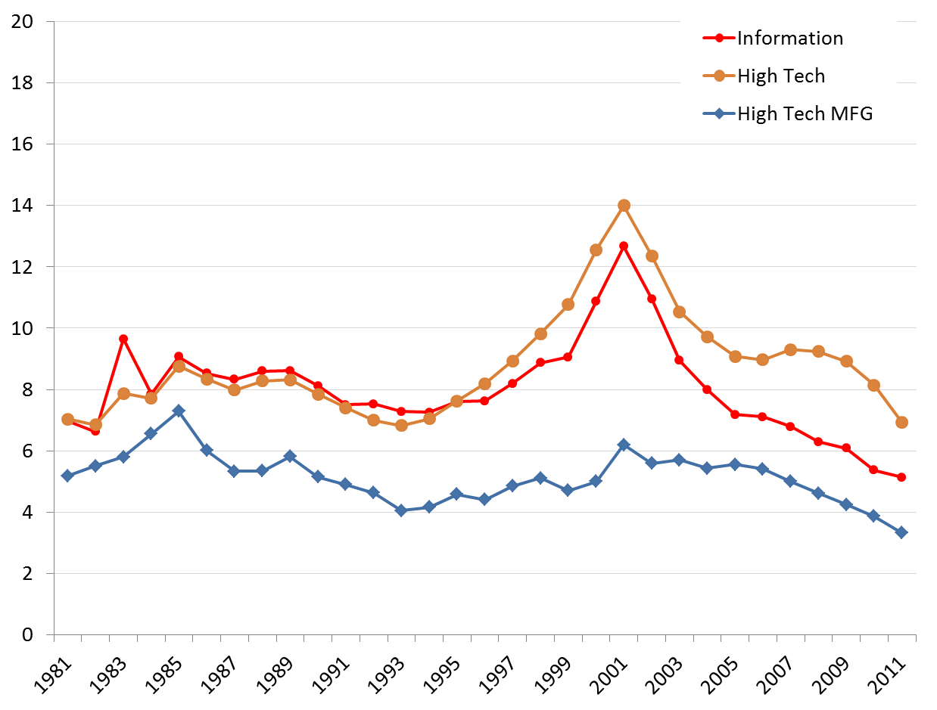
Source: Decker, Haltiwanger, Jarmin, and Miranda (2015)

The secular decline in business startup rates over the 1981-2013 period—there was a 12 percent decline peak to peak between the recessions in the ‘80s and the Great Recession—is a concern in that young firms disproportionately contribute to employment and productivity growth. But the answer to whether the economy or a given sector has become more or less innovative depends on what types of startups are in decline. If it has been “mom and pop” businesses or mainstream businesses that are not very productive, then the decline may be less worrying. However, if the decline is in transformational entrepreneurs creating innovative businesses, then it would be a greater concern.

Research by Miranda, Haltiwanger, Jarmin and Decker found that the decline in startup rates during the 1990s was driven mostly by fewer “mom and pop” type businesses starting in the retail sector. After 2000, the trend appears to have been largely driven by a decline in transformational entrepreneurs, the type of businesses that, historically, have generated a lot of jobs.

Given that researchers do not have flags in the data distinguishing between startups by transformational entrepreneurs and mainstream or “lifestyle” entrepreneurs, they have examined measures of skew in the firm growth distribution. The idea takes advantage of the fact that relatively few firms become superstars that generate a lot of jobs. In other words, a few innovative firms generate a disproportionate amount of new jobs. For the high tech sector—a composite of industries (e.g., information services, computer and peripheral equipment, software publishers, computer system design and related services) with more than 25 percent of its workers in STEM—Miranda et al. find a high level of dynamism during the ‘90s: particularly a lot of entry of new firms, coinciding with the productivity growth in the US. Around the time of the dotcom bust, and also the accession of China to the WTO, a sharp reversal and decline in startup activity in the high tech sector took place. Likewise, as shown in figure A, the decline in the share of employment in high tech jobs began in 2000 and, by 2011, it was about half of what it had been a decade earlier. The decline coincides with a slowdown in productivity growth as measured using official statistics (or using Fernald’s numbers cited by Sichel).

But, Miranda asked, what happens to these superstar firms that generated a lot of jobs? To answer this question, one must look beyond R&D data. In the research described by Miranda, measures of trends in STEM worker employment are used to help complete the picture. The research shows the importance of looking at measures of dispersion and skewness to understand what is happening in this sector. And, as explained next by Kristen McCue (U.S. Census Bureau), statistical agencies are looking into different data products to get at this type of heterogeneity.

Kristin McCue (U.S. Census Bureau) reported on two emerging developments at the Census Bureau that are relevant to the study of innovation: The first involves enhancements to Business Dynamics Statistics (BDS) program that will provide useful information on innovative businesses; the second involves two new surveys of small, young firms designed to collect information about innovation that is not available from administrative records.

The extensions envisioned for the BDS program—which produces data on job creation and destruction, establishment openings and closings, and numbers of startups and shutdowns as well as the age and size of firms, establishments—is to produce a high tech industry measure. In the near term, statistics will be produced for a grouping of a set of industries with disproportionate STEM employment using the definition identified above by Miranda. Longer term, statistics may be produced by 4-digit NAICS so users can create their own groupings of high-tech industries.

The BDS program is also looking to put out statistics on high growth employers. The idea is to generate data on percentiles of employment-weighted growth distribution in order to be able to track the skewedness of the distribution over time and across sectors. There have also been efforts to create statistics on whether businesses and employees have been involved in patenting activity. This involves using the linked employer-employee data to link inventors to their data in census. For all of these products, the underlying linked microdata will be potentially accessible to researchers in the Census Bureau’s federal statistical research data centers.

Finally, there are two new surveys that derive content from NCSES’s Microbusiness Innovation Science and Technology Survey, or MIST. One, the Micro BRDIS, is being developed by NCSES. The other, the Annual Survey of Entrepreneurs, includes modules of eight questions from the MIST survey covering process and product innovation and R&D costs, funding, purchases, and employees. These are both surveys of small and young firms. As in past collaborations between agencies, such as between NSF and BEA developing new data for adding R&D and intangibles into the national accounts, questions of data confidentiality must be dealt with.

Design innovation as an alternative or complement to R&D

Bruce Tether’s (University of Manchester) presentation focused on design—and primarily “industrial design” as opposed to engineering design. The latter is often thought of as an activity taking place within R&D, while the former typically is not. Tether cited a number of prominent examples of new product introductions being driven by design: Ford’s Model T was replaced by the Model A in large part because people wanted a new, more varied product—there was nothing particularly innovative about it from a technological perspective. Similarly, Apple introduced the iMac computer with the intention of making computing fun and accessible: the innovation was in the presentation and user-interface, rather than in the underlying technology. In both of these cases, understanding and responding to user needs and desires was central. Design also applies to services. For example, one way that Virgin Atlantic competes with larger airlines such as British Airways, United, and American is by investing heavily in design to create a different customer experience.

So what, Tether asked, is design? The term is as malleable as “innovation.” The traditional view is that design is something applied after all the difficult complex engineering decisions have been made, when the goal is to make a product look attractive: in this view, it is about outward appearance. Even if this were the extent of it, Tether argued that design matters. Its growing importance is indicated by a steady rise in the number of design patents issued since the mid-1980s, as shown in figure 3.6. Over 20,000 design patents have been granted annually since 2006. The total number of patents has also risen substantially so, as a share of patents, it has only gone up marginally. Nonetheless, these data gives some indication of the significance of appearance.

Figure 3.6. U.S. PTO Design Patents Granted, 1963-2015
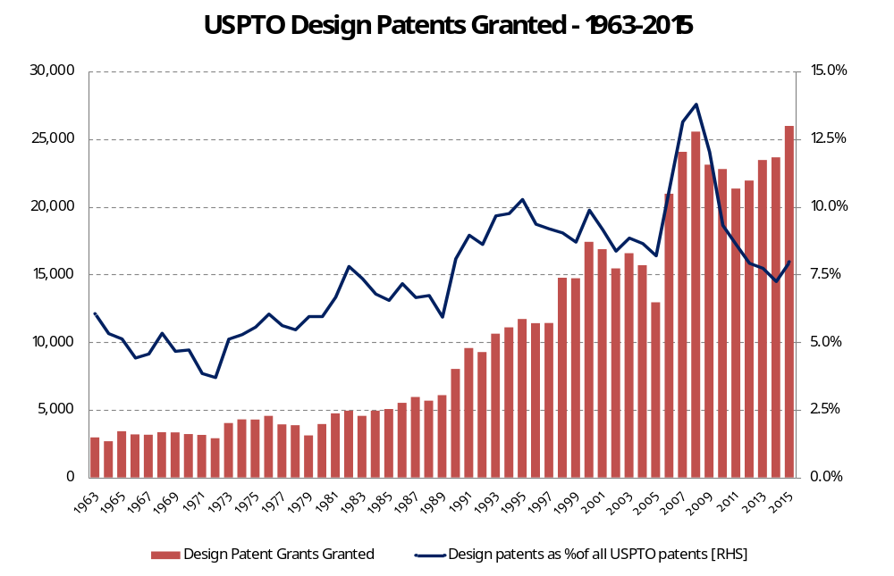
The nature of the big design patent owning firms—e.g., Samsung, Microsoft, LG, Nike, Apple, Procter and Gamble, and Honda—indicates that there is a relationship with technologies, such that design goes beyond aesthetics. These companies have both utility patents as well as design patents. The modern view of design is that it brings together creativity through insights and integration of ideas. A good example is IDEO (a global design firm) which created a program called “Keep the Change” to entice people to save more (every time customers buy something with their Visa debit card, the bank rounds up the purchase to the nearest dollar and transfers the difference from their checking into a savings account). This kind of innovation required a deep understanding of people’s needs and wants and how they can realize them.

Next, Tether provided statistics based on an Innobarometer survey, conducted in 2015, about the extent to which firms in various countries are engaged in design and R&D. As shown in Figure 3.7, over 40 percent of U.S. companies invested in design outside of R&D, a slightly higher share than the share of firms that invest in R&D. Similar findings were found for the EU-27 and for Japan.

Figure 3.7. Investments in R&D and Design (outside of R&D (by Country and Intensity)
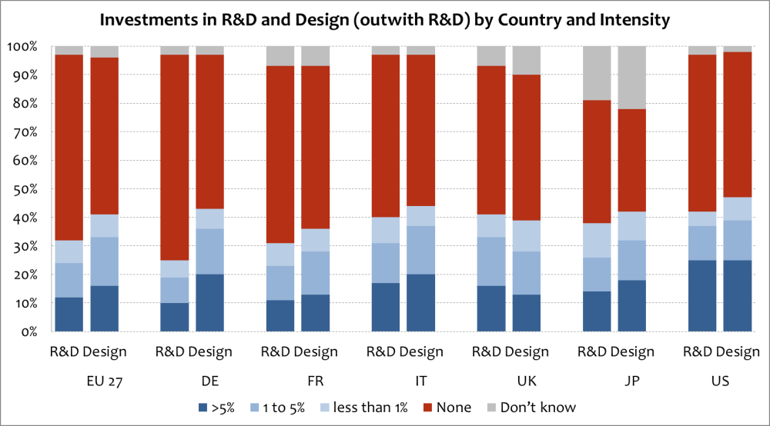

Next, Tether argued that it is not just how much firms spend on design that matters, but the role of design in the firm. The Danish Design Centre developed a design ladder to indicate this. . Firms can use design as a strategy, where it is a central feature in the business concept; or as a process, where it is integrated early on in product development; or alternatively it can be used as a last finish, to give the product form. Finally, some firms do not use design at all.

Controlling for various factors—such as investments in R&D, investments in software, branding, the age and size of companies, sector and country—research has found that firms that spend on design are more likely to innovate and have higher sales from innovation. Work by Galindo-Rueda and Millot using the Danish CIS data reveals this increasing impact from using design more strategically: As shown in Figure 3.8, firms which use design in a centralized way are more likely to introduce innovations than those that don’t use design or that use design as an add-on styling.

Figure 3.8. Impact of design use on the probability of introducing an innovation, 2010
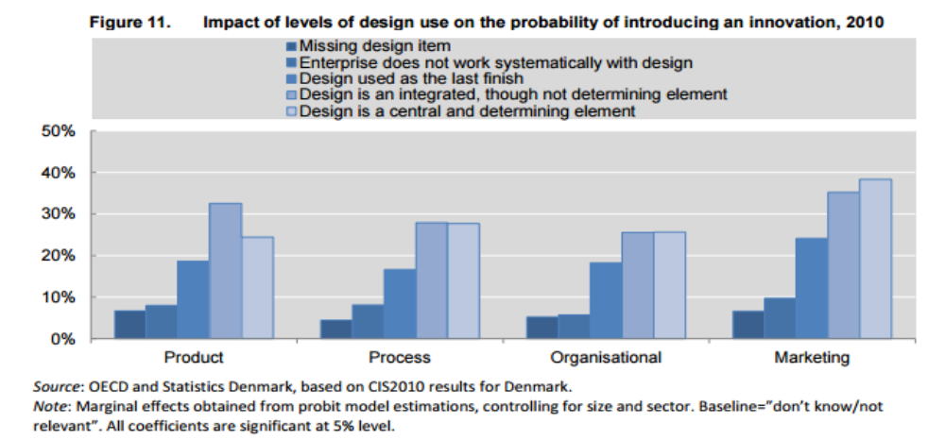

Another recent study using the Innobarometer survey found similar marginal effects on whether or not firms introduce product or service innovations in terms of the centrality of design. As shown in Figure 3.9, design becomes more central, the probability of introducing innovations increases.

Figure 3.9 Marginal effects on the probability of introducing product/service innovations
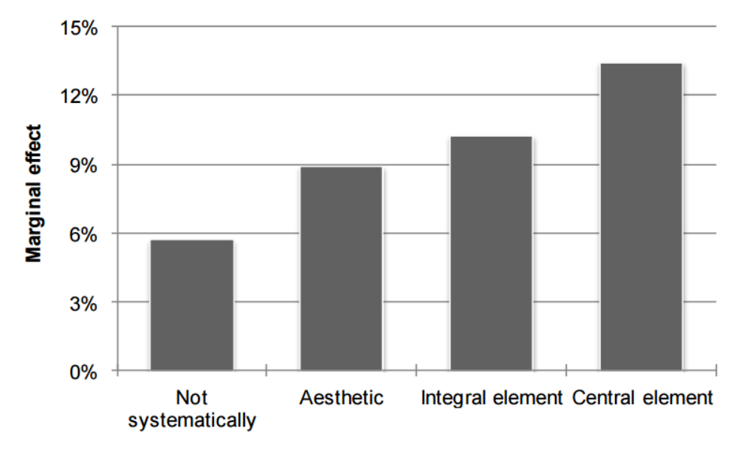
There is also a marginal association with sales, although not necessarily a causal one. Again, where design is a central element, the share of sales linked to product/service innovations is higher.

Tether summarized his presentation with the following points:

- Design has mattered as a competitive weapon for a long time, and yet it has been on the fringes of innovation measurement and, as a result, is not really very well understood.
- Recent studies are showing that spending on design, and its role in the firm, affects the introduction of innovations. So it is not adequate to measure the spending on this input; we also need to know where design it is positioned in the firm.
- Design is increasingly seen as part of a process that integrates an understanding of users’ needs, which are not always explicit. Design relates to appearance matters, and appearance matters (people make selection choices on the basis of how things look), but design now goes well beyond that.
- Design varies across different sectors. A lot of attention is focused on the high tech sectors, but that is only a small part of the economy: design is important in ‘low tech’ sectors and, increasingly, in services (for example in the development of experiences).
- Among the challenges from measurement are: (1) there is no agreed upon standard for defining design; (2) design is often hidden—two companies may be investing the same amount in design but this may not appear to be the case if one has design activity subsumed into R&D and marketing; (3) beyond the amount spent, how the spending is arranged is also important—if spending is fragmented, it seems to have less impact than if it’s concentrated; (4), the quality of design inputs (including key designers) may matter more than position or extent of investment; and (5) contingencies and complementarities are involved, as is usual in innovation studies, that determine when design is likely to be most effective.

Automation innovations

Another aspect of innovation that remains partially in the dark matter of measurement is that associated with automation and robotics. This dimension is particularly crucial given the relationship between automation in manufacturing and services and employment and wages. Rob Seamans (on loan to the President’s Council of Economic Advisors from NYU) presented on the need to track automation across sectors of the economy in a way that informs employment and other policies.

Seamans touched on a number of topics from the 2016 Economic Report of the President which included a section on robotics and automation in its chapter on technology and innovation. Extensive evidence exists that automation leads to productivity growth (Bloom, Sadun, Van Reenen (AER 2012)). However, there has been little research on the robotics component of automation. Seamans cited a paper by Graetz & Michaels (2015) quantifying the shipment of robotics into different sectors of the economy in different countries from 1993 to 2007. This research finds that use of robotics led to, on average, a 0.36 percentage point increase in a country’s annual labor productivity growth, accounting for slightly more than one-tenth of overall GDP growth during this time. This may seem small, but it is an impact of similar magnitude to that resulting from steam engines in the United Kingdom in the late 19th century—and about a tenth of the productivity growth that occurred during this time period.

Robotics can either complement labor or it can substitute for labor. And, while macroeconomists tend to focus on top-line productivity growth, it is also important to know whether it comes at the expense of labor and, if so, are there policies that could help mitigate this potential downside. Seamans took workshop participants through a few examples. In China’s Great Wall Motors Assembly Line, robots have replaced workers who previously riveted parts onto cars. A high share of robotic shipments go to the automotive industry in countries like the U.S., China, Germany, and most notably Japan, where there are high ratios of robots to workers. In this industry, there might be more substitution going on than complementing (although, even in this case, the car robots are likely increasing the productivity of workers at higher plant managing levels). Amazon has invested in a company called Kiva Systems that makes robots that take items to pickers located in a central location in the warehouse. These Roomba-like machines traverse aisles, locate items, and bring them to workers who then perform the tasks that they are really good at which is figuring out what they need to pick in order to fill the order. These robots are performing an essentially complementary role which increases the productivity of the human pickers and processors.

Data from the International Federation for Robotics indicate that total annual shipments of industrial robotics began to increase rapidly around 2010—they have nearly doubled since then. Similarly, beginning around 2011-12, there was a large uptick in the number and rate of patents that cite the robot class. These trends suggest that the 0.36 percentage point contribution to productivity growth estimated by Graetz & Michaels (2015), which only included data up to 2007, may significantly understate current contributions.

The effects of automation on labor are likely to be geographically heterogeneous, given that automation affects industries differently, and some industries are more geographically concentrated than others. . To illustrate this point, Seamans presented the number and share of workers in each county that work in industries receiving the most robotics shipments. Not surprisingly, large counties like LA County, Santa Clara County, have high numbers of potentially affected workers. In terms of the share of workers, counties in which the dominant employer is concentrated in a highly automated industry are at the top of the list. In Calhoun County Arkansas, the home of three large aerospace and defense firms (Aerojet, Lockhed Martin and General Dynamics), close to 100 percent of the workforce is potentially affected. Rates almost this high obtain in Bristol Bay Alaska, which is dominated by canning and seafood processing, and Saluda County South Carolina, home to large poultry and meat processing plants. From a policy maker’s perspective, these geographic locations are interesting because robotics and automation are having large impacts (positive for workers with some skills and negative for workers with other skills) in the local economy.

Researchers have also examined the link between the occupational “threat of automation” and wages across industries. Data from Frey and Osborne (2013) show the probability of automation for each of about 700 types of occupation. BLS data on wages can be matched for each of those occupations, as shown in Figure 3.10.

Figure 3.10. Median Wages and Probability of Automation by Occupation

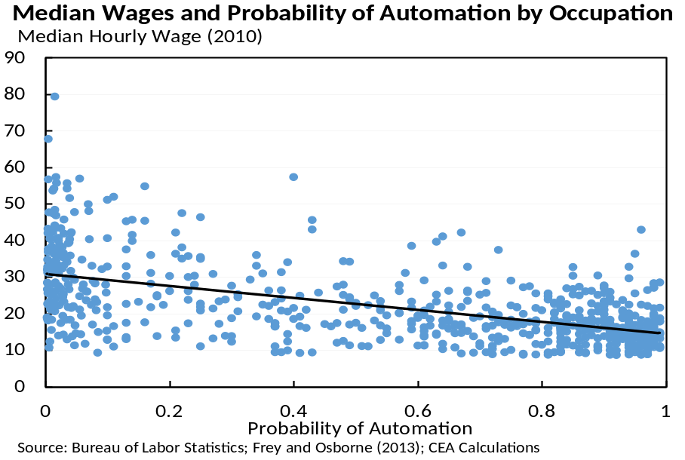
Source: Bureau of Labor Statistics; Frey and Osborne 92013); CEA calculations

In the figure, each blue dot represents an occupation. Toward the left-hand side of the graph are occupations such as podiatry, civil engineering, the clergy, interior design, and HR management— where jobs require manual dexterity or a lot of complex thinking that do not lend themselves easily to automation. On the right-hand side are occupations like tax repair, telemarketing, and cashier and office clerk work where less manual dexterity is required or where there is more automatable thinking. Occupations that are easier to automate than others appear to have lower wages associated with them.

Seamans concluded that—given the recent uptick in robotics (whether measured in units, revenues, or patents), the potential impact on productivity growth and also labor displacement, and the geographic diversity of these trends—the topic warrants more research attention. Data on robotics shipments are available from a private provided (International Federation of Robotics, or IFR) at the country-industry-year level. There is also data on the probability of automation, such as that produced by Frey and Osborne, McKinsey Global Institute, and others, and there is patent application data, particularly patents in the “robot” class. Seamans argued that none of these measures are at a granular enough level to provide information to help policy makers track how automation is affecting industries and economies at a local level. Thus, in order to facilitate research on some of these important relationships, NSF and NCSES could prioritize developing more detailed data indicating which industries are using robots, how much are they spending, and the extent to which robots are substituting or complementing workers. One possibility would be to systematically add questions to a U.S. survey along the lines of “Last year, how much money did your establishment spend on robotics?” and “Has your establishment considered using robotics instead of human labor?” Sheryl Winston Smith commented that robotics is an important input into machine learning; and, in that case, it is essentially a complement in production, but one that is not going to show up in robotics patenting data sources that would attribute the contribution to other categories.

Seamans added that it is the responsibility of policymakers to track affected industries and geographies, to anticipate the downstream effects of these innovations (e.g., they may boost productivity, but there are potentially adverse effects on labor), and to consider appropriate policy responses.

4. The Role of Individuals (and networks of individuals) in Innovation

Compared with institutions and organizations, less attention has been given to the role of individuals and teams in the innovative process. How people’s educations, entrepreneurial talents, and other human capital characteristics result in innovation are vast and largely unresolved research areas. Linkages among individuals and between institutions also play an important role in innovation. One example of how innovation relates to individuals with direct and high profile policy implications is in the area of immigration. High skilled foreign born workers have, by most accounts, played a disproportional role in recent years contributing to human capital formation, innovation, entrepreneurship, and economic growth.

Knowledge diffusion, employee mobility and entrepreneurship

Rajshree Agarwal (University of Maryland) focused her comments on improving understanding of how new product innovation interacts with the career profiles of individuals who create them. Among the main takeaways from her presentation were the following:

- Entrepreneurship is not a destination, but a step in a longer career lifecycle. Thus, the effect of entrepreneurial firm fates on individual career lifecycles needs more attention if it to be fully understood.
- Future research would benefit from a focus on human capital markets. Conceptually, this requires combining demand and supply factors to examine lifecycle choices and also taking into consideration selection effects as they relate to optimal allocation and reallocation of talent.
- Individual level career and knowledge innovation datasets need to be merged to identify systematic sources of bias and to answer questions about whom firms hire, keep, let go, and how these decisions affect career profiles.

Few studies have investigated how entrepreneurship affects long-term career lifecycles (beyond the new venture directly). There are serial entrepreneurs; there are boomerangs—the individuals that choose to go and then come back to the focal firm as a returnee employee; and of course founding teams are comprised of individuals. One key research question is, how do the fates of new ventures affect long-term career outcomes of entrepreneurs and founding team members?

Regarding issue number two above, research often focuses on the product market (where primacy is given to demand conditions) and to individual career choices (where primacy is given to preferences and incentives). A singular focus on either one of these ignores the fact that markets need to clear for human capital. More work is needed to understand the role of mobility and entrepreneurship in the allocation and reallocation of talent.

Several factors, on both the demand side and the supply side, impact mobility and entrepreneurship. There are protection mechanisms and costs associated with mobility across organizations, even startups. Mobility and entrepreneurship are often impacted in the same direction, but sometimes the effects are divergent. For example, collusion among high tech firms to not poach talent may reduce mobility, but it may enhance entrepreneurship. Little is known about how other factors (listed in Table 4.1) impact mobility and entrepreneurship. For example, how does family composition affect individuals’ mobility and entrepreneurship decisions, and the associated wage outcomes? Where do other social processes factor in?

Table 4.1. Factors affecting mobility and entrepreneurship 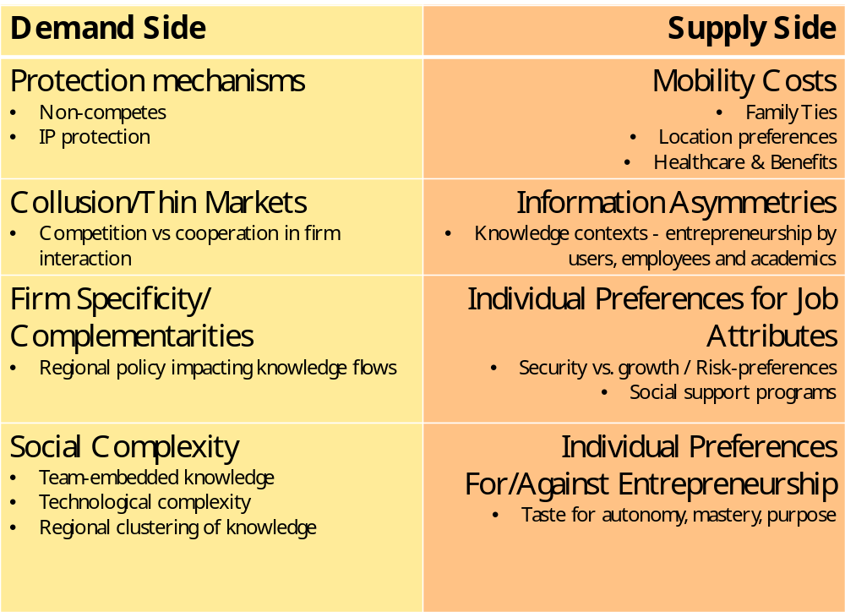

Agarwal argued that mobility, entrepreneurship, and innovation datasets need to be linked in order to study how entrepreneurship and innovation relate to career lifecycles. Figure 4.1 provides an example of the kind of linkages that would be helpful in answering a range of important questions, such as:

- What types of bias impact patent-based measures of mobility?
- Are inventors more productive when they take co-workers with them?
- Is non-inventor mobility a source of knowledge diffusion?
- How much are inventors able to appropriate from a patent their employer owns? Do they see long-run wage/career impacts?
- Is there evidence that inventors are “stealing” ideas?
- Are inventors filing patents soon after they leave for a start-up?

Figure 4.1. Linking patent and census data

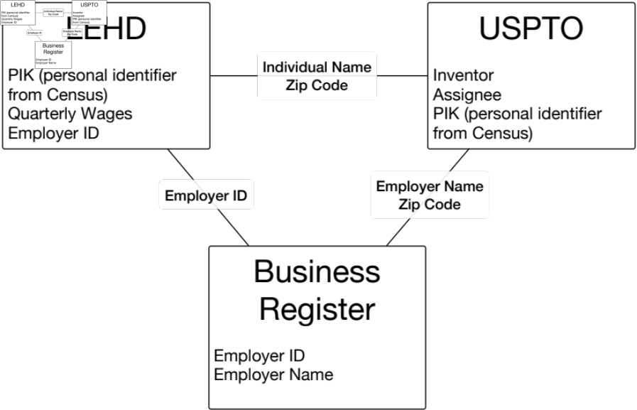

Moving beyond patents to exploit new data and methods to study innovation

Lee Fleming (UC Berkeley) continued the discussion of patent data, new metrics, and data linkages, asking the question “How can we be more clever in using our data?”
[The themes here may work better in section 7, Measurement Agendas of the Future]

Among Fleming’s key themes were the following:

- Patent data are over-used and abused; they are very easy to observe, but not necessarily the right thing.
- Researchers need to stop relying solely on patent counts and citations to measure innovation—richer measures are not that hard to calculate
- Advances in machine learning and natural language processing useful, though need thoughtful application.
- Newly available data and tools provide opportunity to advance our understanding of innovation.

In developing these themes, Fleming posed several research questions, the first of which was “what happens when an individual changes fields?” One viewpoint, standard among economists, is that a person gives up expertise in his or her old field, which is typically harmful to earnings. A second viewpoint, emphasized by Thomas Kuhn, is that “almost always the men who achieve these fundamental inventions of a new paradigm have been either very young or very new to the field whose paradigm they change.”

Fleming argued that, to answer his question, novelty must be separated from value. Some products may be quite novel yet may provide relatively little in terms of market value. He hypothesized that the patents invented by those who change fields are likely on average to be more novel and less valuable. One alternative for testing this hypothesis is to using citations—but they have been used to measure value and novelty, so this is unlikely to work; another alternative is to use a machine learning technique that enables hundreds of papers to be traced to inventions and inventors.

Easily accessible data on patent renewals can be used to create measures of value. But what about novelty? Looking back through the patent corpus, one can identify where key words first appear and weight them by their future use. This can be done, for example, with terms like “non-transitory,” a limitation put in mainly in the software patent field, and other important words such as “browser and computer executable,” “http,” “java,” and so on. Combining this kind of information on new words that show up in patents with person-level data, it is possible to demonstrate that new entrants are more likely to invent patents with new words, and less likely to invent patents that are renewed. This kind of research question would be very difficult to answer using only traditional kinds of data and analytic methods.

Fleming’s research question number 2 was “how does governance influence innovation?” The decade of the 2000s provided a fertile case study period for considering this question because governance was increased (via Sarbanes-Oxley, for example) that forced firms to adopt more independent oversight. Stronger governance could increase innovation, because it requires greater focus and effort; on the other hand, it could inhibit creativity and risk-taking. In the finance literature, patents, patent counts, and patent citations have not been utilized very successfully to measure this.

Research by Balsmeier, Fleming, and Manso using Sarbanes-Oxley as an instrument, finds that the signals are clear: greater governance makes firms more productive by some measures—e.g., they get more patents (although they tend to be in areas of technology where they have previously been patenting). But increased governance appears to lead to cutbacks on exploration and willingness to try new things—fewer patents are issued to firms in new technology classes.

Analyses relying purely on counts and citations miss the kind of details described above. The advance by Fleming and collaborators came with the realization that an instrument could be developed using a principal components analysis to break out two components of innovative activity. The first, exploitation, captures portfolio measures of firms patenting in known classes, staying close to their previous technological proximity (and inventors are getting older). Component 2 is exploration—firms entering new patent classes (and inventors are getting younger). The measure subsequently produced in this research allows for a much deeper and richer look at firms’ patenting portfolios than would be allowed by simply counting patents.

Looking at all of the firms in their study (figure4.2), on average, exploration appears to slow considerably over their lifetimes. They inevitably evolve toward patterns of more exploitation as they age.

Figure 4.2. Exploration/exploitation path dependence
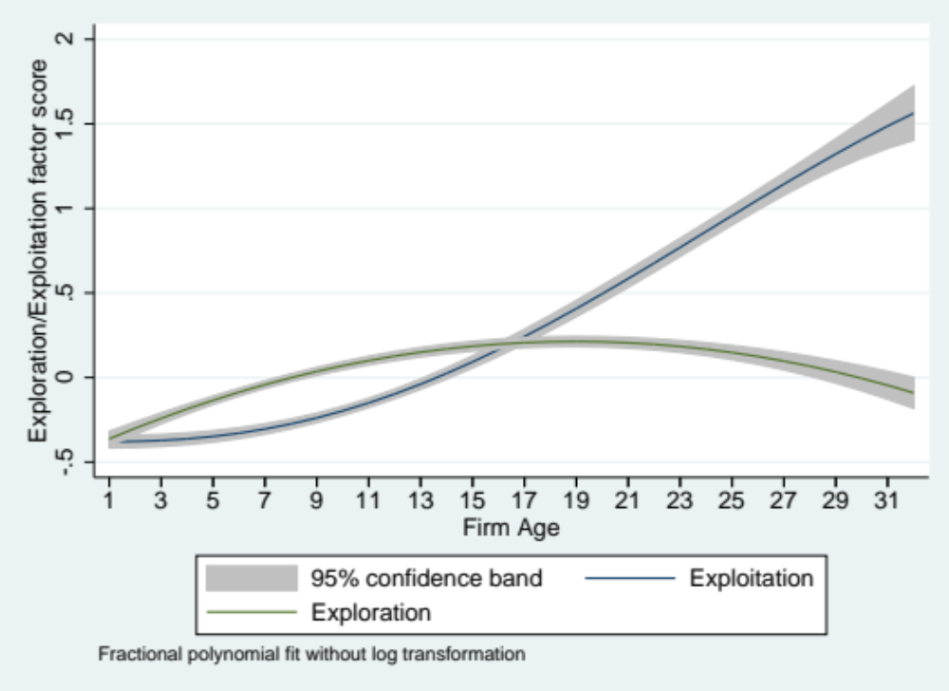

A third research question posed by Fleming was, “can we see changes in innovation components in the larger economy and the business cycle?” There is a literature indicating that, during downturns in the business cycle, there should be more innovation. The reasoning is that firms are busy making money during the upturns which increases the opportunity cost of taking risks and exploration. However, analyzing just R&D and patenting data, the signals are not clear.
Greater detail is required to discern that exploration goes up in a downturn and that exploitation becomes stronger during an upturn. And, indeed, when the data are plotted across the business cycle, this is exactly what Fleming and colleagues have found.

Fleming concluded that (1) data on patent counts are (almost) dead as a means to measure innovation; (2) advances in machine learning and natural language processing are valuable for this purpose, although their use requires thoughtful application—crowdfunding is an example of a fertile area; and (3) newly available data and tools provide opportunity—e.g., studying real-time inventor networks, exploiting natural language processing to see parts of the innovation economy that are not visible through patenting—particularly when analyzed in collaboration with computer scientists.

Alfonso Gambardella (University Bocconi) discussed the relationship between managerial practices and incentives for research and innovation, and what could be learned from experiments, from large and systematic computerized data bases, and from surveys.

Researchers have known for a long time that managerial practices are important in terms of performance and productivity. Less is known specifically about the impact of management on innovation. Preliminary work by Manso (2011), Azoulay et al. (2011), Ederer & Manso (2013) suggests that the relationship is also important here. Consistent with Fleming’s observation about the business cycle, Manso found evidence that short-term rewards and penalties discourage exploration. However, managerial practices have the capacity to offset this by creating an environment that tolerates short-term failures and favors long-term compensation schemes. This suggests that special managerial practices are needed to nurture exploration (as opposed to exploitation). Manso and colleagues argue that most pay for performance schemes are not ideal for promoting creative work because they penalize short-term failures and favor short-term success. Implementing schemes for a CEO may not be conceptually difficult—compensation can be linked to longer term performance of the firm. But for midrange employees such as researchers, who actually produce the innovations, it is harder to create verifiable measures of their long-term performance—variables such as stock performance of the firm are too distantly related. So other instruments and practices are needed.

Gambardella noted that very little is known about what managerial practices are effective for promoting innovation, in part because there are some fundamental conceptual hurdles to overcome. It is well established that creative people like independence (Gagnè & Deci, 2005; Bartling et al., 2014) and dislike pay for performance (Amabile, 1996). For example, scientists pay to be scientists (Stern, 2004) although to a varied extent (Sauermann & Roach, 2013). It is also known that motivation matters for innovation (Sauermann & Cohen, 2010). Findings from this literature are suggestive that policies about the independence and autonomy of individuals are candidate tools for improving innovation performance at the level of managerial practice. Nicola Lacetera (2009), for example, found that autonomy is a powerful device for increasing scientists' incentives to supply productive effort, especially when their objectives and priorities are not aligned with the top management. Using the NSF Scientists and Engineers Statistical Data System (SESTAT), Sauermann & Stephan (2013) found that 61% of respondents in S&E industry value independence highly versus 81% in academia.

Given that inventors value autonomy, Gambardella et al. (2015) argue that firms can use autonomy as a tool to motivate their employees, especially when output cannot be used to measure innovation performance. Data from the PatVal European patent inventor survey (Torrisi et al., 2016) provide consistent evidence. In particular, Gambardella et al. (2016) show that firms provide more autonomy to inventors in projects in which they are less motivated.

To better understand the role of management practices in innovation, Gambardella concluded that more data are needed that follow cohorts of workers at S&E firms so that the role of practices related to tolerance for failure, long- vs short-term rewards, and autonomy on innovation and performance can be assessed. Scenario-based experiments—e.g., asking informed parties how they would respond under different scenarios—and field experiments are also needed.

Measuring Flows of Human Capital to Firms; the Role of University Administrative Data

The focus of a presentation by Paula Stephan (Georgia State University) was on measuring the flows of highly skilled individuals to firms. It is common for researchers to track the contribution of universities to innovation in terms of patents, licenses, and startups; it is less common to focus on the placement of highly trained individuals with firms, despite the fact that individuals are a powerful way of transmitting information, especially tacit knowledge. As J. Robert Oppenheimer wrote, “the best way to send information is to wrap it up in a person.”

While difficult in the past, it is now possible to identify the placements of highly trained people, such as PhDs, with individual firms by matching university-maintained records and U.S. Census data. The approach was demonstrated in a “proof of concept” paper published in Science. Under strict confidentiality protocols, researchers matched data from a source called the Universities: Measuring the Impacts of Research on Innovation, Competitiveness and Science (UMETRICS) to Census data for a sample of recent PhD graduates who had been supported by grants as students. The UMETRICS project collects administrative data on federal research funding, and also private funding on some campuses, for graduates from eight universities (Indiana, Iowa, Michigan, Minnesota, Ohio State, Purdue, Penn State, and Wisconsin). Linking student grant data with data on dissertations (ProQuest) and Census records, the researchers were able to track placements of 1,983 recent PhDs. Additional linkages could, in principle, be made. For example, matching the Survey of Earned Doctorates (which no longer collects the full Social Security number) with Census data could allow stay rates of graduates in firms to be estimated.

Results indicate that recently minted PhDs that go into industry tend to be employed at larger, high wage firms. As shown in Figure 4.3, the distribution of payroll per worker at the establishments where these graduates work is much more skewed than it is for all U.S. establishments or R&D establishments.

Figure 4.3 UMETRICS doctoral recipients are placed at establishments that are larger and have higher payrolls per worker

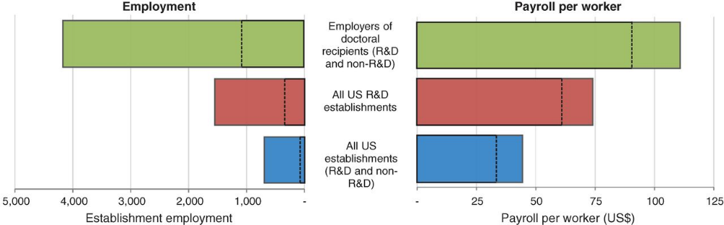

Note: Medians—dashed lines; means—solid lines
Source: Nikolas Zolas et al. Science 2015;350:1367-1371.

The placement of doctoral recipients supported by grants also varies by field. As expected, engineers are most likely to go into industry, followed by math and computer scientists. Only a very small percent go to young firms. The data also permit annual earnings distributions to be estimated [from W-2 based data?] and compared across government, academic and industry sectors (industry has the highest earnings), or across disciplines (engineering is highest).

These kinds of data linking projects open up a wide range of research opportunities. Stephan noted, for example, they allows modeling of how knowledge stocks embedded in human capital contribute to innovation and performance at the establishment level. Research questions—such as how different types of support received by PhD student relates to employment outcomes—can be examined, as can the role in job placement of social networks between universities and establishments, or across firms and establishments.

Stephan also noted the importance in the global economy of measuring the international mobility of highly trained individuals. Research suggests that internationally mobile scientists and engineers contribute disproportionately to innovation. But, she cautioned, we really know very little about how various outcomes are impacted by international mobility. For the U.S., the Survey of Doctorate Recipients can be used to follow PhDs who stay in the U.S by field. A major effort is now underway to follow individuals who receive PhDs in the U.S. and move, but it's much more difficult to follow individuals who arrive for postdoctoral training with a PhD in hand. And it is extremely difficult to compare mobility of scientists and engineers in the U.S. with patterns outside the U.S. Virtually no country has data on emigrant scientists, and there is little empirical evidence concerning how we compare performance of mobile scientists across countries. This, Stephan suggested, is an area where improvement of data should be a priority.

To begin addressing this data gap, Stephan (along with colleagues Chiara Franzoni and Giuseppe Scellato) developed a survey of Italian scientists in four fields who had migrated to 16 countries. Details of the survey, called GlobSci, are summarized in an article in Nature. Among the major advantages of the survey over existing alternatives are the following:

- it is possible to track mobile researchers who returned to their country of origin (if included in the 16 core countries) or who emigrated to a core country.
- data on “entry point” of foreign born (e.g. PhD, postdoc, faculty) are captured
- numerous individual level controls are in place
- bibliometric measures of focus article are generated

Among the limitations are:

- there are no data for China and South Korea
- it covers only four fields
- the questionnaire provides only a snapshot (2011)
- statistics reflect outbound mobility only to the 16 countries
- there is no information on “quality” of scientist

Fhe findings from the GlobSci survey indicated that patterns of mobility vary considerably across 16 countries. The major reason individuals return to the home country is for “family and personal, not because of disparate opportunities. Additonally, mobile scientists were found to be more likely to establish international links, have links with larger number of countries, and exhibit superior performance on international collaborations. They were also more productive than non-mobile scientists and returnees, and results persist even after instrumenting for mobility. Finally, graduate students and postdoctoral fellows are drawn to study in the U.S. disproportionately because of reputation of institutions, financial support, and perceptions of how study in U.S. affects career paths. Lifestyle issues were found to be a discouraging factor for studying in the U.S.

Stephen closed by noting that surveys are only going to take the research into international mobility of scientists and engineers so far. She encouraged NCSES to continue to work with agencies in other countries to develop systematic ways to collect data providing consistent longitudinal information about internationally mobile scientists and engineers. More generally, she added, more thought needs to be given about how to benchmark U.S. data with data from other countries on the production and movement of human capital. During open discussion, Ziedonis added that using individual level data was also important for tracking the mobility of scientists and engineers, both career-wise and employment level-wise across states and regions within the U.S.

Jason Owen-Smith (University of Michigan) elaborated on some of Stephan’s themes with a presentation on the use of university administrative data for studying the research process, specifically the role of network creation in enhancing productivity. His focus was on people as the “vectors of innovation, science, entrepreneurship” and on the structures and processes underlying scientific discovery and training in university settings. The Institute for Research on Innovation & Science (IRIS), of which he is executive director, serves as a “global source for data to support fundamental research on the results of public and private investments in discovery, innovation, and education.” IRIS offers useful opportunities for expanding the kinds of administrative data discussed by Stephan and others.

A standard theory of innovation and discovery is that these processes involve a combining of knowledge or techniques that haven't been combined before. Advances occur when ideas come into proximity with one another, even when there is no reason a priori to expect that such a network would include these particular pieces. Every university maintains administrative data, compiled for purposes other than research, that can be exploited to advance the understanding of these processes. Owen-Smith provided a visualization of how different kinds of data—whether on sponsored projects, human resources, procurement, or a host of other areas—can be combined to map a collaboration network. Constructed from UMETRICS data, nodes of individuals tied to one another—i.e., being paid by the same sponsored project in the same year, as coauthors or members of co-patenting networks, etc.—can in principle be shown. Similarly, different parts of the network associated with the dominant topics can be mapped.

What contributes to the growth of these idiosyncratic networks that put topics together and people together? An example of a research topic around which a network has formed is hepatitis C, which is a big problem for homeless teenagers. Clinicians and consultants work on one dimension of the problem, while specialists on liver cancer and organ transplants work on another dimension. This is an instance where social science expertise and bench science expertise is bridged by clinical expertise. With the right administrative data, Owen-Smith showed how it is possible to map the knowledge and collaborative space of a whole campus and to examine implications of the positions of individuals and teams (or even departments and programs) in it have for scientific training and later career outcomes. This is interesting because there is dramatic campus to campus variation across universities, and it has implications for actionable planning policies.

One question that the IRIS team has asked is “how can the expansive set of university administrative data be used to explore the relationship between where people are situated in physical space and how networks evolve?” Using administrative directory data to position every investigator in a two building space, they were able to map out how proximate they were to one another and to calculate what they called a functional zone. For every pair of individuals, the number of linear feet of overlap for those two paths was established as a naïve proxy for how likely they were to bump into each other and talk as a matter of course during their daily work.

Next, the team matched the physical space data to data on grant applications, both funded and unfunded, drawn from sponsored projects, IRB applications, and animal use applications, over about a 15-year period for everybody in the two buildings. They also identified instances in which these activities were done jointly over a 3-year period. The research found that a 100 foot increase in functional overlap between two investigators was associated with a 14-19% increase in the likelihood of them forming a new collaboration (IRB, UCUCA, grant submission). Similarly, conditional on grant submission, the same 100-foot increase was associated with an 18-20% increase in the likelihood of a funded joint project.

Such findings are indicative of how the idiosyncrasies of space and the capital investments shape networks that produce findings. And the entire approach is based on administrative data platform that serves as a model for exposing interesting research question that can be addressed.

During open discussion, Agarwal reiterated the value of combining data. The dream, she said, would be to integrate proprietary datasets with sources such as the LEHD and SESTAT, or IRIS. A big advantages of SESTAT is that it includes rich data on motivations and preferences, which is absent from most of the secondary data from censuses or on patents. She argued that, if we want to take seriously the notion that both abilities and aspirations matter in determining innovation, we need to be combining data which capture factors about managerial practices, as described by Gambardella, and networks of physical space, as described by Owen-Smith. From her perspective, it would represent a big step forward to move away from product-based innovations concepts toward measures that capture where the innovative activity is occurring and why it is occurring.

Stephan pointed out that some of the data improvements proposed during the session are not that expensive, and that linking across sources can be an efficient way to expand information. For example, the Survey of Earned Doctorates covers practically the entire population of new PhDs in the United States. But it needs to be matched to other sources such as the Survey of Doctorate Recipients (SDR) or to Census data in order to study what happens to innovative workers over time.

Owen-Smith added that a lot of the costs of data linkage projects are social, not technical. They materialize in the form of negotiating MOUs, maintaining security, and data management. Currently, people are doing this individually and effort is being repeated over and over again in different ways that are slightly incompatible and sometimes not well documented. One benefit of taking on these tasks as a community is to streamline linkages, systematize data use, and broker between data producers and parts of the federal statistical and science system to maximize the value of investments in data.

He went on to note that one of the greatest challenges to creative data linking is the lack of stable individual identifiers outside of the context of the Census PIK, which can only be used under very restricted conditions in the RDCs. So whether it is nonproprietary data to uniquely identify scientific and other academic authors and contributors (e.g., ORCID ID), student record transcript data, or workforce information, regulatory and other problems are faced. Microdata that are shared and curated by a community requires development of persistent identifiers. Lucia Foster of the Census Bureau noted that her organization was in the process of developing unique identifiers for the projects taking place within the RDCs and that, as they bring in other outside agencies into the FSRDCs, they plan to develop datasets with unique identifiers to identify people in datasets over time.

5. Measuring Public Sector Innovation and Social Progress

Comprehensive measurement of the benefits generated by innovation requires capturing data on a range of activities that goes beyond those traditionally tracked. Innovation that takes place in the public sector is one area to be explored. Innovation that advances the public good or in ways that accrue outside the market is another. Both have featured in discussions about revision of the Oslo Manual and in planning for OECD’s Blue Sky Conference. Questions addressed during this session included: What approaches to innovation measurement can be developed for capturing activities that take place within the public sector? Can metrics be developed that go beyond the contribution of innovation to efficiency, effectiveness, or quality in the production of market goods and services? Specifically can the successful exploitation of ideas in the provision of public goods and in the promotion of societal well-being more broadly be measured? And, are there negative social impacts of innovation that should be considered in our understanding of the outcomes of innovation?

Measuring Public Sector Innovation and Social Progress; Innovation Indicators for the Public Sector

Fred Gault (UNU-MERIT, Maastricht) led off the session with a discussion of the variables that factor into public sector innovation measurement. He began by proposing an inclusive working definition of innovation:

An innovation is the implementation of a new or significantly changed product (good or service) or process (production or delivery, organisation, or marketing).

And:
A new or significantly changed product is implemented when it is made available to potential users. New or significantly changed processes are implemented when they are brought into actual use in the operation of the institutional unit, as part of making product available to potential users.

The clause “making the product available to potential users” provides a way of broadening the scope to include the public sector domain (and also households).

Currently, there is no equivalent to the Oslo Manual or the Community Innovation Survey for measuring innovation in the public sector, although both provide models for guidelines and measurement. One problems to be overcome is the need for registers for public sector institutions comparable to those for businesses. That said, the Nordic MEPIN project has made a major contribution in this area (Bloch and Bugge, 2013).

Elsewhere, there has been experimental and evolving work including in the EU: The Innobarometer (2010), attempts to measure the activity of public sector innovation; The Report on Public Sector Innovation (2012) includes case studies; and The European Public Sector Innovation Scoreboard EPSIS (2013) takes on the topic. The 2013 scoreboard includes several measures of human resources and of the quality of public services. For the latter, this is the share of organizations and public administration with services, communication, process, or organizational innovations. All the other indicators are indirect or are contextual, which Gault asserted, is one of the weaknesses of such scoreboards.

The OECD has also pursued work on the public sector, including: the Observatory of Public Sector Innovation; the STI e-Outlook; the Blue Sky Forum 3, taking place in September 2016, and the revision of the OECD/Eurostat Oslo Manual, which started in 2015 and is expected to complete in 2017. The Observatory of Public Sector Innovation does not include definitions, but it does collect observations about public sector innovation and, ideally, about best practices. The Science, Technology, and Industry e-Outlook, provides a definition of public sector innovation which is not too far removed from what is found in the Oslo Manual: “the implementation by a public-sector organisation of new or significantly improved operations or products. The OECD Blue Sky Forum, which happens every 10 years, governs OECD thinking about measurement programs for the next decade. The revision of the OECD Eurostat Oslo Manual could address broader definitions of innovation that would be a first step towards providing guidance on the measurement and interpretation of innovation in the public sector and the household sector. The Oslo Manual could remain focused on the business sector but, if broader definitions are not considered, other organizations may rise to the challenge.

Gault assessed the current state of measurement: Innovation in the public sector can be defined, but a consensus is needed if measurement is to be consistent and comparable. Surveys have been tested, but the results are not comparable over time or across geography. The EU and the OECD are supporting work on public sector innovation.

Relative to the public sector overall, much less thought has gone into measuring social progress, equity, inclusion, public health, education, culture. The first step is to be able to detect the presence of innovation through surveys or other data collection means. The next step is to ask how innovation contributes to social progress, and how it can that be measured. For example, social housing tower blocks in the UK may have qualified as an innovation but they did not deliver on social progress. Thus, as with the business sector, if value is to be measured, there must be a follow up survey or use of administrative data. On the policy front, public sector actions change lives. Innovation policy can act directly to support innovation or indirectly, but measurement is required to monitor and evaluate policy once it is implemented.

Providing a continuation of the discussion initiated by Gault, Daniel Sarewitz (Arizona State University) spoke about innovation and social progress with the development of next generation indicators in mind. He began with the observation that innovation can lead to either positive or negative outcomes, or both. Research is naturally focused on players directly involved in the innovation system, while little though is given to those who are excluded from its benefits or who are negatively affected. The internet, for example, sparked destructive progress in a number of ways. While revolutionizing the diffusion of information, it also all but destroyed traditional journalism, for example. Financial innovations led to the subprime mortgage debacle of the late 2000s which affected broad swaths of society. Thus, the value of innovation often depends on the perspectives of particular segments of society that are affected. The Luddites smashed power looms because they were going to be displaced them from their jobs. So they were part of an innovation episode, but they would not be a part that we would typically try to account for in our measures of it.

Sarewitz also urged workshop participants to keep in mind the idea that innovation and its consequences are sometimes political and normative, arguing that the presence of uncertainty and political elements means that convergence on a canonical consensus set of indicators is not possible. However, acknowledging the normative aspects of underlying processes that lead to both good and bad consequences in a complex society allows for a broader understanding of innovation. As a political process, beyond the winners and the immediate participants in the innovation system, it involves those who may not have as a conspicuous voice in that system.

Innovation Policy

Charles Edquist (CIRCLE, Lund University), speaking from the perspective sitting on the Swedish National Innovation Council addressed three topics: (1) the conceptual basis for the design of innovation policy, (2) the usefulness of the Innovation Union Scoreboard, and (3) innovation-related public procurement.

Regarding topic (1), Edquist defined innovation policy as encompassing all actions by public organizations that influence innovation processes. A less than straightforward question is “what actions should be taken by policymakers and what should be done by private organizations?” He suggested that two conditions must be fulfilled for public intervention to be warranted in a market economy. First, private actors must fail to achieve the objectives formulated—a “problem” must exist. And second, public actors must have the ability to solve or mitigate the problem. In short, policy makers must identify innovation policy problems and their causes.

In order to identify whether a country or region is doing well or badly with regard to certain kinds of innovations, they need to be measured. And, ideally, innovation indicators must be comparative between countries and regions since there is no objective optimality. The Innovation Union Scoreboard (IUS) is one such attempt to measure innovation. It is published every year, and it is intended to have an impact on policies. It includes 25 indicators that measure everything from R&D input to product innovation output. While recognizing its value in concept, Edquist identified a number of problems with the IUS, which claims to measure “EU
Member States’ Innovation Performance” by calculating a Summary Innovation Index (SII).

But Edquist claimed that the SII fails to live up to its mandate, which means that it provides misleading information for politicians, policy-makers, researchers, and the general public. The problem is that the Index calculates a simple average of the 25 individual indicators, with each factor given the same weight. And, among the indicators are both inputs, such as R&D expenditures, and outputs, such as actual product innovations. No distinction is made between them, which renders the underlying method akin to taking the average between the total production and the number of employees in a firm and calling it performance. In this sense, the aggregate index has no meaning.

Given this methodological problem, Edquist and colleagues have worked on an alternative approach based on 4 input indicators and 8 output indicators (using only IUS data). The innovation input indicators refer to the resources (human, material and financial; private as well as governmental) which are used to create innovations, including bringing them to the market. The innovation output indicators refer to new products and processes, new designs and community trademarks, and marketing and organizational innovations, which are either new to the market and/or new to the firm and are adopted by users. Next, outputs are divided by inputs in order to calculate the efficiency of innovation systems at the national level.

The results from this calculation are very different fromt those derived using the SII. If nothing else, this shows the inherent arbitrariness of aggregate measures based on indicator scoreboards. If summary indicators are to be calculated, the conceptual and theoretical basis has to be clear, and effort must be made to understand details driving the dynamics of innovation systems. Only then can policy instruments be selected to solve or mitigate the problems (if the main causes of the problems are known).

Edquist turned next to innovation policy, which he argued was far behind innovation research. The failure of the interaction between research and policy suggests the need for “a holistic innovation policy,” defined as a policy that integrates all public actions that influence or may influence innovation processes in a coordinated manner. It includes actions by public organizations that unintentionally affect innovation, and requires a broad view of innovation systems, including all the determinants of the underlying processes. Edquist identified 10 important activities that are hypothetical determinants of the development and diffusion of innovations:

1. R&D
2. Education and training
3. Formation of new product markets
4. Articulation of quality requirements
5. Creation and changing organizations
6. Interactive learning
7. Creating and changing institutions
8. Incubation
9. Financing of innovation processes
10.Consultancy services

These activities also play a role in the public procurement of innovations. Public procurement represents between 10 and 20 percent of GDP in the European Union (around 2.3 trillion euros). This amounts to perhaps 40 to 50 times the size of the public R&D budget.

To analyze procurement demands, an assessment of what is bought in the public sector in functional terms (as opposed to products, goods or services) is needed. In other words, policy makers should focus on the problems to be solved through innovation and spending rather than on products purchased. For addressing traffic noise in a neighborhood, for example, a local government should think in terms of buying a 1 decibel reduction in noise, not a specific item, such as a fense. The former encourages creative, competitive thinking about the effectiveness of alternatives, such as a plants, quieter road surfaces, or enforcement of slower speeds. This kind of procurement strategy is a powerful innovation policy instrument and, according to Edquist, it is starting to be used systematically by the Swedish National Innovation Council.

Kaye Husbands Fealing (Georgia Tech) continued the discussion of innovation in non-market contexts, and specifically as it applies to public health outcomes. She focused her comments on the USDA-funded study on food safety and security food security and safety study, an example of innovation that directly affects public welfare.

The overarching question illustrated by her example is “What are the social returns to public and private expenditures on science, technology, and innovation activities—and how can they be measured?” In the area of food safety one can look at patents but, as argued by a number of participants in other contexts, this offers a highly truncated accounting of innovation. In the case of food safety sciences, new knowledge and innovations are often shared and not patented—they are not private goods. Additionally, the economic returns to federal (or other) government investments in food safety research and clearly some of the returns are just not pecuniary—they cannot be account for just in terms of dollars and cents. Some of the value comes in the form of the development of new talent (as discussed by Stephan and others), and some will be the development of new ideas that spill over into other areas as well. For all of these reasons, a broader measure (and indeed concept) of outputs of R&D is needed. If a goal is to have comprehensive measures of innovation inputs and outputs, particularly in the public sector, these are the kinds of factors that have to be assessed.

Husbands Fealing proceeded to attach some figures to the food safety outcomes research: In 2011, the Center for Disease Control and Prevention (CDC) estimated that there were 48 million cases of foodborne illnesses and infections which led to 128K hospitalizations, 3k deaths, and $14.1 billion (in 2010 dollars) in economic burden. One in six Americans are sickened by food-borne disease each year, based on CDC estimates. This is a serious social problem that warrants investment in new knowledge and innovation on a regular basis. The CDC identifies food safety as one of eight “Winable Battles” in the public health sector (see https://www.cdc.gov/winnablebattles/).

Investment in research solves, or begins to solve social and health problems, but few agreed upon measures exist for assessing the value of this work. In the case of food safety, assessment involves tracking steps throughout the entire value chain from farm to table. With this goal, Husbands Fealing’s research team is developing frameworks and techniques for measuring outcomes from federally funded research targeted at the agricultural sector in general and food safety in particular. The investigation has raised the following key questions:
- What expenditures have been made and how have these expenditures changed over time?
- Who is doing the research (principal investigators, graduate students, postdoctoral fellows, and staff scientists)?
- What kinds of jobs are taken by recent graduates trained in food safety? How do these early career activities relate to graduates’ career paths? What is the role of food safety research funding in graduate student training?
- What are the outputs of federally sponsored academic research? How are the results transmitted to the scientific and private sector, commercialized, and effective for the social good?
- What is best method for funding research leading to the most significant breakthroughs?

Answering these research questions requires a coordinated data structure (as illustrated in figure 5.1) that includes project-level data (e.g., payroll records); natural language text analysis to identify food-safety research; and linkages between researchers, students, postdocs, patents, publications, dissertations, employment, enterprises—tech transfer.

Figure 5.1. The emerging Large-Scale, Disambiguated, Longitudinal Researcher Database

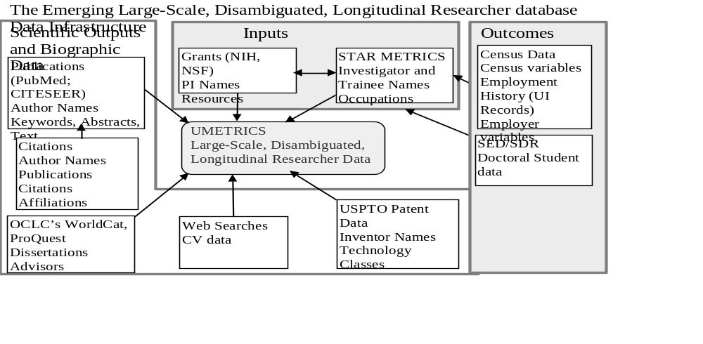Source: Julia Lane, et al. ( )

Linking the data from these sources, the team can begin to see how much money is spent on food safety research and related activities over time. This involves not just general funding by NSF in biology, but also a number of other fields and disciplines organized in a taxonomy designed to shed light on which grants actually relate to food safety and then tracing them through the system using all the data linkages shown in the figure.

Using the food safety example, Husbands Fealing demonstrated the possibilities of measuring the role of innovation for social goods. As in environmental, health, and other research areas, there is a lot of policy value to be gained from improving assessments of the return—the social benefit—from such funding on science.

Household sector innovation
[section may belong in “the role of individuals” or in the “innovation beyond R&D” section?]

Continuing with the theme non-market production, Eric von Hippel (MIT) discussed household sector innovation and made the case for why it should be measured. His argument embodied the following observations:

- Household sector innovation is quantitatively very large.
- Household sector innovation is currently not being measured; many activities are not even defined as innovation because the outputs are diffused for free.
- Not measuring household sector innovation creates distortions in public policy discussions that determine what governments choose to do.

By way of background, von Hippel noted that, in economics, consumers are traditionally viewed as passive users of producer-developed products and services, and not as developers themselves (Schumpeter, 1934). In reality, however, as revealed by nationally representative time use (and other kinds of) surveys, an enormous amount of innovation originates from the household sector. Eliminating certain activities (e.g., those resulting in little functional novelty), von Hippel found that 6.1 percent of the UK population innovated within the last 3 years, developing or improving a product for themselves (the numbers were comparable, but slightly lower for the U.S.). This amounts to 2.9 million people engaged in such activities whereas, in the entire UK, only 22,300 R&D professionals work developing products for consumers. The ratio is over 100 to 1. And the amount that households are spending is not measured at all—this is true dark matter in the innovation statistics. Inferring from the above statistics, however, it is reasonable to suspect that the level of expenditures on innovative activities is not very different than the amount that firms are spending on R&D.

Next, von Hippel provided several examples of household sector innovation. One of these, the Ushahidi Crisis Map service in Haiti, is a very important reporting tool for providing free disaster information. It was developed in the household sector by a group in New York City who, when faced with a crisis affecting friends and relatives in their homeland, had no data about who was buried under what building and so forth. In the medical sector, patients have developed an artificial pancreas ahead of medical producers and diffused their design for free. The “NightScout” team created predictive software that provides real-time treatment recommendations. Then they built a closed loop artificial pancreas to automatically adjust insulin levels on an insulin pump. The result was an artificial pancreas that achieves within-range blood glucose outcomes better than was possible using manual calculations. People are using the innovation, and the design is distributed for free on the Web to others. Market-based producers will follow after FDA approvals.

The policy question that arises is whether these kinds of innovations can be nurtured as opposed to quelled. Is it possible to equip individuals and households with clinical trial software so that they can engage in grassroots innovation processes themselves? Are FDA regulations set at the right levels of stringency? Just as we have intellectual property to enhance innovation by producers, it is important to think about public support for enhancing diffusion among household sector innovators. These are policy choices.

Turning to a possible measurement strategy, von Hippel identifying two elements in the definition of a “free” innovation: (1) it is developed at private cost by individuals during their unpaid leisure time—no one pays them to do it; and (2) design information is unprotected by the developer and potentially acquirable by anyone “for free,” representing a kind of market failure. This means that there are no transactions during the process that can be tracked by ordinary economic measures (e.g., sales, patents). Another characteristic is that less than 10 percent of these individuals try to protect their innovations, and they rarely spend much time diffusing them. As a result, intellectual property is not a central feature of this system.

The above-described types of innovation are not measured at all in official statistics. One reason is that free innovation does not fit the Oslo (2005) definition of an innovation (described earlier in this Summary): “A common feature of an innovation is that it must have been implemented. A new or improved product is implemented when it is introduced on the market” (Oslo Manual 2005, paragraph 150). The consequence is that a free innovation—even one diffused millions of times for free over the Internet—conforms to the definition only if it is introduced to the market. Even then, it is credited to the producer that commercialized it, not the person that developed it. As a result, estimates of the effectiveness of producer R&D and the apparent importance of IP are overstated. Meanwhile, free innovation is understated and free innovators, who are often innovation pioneers, are undercounted. These distortions created by not measuring free innovation, von Hippel argued, carry policy implications. In order to correct for this weakness in the innovation measurement system, von Hippel proposed that social surveys are needed to supplement business surveys such as the CIS.

Working with colleges Alfonso Gambardella and Christina Raasch, von Hippel showed that free innovation increases social welfare. Since free innovation competes with producer innovation, prices may be lowered—for example, when Linux is provided for free as opposed to Red Hat. Free innovations are also a source of supply designs and free complements. Also, there are many things that producers make that require complements that are only provided for free, because there is no market for them. Product users—who are often early but invisible innovators—frequently play this role. Von Hippel gave the example of mountain bikes which are of course produced by manufacturers. However, mountain biking techniques are not developed in a commercial market; they are diffused peer to peer among bikers in a way that is detached from producers. But producers benefit because technique innovators increase the value of mountain bikes and may increase sales. Von Hippel also studied whitewater kayaking and discovered that, over 50 years, among 100 of the most important innovations, eighty percent were introduced by the users of kayaks and picked up for free by the producers. If producers had had to develop all the designs that Kayak users developed, their budgets for R&D would have needed to be three times larger. These process take place throughout the economy—this kind of feedback is common with scientific and medical instruments for example.

Von Hippel concluded by offering some guidance to NCSES, OECD and statistical agencies. He urged that the Oslo Manual include non-market diffusion. Its exclusion from the definition is a barrier to recognizing that activities taking place beyond the market can be innovations. This is the gateway problem. Myopic focus on the market is an outdated way of thinking, reflecting a time when the market was the dominant mechanism for diffusing things. Now, in an internet-based world, free diffusion is prominent and should be reflected in new measurement guidelines.

Ben Martin largely agreed with the sentiments expressed by von Hippel, but he added some qualifications about the intrinsic limits of indicators. He agreed that the scope of indicators should be extended to cover a wider range of innovations, but he worried about Gault’s proposal to change the wording in the Oslo Manual definition from “improved” to “changed.” He cautioned that, whether in the market or nonmarket context, there could be a danger of bringing in lots of incremental product changes that did not have an impact on economic or social outcomes and wellbeing.

Gault responded with agreement that measurement is something that should be pursued with as few normative terms as possible. We may observe, for example, that a new financial product based on subprime mortgages has been produced and put on the market. Innovation measures should capture this. That the product is then diffused and goes on to destroy the economy is exposed only after the fact through normative assessment. It is not so clear that the assessment itself should be part of the innovation indicator system (as opposed to in subsequent research findings measuring the outcomes associated with the innovation).

6. Regional Innovation Models and Data Needs

Introducing the session on regional innovation models and data, Maryann Feldman began with the observation that the locus of innovative activity is inherently subnational—certainly substate and, in many cases, very local. Many of the spillovers and complementarities of innovative activity take place at the local level as well. And yet data collection is focused on aggregate, often national levels of geography. This session was intended to provide guidance for addressing this disconnect and to highlight important work developing regional data infrastructures. Much of the focus was on entrepreneurship, one dimension of innovation.

Regional Measures of Innovation and Entrepreneurship

Catherine Fazio (MIT) kicked off the session presenting estimates of the quantity and quality of entrepreneurship at localized levels. She began by with the observation that the benefit of startups for economic growth spring from a handful of fast-growing, young companies such that distribution of the sources of job and wage growth is highly skewed. The policy challenge, as put by Bob Litan, is to propel more startups that are capable of meteoric growth. The problem: it is very difficult to predict at the time of founding which firms are likely to survive and grow. For example, in 1994, what distinguished a startup bookstore that would remain unchanged for years (or go out of business) from Amazon? At the time of founding, it is typically difficult to discern any difference based on traditional metrics. The measurement challenge is how to identify and map growth potential from the start.

Traditional measures provide important information: Quantity-based measures from the Census Bureau’s Business Dynamics Statistics (BDS) document a 30-year decline in business dynamism. Figure 6.1 indicates a significant decline in the rate of firm entry, providing one measure that the U.S. economy has become less entrepreneurial over time.

Figure 6.1: Rates of frim entry and exit, U.S., 1978-2011
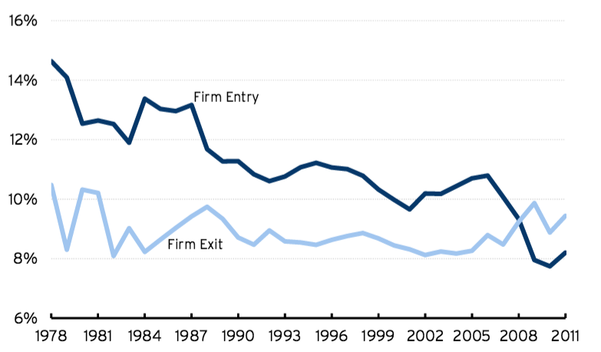

Source: Decker, Haltiwanger, Jarmin, and Miranda (2013,2015)

In contrast, Figure 6.2 provides an indication that high-growth entrepreneurship is on the rise—so much so that there has been concern over whether or not there is a bubble and, in some places, even whether the bubble has now burst.

Figure 6.2: Venture Capital Investments in the U.S. ($B)

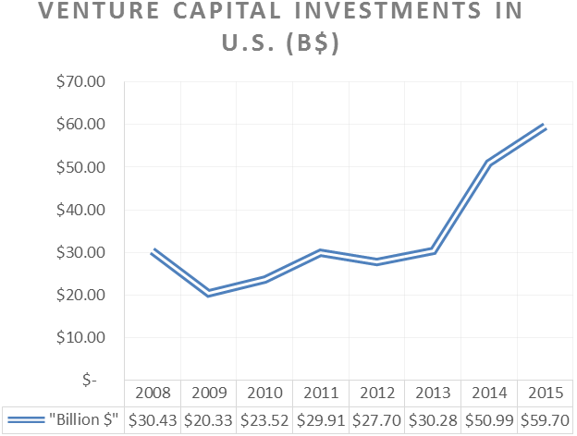
Source: http://www.businessinsider.com/silicon-valleys-denial-is-over-everybody-thinks-were-in-a-bubble-2015-10

The above metrics lead to some conflicting implications. Measures that account for firms' initial heterogeneity and growth ambition and potential are needed to fill the missing part of the story. Fazio asserted that, to maximize the relevance and utility of data collection programs, NCSES, OECD and statistical agencies need to recognize that small to medium-sized enterprises (SMEs) and innovation-driven enterprises (IDEs) are different. To capture these differences, information systems should be broadened to include measures of entrepreneurial quality that enable policymakers to evaluate SMEs and IDEs at the time of formation.

Fazio proceeded to outline new approaches for measuring entrepreneurial quantity and quality and to describe findings emerging from research based on these measures. The quality measures attempt to estimates underlying growth potential of startups, drawing on characteristics observable at or near the time of founding, and deriving conditions which yield consistent population-level statistics: the Entrepreneurial Quality Index, designed to indicate the average growth potential of any given group of new firms; the Regional Entrepreneurship Cohort Potential Index, which is the number of startups within a region which relates to expected growth outcomes; and the Regional Entrepreneurship Acceleration Index, which is the ability of a region to convert entrepreneurial potential into realized growth. These measures generate novel characterizations of entrepreneurial ecosystems over time at different levels of geographic granularity.

The approach described by Fazio builds on three interrelated insights to develop a new data source on innovation-driven entrepreneurship. The first is that business registration is a practical requirement for growth. Business registration represents, at the state level, a robust sample of entrepreneurs that are at similar foundational stages of their process. Business registers are comparable over time and place, but they do not include all data that are needed. They do not include non-registered firms, sole proprietorships, unincorporated or self-employed people, or the household innovators described by von Hippel.

The second insight is that markers of entrepreneurial quality are observable at or near the time of business registration. Firms with the potential and ambition for meaningful growth outcomes often have different “start-up characteristics” some of which are directly observable within business registration records. Firms often aim for a certain level of growth and then strive to achieve it. For example, their growth ambitions are sometimes reflected in the names that they choose. Cathy's Corner Café has a different growth ambition than Akamai Technologies or Amazon. Patent filings made by early stage ventures are also directly observable and may signal a new firm's potential and ambition for growth. These kinds of characteristics captured by various data sources can be distilled into measures and then scored depending on whether those characteristics were exhibited or not.

The third insight highlighted by Fazio is that meaningful growth outcomes can be observed with a lag, creating the potential to map observed growth with characteristics. Rather than assuming this relationship, the relative importance of different factors can be investigated by developing a predictive model of growth or entrepreneurial quality based on start-up characteristics. Among the findings from such a model: a startup that is a corporation is 400 percent more likely to grow compared to one that is not; and, a startup named after a founder is 70 percent less likely to grow compared with one that is not. If a startup exhibits a combination of positively correlated characteristics—such as having patents and a Delaware registration—the probability of growth jumps astronomically. Such findings can be used to construct, for every registered firm, its underlying probability of growth at the time of founding. Fazio described these startup characteristics as digital signatures of growth ambition and potential, not causal drivers. In a test of skewness among new firms using Estimated Entrepreneurial Quality, Fazio [and her team?] found that 65-72% of realized growth events fall within top 5% of the model’s estimated entrepreneurial quality distribution, and 51% of realized growth events fall within top 1% of the distribution of startups. In other words, growth potential is a key dimension of heterogeneity among newly founded firms.

Fazio turned next to results based on regional entrepreneurship cohort quality indexes (which can be used to estimate the expected number of growth events) and the ecosystem acceleration index (which indicates the ratio of realized to expected growth events in a region). These tools can be used to map where firms with high growth potential are being founded and located. In a Boston area analysis, for example, the Cambridge Innovation Center and the cluster of biotech lab spaces and wetlab accelerators clustered along the Charles River appear prominently. When the above described quality based measures of innovation-driven entrepreneurship are added to quantity measures, areas such as Kendall Square become more prominent, while areas with standard type businesses become less so.

As a policy tool at the subnational level, these models enable evaluation of innovation-driven entrepreneurship at a more granular level than has been possible. They permit more tailored analyses and could contribute to the development of more targeted policy interventions that can be testing through experiments. For regional policy-makers, these analyses can help identify whether IDEs are being started, which firms have high potential, What that potential for growth is, and what sectors are they in (including potential opportunities for cluster based IDE). Trends can be identified: where are firms locating? Are they moving? Is realized growth matching expected growth? Is the ecosystem conducive to growth? And, is there coincident with any government programs? Finally, these analyses enable diagnosis of challenges and opportunities to be diagnosed with respect to innovation driven enterprises at a granular level.

Fazio concluded by identifying opportunities for collaboration between researchers, NCSES, and the statistical agencies to advance this research program. Among her priority areas are:

- Developing quarterly metrics of entrepreneurial quality as a regularly produced statistic for the U.S.;
- Connecting entrepreneurial quality with alternative measures of performance via LBD micro-data; and
- Extending the evidence-base for innovation and entrepreneurship program evaluation.

More generally, Fazio concluded that it would be possible to implement predictive analytics in statistical approaches to complement other data being collected on innovation—for example, to assess the entrepreneurial potential of patent-holding entities and to tailor entrepreneurial quality measures to complement Science and Engineering Indicators with measures of local science-based entrepreneurship.

Following up on several of Fazio’s themes, Sheryl Winston Smith (Temple University) discussed micro-level foundations for measuring innovation and entrepreneurship using novel data created by financing programs on founders, startups, and early hiring characteristics. She shared insights about the changing face of regional innovation—who is involved, what types of businesses enter, where they are entering, and how they get launched—derived from research on seed accelerators. Early stage financing has particular implications for who enters into STEM entrepreneurship and for the trajectories of these new ventures.

A key question raised by Winston Smith is whether current measures are capturing modern entrepreneurial processes, and new aspects of the ecosystem. And, if not, what types of novel data can be collected and analyzed in order to gain deeper insights? She discussed both the opportunities associated with new kinds of data—e.g., LinkedIn and Crunchbase—and offered some caveats and cautions as well.

In the search for answers to the kinds of questions highlighted by Winston Smith, researchers can take advantage of the fact that, when ventures are launching, they typically require seed capital; informal funding goes only so far. Entrepreneurs with high-growth potential ventures typically reach a stage where they need formal outside equity financing. The traditional next step has been angel capital, particularly professional angel groups, which are regionally distributed.

Seed accelerators provide a distinctly different model. They operate on a short, finite time period, typically about three months. People apply to enter the accelerator events and then those who are accepted proceed as a cohort through intensive boot camp periods. The process culminates in pitch events—“demo days”—where founding teams pitch their proposals to a roomful of investors and potential acquirers. There are strong elements of mentorship and peer learning, but competition as well. Winston Smith cited a number of prominent companies that have gone through different startup accelerators: Dropbox originated in a seed accelerator held by Y Combinator in Boston in 2007; Airbnb went through Y Combinator in Silicon Valley in 2009; BB-8 started life with a company called Orbotix, now Sphero, that went through TechStars in Boulder in 2010.

Winston Smith cited several figures to provide a sense of the magnitude of the seed accelerator trend: companies that have gone through TechStars average about $1.6 million in outside venture capital financing after leaving. The average valuation of TechStars' alumni is $4.3 million; the total value of the companies is over one and a half billion dollars. The total valuation of Y Combinator alumni companies is greater than $65 billion. Eight Y Combinator companies are valued at over a billion dollars each. By comparison, angel backed companies—the traditional source for early stage financing—have a median pre-money valuation of $3 million. For 2014, 870 angel deals involved about $1.65 billion in total rounds of financing. These figures indicate that accelerators are a phenomena (or an innovation) on par with the impact that angel groups have traditionally held in the economy.

For measuring entrepreneurial activity, including the financing dimension, the issue of a skewed distribution rises to the fore once again. It is known ex ante that most firms—even most high-growth potential firms—that launch will fail. There are a few potentially very big successes and also a large middle distribution (Guzman and Stern, 2015). Issues also arise concerning typical milestones that are very rare events. An IPO is a rare event; even venture capital funding itself is a rare event (about 4 percent of firms receive VC investments at some point). It is not the characteristic path of most new ventures, even among high-growth new ventures. In order to address policy questions, the full distribution of these phenomena needs to be understood. And, intangibles—the learning, competition, follow-on networks, and mentorship—may matter even more than the amount of financing. These things are hard to capture when we just think in terms of totals and averages.

Next, Winston Smith asked “How do the incentives and institutional structure associated with different kinds of financing affect the growth trajectory of new ventures?” There may be regional implications for the entrepreneurial ecosystem, short and long-term impacts in terms of network and syndication ties, job creations, the recycling of founders successful and unsuccessful new startups, new investors, and new mentors. For startups, there are questions about people—the source of human capital behind these ventures. What prior experience, networks, background and education (particularly STEM) do founders and hires bring to the table? What is the team’s funding and exit options (e.g., quitting or acquisition). For some of these issues, it is particularly hard to get data from traditional sources. Information on failures and stagnation has to be tracked down because the steam of data typically ends along with the venture.

The accelerator process brings a novel microdata set to bear on some of these key questions. Wintson Smith’s team [[add citation to paper(s)?]] has been able to assemble data on 25 cohorts from Y Combinator and Techstars (the two most established accelerators) covering the 2005-2011 period. They have been able to track every outcome associated with 394 startups, 933 founders, and more than 15k hires through 2016. The “census” of ventures that went through these two accelerator firms is diverse, both geographically and by industry. The researchers also created a matched angel sample for a similar range of industries and geographic locations for the same time period.

One finding from a comparison of the accelerator and angel data is that, while the accelerator events are located in a limited number of locations throughout the United States, the startups that apply to and are accepted into these programs come from a much broader set of locations. And hires from the successful startups are drawn from an even more widespread, global distribution. This means that the accelerator process is having an impact on the distribution of human capital in a large and powerful way.

Data underlying the analysis includes both established and novel methods (web scraping) and hand collection. Sources such as Crunchbase, LinkedIn, CB Insights, and technology blogs are triangulated to trace the trajectory of start-ups from inception, to seeding by round, to various outcomes. For each startup and founding team, Winston Smith et al. track outcomes on quits, acquisitions, follow-on funding from VC, and hiring (e.g., first hiring choices, timing, generalist vs. specialist), and long term growth.

Among the many findings emerging from the analysis is that entrepreneurs with STEM backgrounds make up about a third of founding team members; another third have computer coding backgrounds, and about 54 percent have business backgrounds. Winston Smith et al. ( ) find that graduates from computer science programs have a particularly strong impact; even students who study other fields but go to universities that have strong computer science programs are much more likely to enter an accelerator event. Additionally, the researchers were interested in cohort heterogeneity. In terms of the distance between the founding team from the rest of the cohort [[in terms of what?]], can impact the trajectory of the different startups.

In terms of next steps, Winston Smith suggested that researchers would benefit from being able to generalize their method to a broader group of accelerators since there is not a one size fits all model for all types of founders and startups. Increasing data coverage would allow researchers to scale up the analysis and compare findings based on established sources such as Census data or the Kauffman Firm Survey. A set of best practices for this kind of research should also be developed.

What can be learned from administrative and other data sources about innovation and entrepreneurship at the regional level?
Rosemarie Ziedonis (Boston University) addressed the question, what can be learned from subnational, state, regional, local government programs directed toward supporting innovative activity? Her focus was on distinguishing young gazelles in the waiting from the majority of companies that fail along the way. It is difficult to predict which way a firm will go, but Ziedonis asserted that opportunities exist to analyze nascent companies using data, primarily administrative, that are already collected but not often easy to access.

Using the Michigan R&D Loan program as a case study, ongoing work by Zhao and Ziedonis leverages data on a sample of 297 proposals from 241 startups seeking funding during the period 2002-2008. A typical applicant would be a 4-year old life science company. The idea behind this research is to test the effect of public R&D financing on recipient startups in terms of a range of outcomes: their survival (based on state business registry data), their ability to secure follow-on financing (VCs & SBIR), their broader business activity (proxied by information gathered from news articles and elsewhere), and their production of patents. Preliminary findings suggest that, among close-call applicants—those with similar merit scores, some of which lost out on loans by a small margin and some of which won by a small margin—those that were awarded financing experienced: (1) an increased of about 20 percent in the likelihood of survival six years following the competition; and (2) a higher likelihood of follow-on financing from VCs and greater business expansion. This finding holds for the youngest companies and those that do not have prior SBIR funding and for those that are farther away from state hubs of entrepreneurial activity. No discernible impacts were found regarding the impact of receiving funding on patent-based outcome measures.

The method employed by Zhao and Ziedonis allows for treatment effects to be estimated—not perfectly, but better than in most other options. The alternatives typically involve surveying successful recipients of these awards, which indeed can be useful. But, without the comparison group, it is difficult to make inferences about what would have happened to companies had they not received funding. This follow-up survey approach has been more commonly used with proprietary, applicant-level data for evaluating the effects of public R&D grants on postdocs, on the career paths of scientists and, in a couple of studies, on firm-level outcomes.

Thus, while the research by Zhao and Ziedonis illustrates a useful method for program evaluation, it is essential to point out that they had atypical access to data—including scores from a competition-based program—for an entire pool of loan applicants as well as outcome metrics for these young and small companies. Without access to government archives from the state of Michigan, the project would not have been possible. The challenge to scaling up this kind of effort is that it would require creating a clearinghouse wherein state economic development officials could, with confidence about valid confidentiality issues, deposit data that could be accessed by researchers. This kind of research also requires hard work on other aspects of data collection. Zhao and Ziedonis compiled press releases and news articles capturing information about presentations, technical conferences, sales, contracts, and product development announcements.

The takeaway from Ziedonis’s presentation is that administrative data are extremely useful for measuring outcomes and for designing program evaluation studies. From a policy perspective, experiments of this sort reveal evidence about the marginal impact of funding—specifically, does financing allow new firms to remain in business? The approach facilitates analyses of the “stay rates” of entrepreneurial firms and consideration of which policy levers are most effective for promoting economic development. But, until this kind of data infrastructure becomes more broadly based, a number of important questions will go unanswered: Do the findings hold when smaller award sizes are involved? Do results differ for loan versus subsidy programs? And, do the results translate to other state and local environments? At this point, researchers have produced illuminating case studies, but it is hard to know how generalizable the results are.

During open discussion, Ben Martin remarked how encouraging it was to hear about “handcrafted indicators” of the kinds described by Fazio, Winston Smith, and Ziedonis. Returning to the dark matter analogy—the aspects of innovation that are not well measured—he concluded that new lamp posts were being built through this cutting edge research. He added, however, that much of the work reported on focuses on entrepreneurial activity, and not broader aspects of innovation. And Martin wondered what exactly the relationship is between the two. Owen-Smith responded that, because much of what had been discussed involved STEM-based entrepreneurship, many of the outputs translate into innovations. Much of what these new firms produce involved traditional innovations—new products, new services, new technological products, or new applications that come to market. A lot of the relevance, he argued, is in understanding the entrepreneurial activity, but also the next step would be to trace that to innovation outcomes.

Javier Miranda weighed in on the access issue. He acknowledged that access to Census data, much less local data sets, can be difficult but sought to assured workshop participants that, at least at the Census Bureau, a process for researcher use of data was in place. Specifically, there are 23 Federal Statistical Research Data Center (RDC) locations created in cooperation with organizations including universities, non-profit research institutions, and government agencies. You can access this data through I think it is 24 different centers. He pointed out that the Census Bureau and the Evidence-Based Policymaking Commission (the Ryan-Murray bill) has a mandate to establish a clearinghouse for not just federal data, but also state and local data in as much as it informs federal policies. That is a broad umbrella, but it has the capacity to create leverage to begin coordinating data more systematically and in a way that researchers can have access.

Maryann Feldman (UNC, NSF) presented research on regional innovation systems motivated by questions about the ways in which places change and evolve over time. She cited Durham, North Carolina, a tobacco city that fell into disrepair then reemerged as a high-tech hub, as one among thousands of possible case studies. There are many entrepreneurial firms located there, as well as accelerators and incubators. A major goal of recent research by Feldman and her team is to operationalize the entrepreneurial ecosystem, and to study it as a temporal spatial process.

Feldman began by noting that the literature on regional economies is dominated by two theoretically distinct concepts: the industrial cluster and the regional innovation system. Industrial clusters are defined as “a concentration of inter-dependent firms within the same or adjacent industrial sectors in a small geographic area” while innovation systems are “interacting knowledge generation and exploitation subsystems linked to global, national and other regional systems” (Asheim and Coenen, 2005, pg. 1174). Cluster analysis is firm-centric and delineates how different types of firms interact with one another within a given industry and geographic space (Porter 1990; Renski, Koo, & Feser, 2007; Lowe 2009).

In this literature, processes of change tend to be under examined. What is missing is the institutional richness of the systems of innovation and an understanding all of the supports that touch entrepreneurial firms. To address this gap, Feldman and colleagues have engaged in a deep dive data collection centered around one region—the Research Triangle Park, a large industrial park in the middle of three universities, University of North Carolina, Duke, and North Carolina State University—that was very consciously created by public policy over a 60-year time period and is now defined by a configuration of firms that has evolved over time.

The Research Triangle Park, which now consists of around 5000 firms, was established near the cities of Durham and Raleigh. It has been filled with a large number of startup firms. But, even though it is a vibrant economy, the area does not make many lists of the top fast-growing regions in the country because most of those are compiled by MSAs. Durham and Raleigh are two separate MSAs; but, if these MSAs are combined, the area’s population is about the same siaze as that of Austin Texas.

Feldman’s research team has built a relational database, the structure of which is represented in Figure 6.3, in order to organize as much detail as possible about firms in the Park—the year they were established, their technology, annual events, job counts, and institutional supports. The cumulative effect, what makes a firm successful, is the multiplicity of all of these factors and interventions by the many people who have touched them and influenced their behavior.

Figure 6.3: Firm Forensics: > 20 Sources

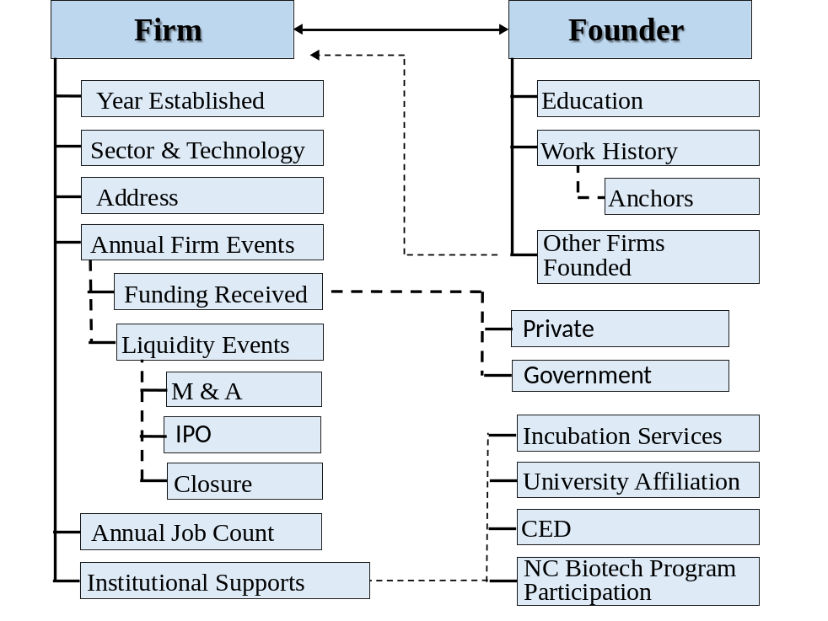
Source:

Feldman et al. triangulate data sources to establish when a firm begins, its growth trend, and its innovative activity. State registries are used to identify firm births and to establish starting dates. Firm growth can be tracked in terms of annual employment, sales, and revenue, numbers.

Innovative activity is tracked using data on patents, FDA trials, and new product announcements using web scraping methods, some of which has been automated by the team. For every firm, the researchers look at events such as funding raised (public & private), M&A, IPOs, and participation in incubators and entrepreneurial support organization programs. To this firm level data, geocoded addresses can be added to examine the development and growth of the region over time and to identify micro geographies where activity has developed.

Feldman pointed out that, early on, the Research Triangle Park was not very interested in small entrepreneurial firms because they are unreliable tenants. Now, however, the Park is full of technology-intensive industries that include biotech firms spawned from corporations (many are traced back to two prominent pharmaceutical firms in the region, GlaxoSmithKline and Burroughs Wellcome). These large companies have spun off more new firms than the adjacent universities (UNC, Duke, and NC State). About 146 first generation spawns alone came out of GSK. This in depth analysis reveals a lot about how what the large firms are doing affects entrepreneurial activity. For example, the data indicated that, every time there was a merger or an acquisition, layoffs followed.

Feldman concluded with several summary observations:

- Regional data are at present inadequate—there is not enough granularity; there are 2-3 year lags in publishing; and there is not enough data on the outcomes. For these reasons, her research projects have required hand collect data.
- We have entered a new age of cyber-enabled research. In addition to the growing richness of data housed at the Census Bureau’s research data centers, Feldman noted that the amount and detail of information that people will reveal about themselves on the web is amazing. And sometimes records can be matched across sources which creates even greater richness of detail. New visualization techniques are also adding value to the data being generated and linked.
- State and local administrative records need to be better exploited. Feldman suggested that an equivalent of the Evidence-Based Policymaking Commission Act of 2016 (the Ryan-Murray bill) for the state level would offer great research promise. At present, little is known about how much money is spent by state and local agencies on R&D programs. For purposes of accountability, making such data available is becoming increasingly important.

During open discussion, Wes Cohen reiterated points made by Winston Smith, Diedonis, and Feldman about the importance of being able to track companies that fail and what happens to the entrepreneurs associated with them. He noted that many founders of biotech firms that fail go on to benefit from the experience in ways that aid future ventures or that help them move into other areas altogether. A data infrastructure allowing individuals involved in these ventures to be followed would no doubt produce valuable insights. Feldman reported that, of the 5000 firms in their study, about 40 percent of them exited through one mechanism or another. They are easy to track when they are involved in mergers or acquisitions. When firms are born, there are lots of announcements and other signals; however, deaths are typically quiet. One way to tell if a firm has gone out of business is if their business registration is not renewed. In her survey, individuals involved with disappearing firms are not captured is they leave the profession or the region. Data would have to be collected systematically on a more national scale to capture the career paths of everyone involved in Research Triangle Park ventures. Cohen agreed that being able to track where talented, often high-skilled and high-powered individuals go after firm death or other events would be highly important and interesting. Feldman noted that, for some kinds of studies, Census data such as the LEHD provide a good platform. Owen-Smith added that their UMETERS data allows for founders involved in failures to be tracked because the tool is organized around individuals and not locations. This is the case because their data usually include people's entire career histories.

Innovation data and analysis to inform regional policy

Thomas Guevara (Economic Development Administration) spoke as a policy maker and consumer of information produced by the statistical agencies. His interest is in seeing boundaries pushed in terms of the capacity of data to be used for informing and affecting policy and ultimately serving communities. His overarching premise is that the purpose of any government agency is to improve the quality of life for the citizens it serves.

When EDA started out as a public works agency 50 years ago, the perceived route to prosperity was to build more infrastructure. Implicit in this view is that prosperity is based on consumption. Guevara observed that researchers and policy makers are coming to realize that continuous growth and prosperity is not going to be achieved simply by consuming. In that spirit, his agency adopted the following definition economic development:

Economic development is the expansion of capacities that contribute to the advancement of society through the realization of individual, firm and community potential. (Feldman, et al). Economic development creates the conditions for growth and improved quality of life through innovation, lowered transaction costs and the utilization of capabilities to responsibly produce and sell valuable goods and services.

The emphasis in this definition is on human activity, behavior, and the way people work with one another with the resources they are given. With this in mind, Guevara’s agency seeks to help communities understand their assets as well as their strengths and weaknesses, and the opportunities and threats that influence prospects for prosperity and improvement in quality of life. The agency works toward this goal by investing with local partners. They do not invest in businesses directly; rather, they provide grants to government entities and not-for-profits, including universities, to take advantage of opportunities in the local ecosystem. At the same time, the agency requires that businesses benefit directly from assets that they build and that they are maintained in the public trust.

Fundamentally, EDA is about increasing capacity through the sponsorship of innovation-inducing activities and resources that are inputs to economic development. Guevara injected the view that, underlying the innovation and development process, agency matters in terms of the ability of people to work together with scarce resources. And, if agency—whether this is in the context of exchanging knowledge, discrete objects, or technology—matters, then complexity must be built into the measurement framework. This is the reason, in Guevara’s assessment, why the research reported on by presenters during this session is essential: the work by Feldman, Fazio, Ziedonis, and Winston Smith all involves data that provide insights into how people work together. This, Guevara concluded, is the boundary that needs to be pushed if agencies like his are to become really effective at investing resources to achieve outcomes that result in prosperity and improved quality of life.

Next, Guevara raised a set of questions related to improving the data infrastructure:

- What do we know about agency’s role in inducing innovation?
- Can we design research and data collection methods that ultimately lead to more precise “diagnosis and treatment” interventions for public investment, and better policy as a result?
- Can the principles that currently define complex adaptive systems lead us to greater insights about how innovation emerges?

He noted that much of what we know about the first question can be found in the research on complex adaptive systems by John Holland (Santa Fe Institute), Kenneth Arrow, Brian Arthur, and others. The second question goes to a point made by Guevara’s about the absence of a systematic approach to data collection, analysis, and evidence to support policy and economic development. This relates directly to how the social science community does research: We try things out; we test and measure; and then we hope to inform policy through a sense of what is learned from research findings. We learn with some set of probabilities what might be more likely to work and what might be less likely to work. The result is, hopefully, better policy. Health care is a great example of an ecosystem operating in a complex, adaptive system. And, finally, regarding the third question, the data being created by government agencies and elsewhere in the private sector provide the foundation for understanding innovation and its role alongside other factors in contributing to economic growth and improved wellbeing? Guevara closed with the notion that some of these things emerging from other disciplines—such as cluster mapping tools—may help to create new frameworks for evaluating measures of innovation and what people do to induce innovation in their environments.

During open discussion, Ziedonis pointed to growing evidence that direct intervention programs (such as those discussed by Guevara) also serve an informational role to the private capital market. While there is not a lot of consensus about why and how, research by Josh Lerner and others has looked at various programs and attributed some impact on outcomes to certification whereby, when awards are won, a promising startup is declared in a sense. More research is needed, she added, about how this mechanism works. Is this simply indicative of where money is being put to prototype and further develop things to a stage in which it becomes easier to communicate and actually attract private financing? These are important questions to answer.

7. Innovation Measurement Agendas of the Future

Going forward, new measures of science and technology describing inputs and outcomes associated with innovative activity will be demanded, and multiple data modes will be called upon. Commercial data, some recoverable from web-scraping and other computer science methods, may shape future measurement in a range of areas—e.g., for tracking new product introductions, quality change, prices and productivity, and product diffusion—where large data sets provide advantage in terms of granularity, timeliness, geographic specificity, etc. During this session, presenters continued discussing several of the questions raised at various points during the workshop: To what extent can the digital revolution transform metrics in the area of innovation measurement? What are the roles of specialized surveys in innovative data collection? And, how can administrative records best be exploited?

The Character and Distribution of Innovation Activities and Outcomes

Scott Stern (MIT) presented his perspectives on developing metrics for capturing the characteristics of innovation application and diffusion. In the process, he made the case that distinguishing between innovation that is cumulative versus that which is one off in nature is essential to understanding the relationship between inputs to and the skewed distribution of outputs and outcomes from the process.

Stern opened with an illustrative example—CRISPR, a gene editing tool that was developed with public funding in the 1980s. It was not until 2012, however—when a group of researchers at Berkeley, followed shortly thereafter by others at MIT and Harvard, figured out that the tool could be repurposed slightly—that CRISPR became arguably the single biggest advance in life sciences gene editing ever. The cumulative number of forward citations of articles by these research teams on the topic is now up to about 3500 on an annual basis.

CRISPR is essentially a very clever cut and paste editing tool for genes that can be used by large pharma, biotech firms, and lots of startups. For example, very recently, the tool was decisive in the creation of a platform for detecting Zika virus, a major public health hazard for the world. The emergence of Crisper is an example of the process whereby basic discovery transitions from basic discovery to traditional science and technology, to unanticipated applications—in this case, all within a three-year period. And the episode illustrates three important points: (1) Innovation is inherently cumulative; (2) innovation is inherently uncertain; and (3) innovation is highly skewed in the distribution of application and in its impact across multiple dimensions.

One of the key questions of the workshop was, “how do these fundamental characteristics of innovation get reflected in our measurement framework and in our systematic statistical programs for collecting information about innovation? Are we able to move beyond examples?
The cumulativeness of innovation—that is, the ability to draw upon an ever-wider body of scientific & technical knowledge—is widely regarded as the critical component for idea driven, long-term economic growth (Rosenberg, Mokyr, Romer, Aghion & Howitt, David & Dasgupta). But, Stern asked, how do we know that innovation is cumulative, and how and whether the degree of cumulativeness varies by time and place? How do we measure it?

To test cumulative impacts, Stern and Furman examined biological resource centers, wherein biological materials used in research are deposited and made publicly accessible to future generations of researchers. It allows them to avoid having to reinvent the wheel. The authors identified an approach using citations data to track the diffusion of knowledge from scientific papers placed into an institutional environment that promotes cumulativeness—a biological resource center—compares with that of otherwise similar articles that remain in a less open system. The articles were tracked to estimate cumulative impact, measured by the rate of citation (which, of course, is not the same as innovation, but an indicator of influence). By this metric, for articles placed in the biological resource centers, the authors found a more than doubling of the impact on subsequent productivity of publicly funded knowledge.

For purposes of systematic measurement, the question that arises is, how can this kind of study of cumulativeness (and the role of institutions and policy in shaping cumulativeness and outcomes) be aggregated beyond the level of individual “pieces” of knowledge? Can it be mapped? Research by Heidi Williams (MIT) does just this, using evidence from the human genome mapping to examine the role of intellectual property rights on innovation. During the final years of the HGP, Celera was granted temporary licensing rights for sequences they identified prior to HGP coverage. Williams took advantage of this natural experiment to investigate whether follow-on research on individual genes in the post-HGP era were impacted by Celera IPR claims. Her results suggest an approximately 30 percent reduction in subsequent publications, phenotype-genotype linkages, and diagnostic tests for genes first sequenced by Celera—it impacted cumulative knowledge occurring at the level of a research community.

Turning to the topic of uncertainty—and the highly skewed nature of knowledge creation and innovation—Stern highlight three points. First, he cited the work of Jones and Uzzi (2013) who used unconventional metrics to predict which publications become the rare ones that go on to have a high impact. Their analysis of 17.9 million papers from all scientific fields suggests that science follows “a nearly universal pattern: The highest-impact science is primarily grounded in exceptionally conventional combinations of prior work yet that simultaneously features an intrusion of unusual combinations.” Stern called insights from these kinds of analyses game changes. In a similar fashion, the presentation by Fazio on research by her and her colleagues (summarized in section 6 above) provided insights about the structure of skew in the area of entrepreneurial quality, where a high portion of consequential outcomes emerge from one, or even one-tenth of 1 percent of the overall activity.

Stern next asked the question, how can the skewed impact of patents and other phenomena related to innovation be mapped in a way that captures cumulativeness, uncertainty, and high skew? And how do we think about the fact that discovery may occur in an area that was unanticipated? By way of analogy, Stern described how the availability of “open” satellite image maps of the earth impacted discovery and entrepreneurship in the gold industry. Research by Nagaraj found a large and persistent difference in the rate of gold mining and discovery depending on the availability of public images—open-access maps—for a given geographical area. Furthermore, entrepreneurs were found to be far more likely to take advantage of open access maps than established firms. Providing the mechanism for this application was a research community—who figured out that these photographs could dramatically improve the chances of understanding where gold was located on the earth’s surface—which had nothing to do with the initial motivations for the NASA program. The takeaway here is that discovery of gold, which is unexpected and highly skewed (but have been concentrated in regions where the satellite imagery was available), benefited from research developed for other purposes.

Stern concluded with some summary statements about future measurement and policy making:

- Innovation statistics and metrics are increasingly being used to evaluate and track innovation systems (at multiple levels of granularity).
- There is a need to develop meaningful connections that allows cohesive assessment of the role of different elements of the innovation system (inputs) and different outputs of the innovation system over time. This will not always requires new data sources. It may be a matter of connecting existing data—and combining traditional measures with alternatives from unanticipated sources—in creative ways.
- There is a need in measurement frameworks to recognize cumulativeness, uncertain and highly skewed phenomena, and distributed impacts.

The agenda laid out above is, he argued, particularly important for areas of innovation beyond traditional “tech to market” applications of science, and as it relates to emerging uses of digital knowledge, maps, and non-”science” knowledge systems.

Linking Patent Metrics to Other Indicators

Jeff Oldham (Google) presented insights that can be drawn about innovation from linking patent metrics, which summarize sets of patents, to other types of indicators. Following up on one Stern’s themes, Oldham noted that one way to make knowledge more cumulative is to increase the accessibility of statistics and indicators. This is analogous to the idea behind the biological resource centers raised by Stern.

The key to increasing the value of patent data is to create the capacity to link them to a web of other innovative indicators. In this way, patent data can serve as a nucleus of innovation measurement. Currently, anyone can go to Google patents or to the USPTO website to research detailed information about a patent; there are low barriers of entry for this kind of inquiry. But it is difficult to compute over collections of patent cases. This is why patent metrics, based on summaries of them, have been developed.

Among the metrics that can be generated from patent summaries are publication numbers (which serve as keys), applications and grants, scope of patents by CPC codes, family members (whose patents can be linked), backward and forward citations, and publication dates. A wide range of patent statistics can be added. Researchers can of course compute their own patent statistic using simple SQL queries.

Oldham provided one sample application—an analysis of how long it takes for patents to be approved by the U.S. Patent Office and whether, over a period of time, that process has slowed or sped up. Estimates from this analysis reveal that, for example, sometime between 2000 and 2001, the process in the U.S. Patent Office got much faster, and it has continued on this trend up until now.

[insert graph from slide 5?]

After providing a quick overview of what can be done with patent metrics, Oldham turned to his main message, that the analytic power of patent metrics can be greatly increased by linking them to other databases—in other words, by making patent metrics the core of a web of innovative indicators. Specifically, Oldham suggested that links to the following sources would create analytic content:

- census data: to assess patents' impact on people’s quality of life
- inventor school(s): to assess training effectiveness
- inventor school funding source: to inform NSF STAR Metrics
- government R&D funding: to assess program effectiveness
- company sales data: to investigate financial impact of design patents [B-M+T 2011]
- sector sales data: to assess impact of innovation on sales
- inventor citizenship: to assess effect of immigration policy

Oldham concluded by describing Google’s capacity to make various data sources available at low cost. For example, the company’s BigQuery is basically an SQL that allows researchers to analyze patent metrics data either from a browser or programmatically. Patent metrics provide a means for summarizing patents that allow ordinary people to access and analyze them. Oldham closed by expressing the desire that these tools be made available in a format that is linkable to other data sources—e.g., tables created by other researchers, government agencies, or companies.

During open discussion, Javier Miranda of the U.S. Census Bureau, asked Oldham if Google had begun to think through how data could be combined in safe ways so that information could be extracted while still residing in various silos. Oldham pointed out that cloud data systems have access control levels, so it is possible to approve access to approved people for specific projects. He also noted the promise of remote access protocols whereby certified individuals from within an organization run programs and deliver the results to external researchers; or that researchers could compute over particular fields or experiment with a sample.

Sallie Keller agreed that technological solutions will continue to emerge. We are, she noted, seeing progress in fields like the biosciences around genomics and related areas. Computer scientists in the cryptography world are working on access and confidentiality issues and finding that it is possible to compute over two distinct data sets that do not leave their silos. Again, these are solvable problems five or ten years down the road. And, finally, while the concept of data governance is central across statistical agencies, she argued that it is important to begin thinking about changing the conversation about what privacy and confidentiality mean.

Innovation initiatives at the statistical agencies

Ron Jarmin (U.S. Census Bureau) discussed activities and plans of U.S. statistical agencies to continue improvement of their data programs in the areas of business dynamics and innovation. Part of the plan calls for increased collaboration among agencies. Jarmin’s remarks were focused on an initiative at the Census Bureau directed at measuring the inputs and outputs of innovation (or the activities that may lead to innovation) on a granular level. It is a collaborative research project between the Census Bureau, the University of Michigan, Ohio State University, University of Chicago, and NYU that links administrative data from these institutions on funded research projects with assets at the Census Bureau.

The agency’s goals for the program are to (1) improve measurement of a small but important sector of the U.S. economy—that associated with individuals involved with funded research grants; (2) address data gaps in the measurement of innovation and its relation to economic growth; (3) collaborate with data providers to deliver data products they value, such as customized reports that are useful for their purposes; and (4) initiate a prototype project that can be scaled and extended to other sectors of the economy. All of this is consistent with the Bureau’s economic and social measurement mission and directly relevant to the data provider.

“Mashing up” university administrative data and Census Bureau data to create new statistics and facilitate research requires collaboration, in this case, with the University of Michigan’s Institute on Research in Innovation and Science (IRIS). Data from IRIS-UMETRICS on sponsored research projects and the faculty, staff, postdoc, and student involved as grant recipients (see Jason Owen-Smith’s discussion in section 4 above) allows the program to experiment with utilizing “fat pipe” data for a sector of the economy. Data provided by the university data are highly complementary to business and household data at the Census Bureau—i.e., the business register, the PVS system used for matching person records, the LBD underlying business dynamics statistics, and the LEHD underlying the Quarterly Workforce Indicators.

Linking this data, analysts at the Census Bureau are able to identify individuals and link them to records in the LEHD infrastructure that have data on all UI covered jobs in the economy. Data on transactions can be linked to equipment and supply purchases and to the business register in a way that allows researchers to analyze the up and downstream value chain of university-based research. Accurate linkage is one of the major challenges inherent in the project. The quality of the links is directly proportional to the quality of the input data. Universities so far have not provided the Bureau with individual identifiers like social security numbers that would make linking more accurate; currently, name, address, and sometimes date of birth fields must be used.

The link to Census data allows researchers to investigate some of the flows associated with science investments to universities. Hiring and spending can be tracked at a granular level. Even detailed transactions, such as where universities are sourcing their mice from, can be tracked at the lab level. More generally, one can determine the locations of businesses that provide materials purchased by the universities. From employment records, the flow of human capital (mainly students, but some faculty and staff as well) from the university outward into the economy can also be tracked at a national level. So the question, “what happens to people involved in funded research when they leave the university?” can be addressed. For example, taxpayers in Michigan can see that more graduates who received grants on projects took jobs in Michigan than anywhere else. The characteristics of the hiring companies can also be tracked which is helpful for creating a picture of the health and direction of local economies.

Jarmin pointed out that this project is only scratching the surface of what can be done with linked datasets; the ability to track the inputs and the outputs at a granular level opens a wide range of possibilities. Currently, these methods are only being applied to a tiny segment of the economy. However, similar programs could in principle be set up for private sector organizations as well which would allow upstream and downstream impacts of a broader array of activities in the economy to be tracked. Systematizing standards of how companies might implement such data collections to bring in economy-wide transactions would be a difficult task. But, Jarmin suggested, if there were particular areas of interest—such as the health care sector, where advances in electronic health records are creating new possibilities—it may be possible to expand in new directions.

Jarmin concluded with the observation that economists have always wanted access to data on every transaction in the economy. The fact that it is now possible to take a group of organizations and looked at every transaction for a particular set of activities shows promise that the economists’ desires may become reality. It may never be practical to measure every transaction in the economy, but there is a vast space between where we are now and where we may be in the near future in this regard.

Leveraging nonsurvey, local data sources

Sallie Keller (Social and Decision Analytics Laboratory) pulled together a number of discussion threads developed over the course of the workshop about combining alternative types of data to analyze and understand society. She focused on leveraging local data sources in new and foundational ways. Non-survey data—some of it collected in real time while individuals are engaged in day to day life situations—provides a new lens on social observation. Much of Keller’s work is oriented toward adapting statistical methods to make the best use of these data. As with high powered telescopes peering into the universe, these emerging data sources may not be exposing things that are new, but they are exposing things that we have not been able to see before.

Eschewing the term “big data,” Keller described the data revolution in more precise categorical terms. Specifically, data analysts are now able to call on:

- Designed Data Collections: Statistically designed and intentional observational data collections;
- Administrative Data: Data collected for the administration of an organization or program;
- Opportunity Data: Data generated as we move through our daily paces; and
- Procedural Data: Data derived from policies and procedures.

Designed data collection includes the surveys that statistical agencies have conducted for decades, and which they are very good at in terms of quality control and application. Administrative data are increasingly important in that they are broadly collected and highly underutilized across many areas of science and evidence-based policy. Opportunity data exists on the Internet and other platforms (sensors, GPS, video, etc.) that can be captured and analyzed. Opportunity data does not make standard ways of observing or collecting data obsolete, Keller argued, but they do create opportunities. Keller added to these “buckets” procedural data—information about policies and practices that govern a variety of activities and that provide the context necessary for comprehensive studies of various phenomena.

Along with the opportunities, new sources of data and new methods of combining data also create major challenges. Keller suggested that, while researchers innately address these challenged as they use data, as a community there needs to be coordinated, disciplined ways of approaching them. Jason Owen-Smith underlined Keller’s point about the importance of managing relationships involved in data project partnerships. He agreed that better and more systematic ways are needed for thinking about how the research community and the federal agencies tasked with setting up arrangements do this and for articulating what the costs and benefits of collaboration are. Building these partnerships is the key challenge and technical issues are some ways easier to solve than the social ones, at least at the outset. The marginal cost of adding a new university's data to a collection declines dramatically; the marginal cost of obtaining a new MOU signed never declines.

The big challenge with such a diverse data landscape is data quality—both within and across buckets. The traditional approach in science involves controlling measurement processes, whether it is a survey instrument or a physical bench lab instrument. Disciplines have gone through great pains to develop theory and statistical methods—optimizing sampling frames and designing collection processes in engineering and in bench sciences. Considerations of data quality have also required controlling the ownership of data to ensure that reliability and quality are maintained. In three of the four data buckets, Keller argued that we do not have control over quality processes in the traditional ways. Because administrative data are collected primarily for non-researchers uses, they have to be repurposed to do experiments and comparisons. Another major challenge to using new kinds of data—and one not addressed extensively during the workshop—is privacy and confidentiality. Not all work can be done in secure research data centers, so this will continue to be an issue for some time.

[maybe add figures from slides 10 and/or 11?]

Next, Keller walked through some case studies being done by her lab (for the Census Bureau) leveraging new and detailed local data to support or enhance, or even possibly replace, some of the federal reporting and in particular some of the estimates in the American Community Survey. The idea underlying the projects is to “open the aperture” to all possible data sources, not just the ones that are easy to access.

In an education sector case study, Keller’s group set out to acquire sources of data for key variables:

- Profiled variables: student ID, district code, year, gender, race/ethnicity, grade, age, and other variables (e.g., limited English proficiency). Data for most of these variables were valid and consistent requiring very little cleaning;
- Transformed variables: matched school districts with counties; calculated ages from birthdates (NC and KY). For Texas, enrollment estimates were weighted to match the state level counts; and
- Restructured variables: Virginia data were restructured to create tables for race/ethnicity, by grade, gender by grade, and disadvantaged status by grade.

Figuring out which data are relevant and useful for the question at hand requires careful planning. For state longitudinal data systems, there are challenges with geographic alignment whenever local data are being combined with state or federal sources. Feldman’s Research Triangle Park account provided a good example of this challenge as the Raleigh-Durham area spans two MSAs. Likewise, here, school districts do not necessarily align with PUMAs or even with counties. But, Keller argued, these are solvable problems.

Because the data assembled by Keller’s team are so much more granular that traditional federal statistical agency sources, it becomes possible to analyze new things. For example, in an analysis of school dropout data in Kentucky, the team was able to map rates for males and females in the Appalachia and non-Appalachia regions of the state in correspondence with the reasons for dropping out—including pull factors (e.g., employment, illness, pregnancy) and push factors (failing classes, expulsion, etc.). Similarly, their analyses of housing have been able to exploit detailed data—local tax assessment data, data from a host of vendors, a number of transformed variables (e.g., parcels weighted by estimated number of unites), and restructured variables (to create consistent geocodes per parcel)—to produced neighborhood profiles at highly localized levels of geography. From the ACS, one can estimate median house values across Census tracks. With local data, it becomes possible to compute actual house values and, if we believe that housing value is a surrogate for wealth, a granular index on wealth diversity at the neighborhood level.

Keller offered the following concluding points: (1) the use of external data (especially private sector) requires dealing with problems created because analysts and policymakers have no control over its collection; this is the opposite of the federal statistics paradigm developed over the course of decades; (2) case studies are extremely helpful for developing and testing new kinds of data frameworks; and (3) a disciplined, yet flexible and adaptable, data framework is needed to assess data quality and fitness-for-use. Keller envisions that use of granular data from multiple sources can be done in a disciplined way such that students in ten years will have an approach for administrative, opportunity, and procedural data that is similarly rigorous to that which we currently have for survey data.

In laying out future research for NCSES, the statistical agencies, and other organizations, Keller identified the following criteria for evaluating potential data sources: (1) Speed and regularity of acquiring data, (2) flexibility in negotiating data agreements—and dealing with data vendors who may or may not be there in the future, (3) capacity to implement a data framework—e.g., organizational structure and constraints, GIS, longitudinal discrepancies, statistical data integration, etc. Additionally, research is needed to align and harmonize data sources.

REFERENCES

Cutler, D.M. and McClellan, M. (2001). Is Technological Change In Medicine Worth It?
Health Affairs, 20: 11-29.

Decker, Ryan, John Haltiwanger, Ron Jarmin and Javier Miranda. 2015. “Where has all the Skewness Gone? The Decline in High Growth (Young) Firms in the U.S. ” mimeo.

Dolan, Paul and Metcalfe, Robert (2012), “The relationship between innovation and subjective wellbeing,” Research Policy, 41 (8). 1489-1498. ISSN 0048-7333

Entrepreneurship.” Journal of Financial Economics. 96(1): 18-32.
Guzman, Jorge, and Scott Stern. (2015) “Where is Silicon Valley?” Science. Vol. 347. Issue #6222.

Hall, Bronwyn H., and Adam B. Jaffe (2012), "Measuring Science, Technology, and Innovation: A Review," Report prepared for the Panel on Developing Science, Technology, and Innovation Indicators for the Future, National Academies of Science.

National Research Council. (2005). Beyond the Market: Designing Nonmarket Accounts for the United States. Panel to Study the Design of Nonmarket Accounts, K.G. Abraham and C. Mackie, eds. Committee on National Statistics, Division of Behavioral and Social Sciences and Education. Washington, DC: The National Academies Press.

National Research Council. (2014). Capturing Change in Science, Technology, and Innovation: Improving Indicators to Inform Policy. Panel on Developing Science, Technology, and Innovation Indicators for the Future, R.E. Litan, A.W. Wyckoff, and K.H. Fealing, Editors. Committee on National Statistics, Division of Behavioral and Social Sciences and Education. Board on Science, Technology, and Economic Policy, Division of Policy and Global Affairs. Washington, DC: The National Academies Press.

OECD/Eurostat (2005), Oslo Manual—guidelines for collecting and interpreting innovation data, 3rd edition. Paris, France.

OECD (2010), Towards a Measurement Agenda for Innovation, http://www.oecd.org/site/innovationstrategy/45392693.pdf

Torrisi, S., Gambardella, A., Giuri, P., Harhoff, D., Hoisl, K. And Mariani, M., 2016, "Using, blocking, and sleeping patents: empirical evidence from a large inventor survey," Research Policy, forthcoming, http://dx.doi.org/10.1016/j.respol.2016.03.021

Uzzi B, Mukherjee S, Stringer M, Jones B (2013) Atypical combinations and scientific
impact. Science 342(6157):468–472.

Appendix A: Workshop Agenda

NCSES/CNSTAT Workshop on
Advancing Concepts and Models of Innovative Activity and STI Indicator Systems

National Academy of Sciences
2101 Constitution Ave. NW, Washington, DC 20418
Conference Room 120

Thursday-Friday, May 19-20, 2016

AGENDA

Workshop Goals

The workshop will bring together academic researchers, private and public sector experts, and public policy agencies to develop strategies for broadening and modernizing science, technology, and innovation (STI) information systems. The workshop will be oriented toward helping the NSF's National Center for Science and Engineering Statistics (NCSES) refine and prioritize its work on innovation metrics to maximize the relevance and utility of its data collection programs and statistical products to users. The focus will be on conceptualizing innovation—its inputs, outputs and consequences—in a way that reveals elements that are being measured well and those that are being measured inaccurately or not at all. Presentations and discussion will take into account the role of innovation, not just as it affects economic growth and productivity directly, but also as a mechanism for creating greater public good and meeting social challenges such as those associated economic mobility, health, civic engagement, population aging or climate change. Workshop participants should also imagine how new kinds of information—e.g., naturally occurring, unstructured, digital data—may be used to complement more traditional survey and administrative data in the construction of innovation metrics. Participants should seek to identify questions that cannot be answered now but could be with additional data that have a reasonable chance of being collected.

Thursday, May 19 (9am – 5pm)

9:00am Welcome; Project Objectives
(breakfast will be available outside conference room 120 at 8:30)

Key issues pertaining to the changing face of innovation and potential approaches to its measurement will be identified. NCSES will provide an overview of the agency’s goals and future directions, recent work, and the variety of studies initiated on innovation and human capital data. The focus on concepts and models in this workshop is meant to generate input to data development strategies that take into account both user needs and emerging opportunities.

- Scott Stern (MIT; workshop chair): Key questions, goals for the day
- John Gawalt (NCSES): The scope of innovation measurement in the context of the agency’s user community—e.g., for international comparisons and benchmarking, policy, academic research, business uses. Reflections on the NAS Capturing Change report
- Brian Harris-Kojetin (Assistant Director, CNSTAT): Welcome; overview of the Academies

9:15 Assessing Innovation Measurement: How Accurately do we Measure Innovation Processes and the Resultant Outcomes Delivered to Society and the Economy?

Traditional measures of innovation, based largely on data reflecting expenditures on inputs (e.g., investment in R&D), capture the impact of innovation on economic outputs and outcomes in only a partial way. This has led for calls to collect new kinds of data and create new metrics. In this session, participants will identify aspects of the process and its impacts that are currently being measured well as well as those that are being measured incorrectly, incompletely, or not at all. Such assessment encompasses inputs to innovation (R&D and other), outputs and outcomes of innovation (economic growth, better functioning society), and the utility of metrics to stakeholders ranging from government to businesses. The takeaway from this discussion should be guidance to NSF about the extent to which the right data are being collected, and what additional kinds of information should be pursued. [15 minutes each]

- Bronwyn Hall (UC Berkeley; session lead): The role and purpose of indicator frameworks in the analysis of science, technology, and innovation and economic wellbeing; potential impacts and relevance of extending frameworks to include public sector innovation and broader social impacts
- Ben Martin: (University of Sussex): How emergence of the knowledge society shapes innovation; implications for measurement of innovation
- Fred Gault (UNU-MERIT, Maastricht): Developing new indicators to capture the changing nature of innovation; policy and other uses of innovation data and indicators; international comparisons
- Fernando Galindo-Rueda (OECD): International standards for measuring and comparing innovation; public procurement of innovation; status and overview of Oslo Manual revision.
- Dan Sichel (Wellesley College): Innovation and productivity—recent puzzles.

Open Discussion [15 minutes]

10:45 Break (refreshments available outside conference room 120)

11:00 Innovation Beyond R&D

Data on narrow aspects of innovation—such as R&D expenditures or patent applications, assignments, and citations—are often used to proxy levels of innovation activity. However, in the measurement community, it has long been understood that activities both technical and non-technical, including those that are not a directly measureable function of R&D and science, also play an important role in innovation.

NCSES’s Census Business R&D and Innovation Survey (BRDIS) asks firms for information about newly introduced or improved products and processes, and about purchased R&D inflows and outflows, revenue from the sale of patents and patent licensing, and a number of IP-related activities. Some questions about innovative activities can be adequately addressed with current data sources such as BRDIS, while others may require new or different kinds of data. For example, less is known about how innovation takes place in organizations that are not R&D intensive, as is often the case in the service sectors. Questions to be addressed here include: What models exist for assessing different kinds of (e.g., non R&D-based) innovation? What do we know about innovators acquiring inventions from external sources? How would understanding the division of innovative labor affect our understanding of the propensity to innovate? [15 minutes each]

- Wesley Cohen (Duke University; session lead): Recent developments in survey-based approaches to measuring innovation, including the Community Innovation Survey
- Ashish Arora (Duke University): Technology licensing as an alternative to in-house R&D
- Javier Miranda (U.S. Census Bureau): Research using LBD/BDS and other statistical agency data that helps measure innovation. Kristin McCue (U.S. Census Bureau): New and emerging data products at statistical agencies related to innovation [Ask for documentation of current data products along with a summary of things the agencies are planning to roll out (or considering) for the future]
- Bruce Tether (University of Manchester): Design and development—design as an alternative or complement to R&D
- Rob Seamans (Council of Economic Advisers): Innovation, technology, and industrial organization; tracking automation across sectors of the economy to inform employment and other policies.

Open Discussion [15 minutes]

12:30pm Lunch (available outside conference room 120)

1:30 The Role of Individuals (and networks of individuals) in Innovation

Compared with institutions and organizations, less attention has been given to the role of individuals and teams in the innovative process. How people’s education, entrepreneurial talents, and other human capital characteristics result in innovation are vast and largely unresolved research areas. One example of how innovation relates to individuals, with direct and high profile policy content, is in the area of immigration and human capital formation. Linkages between individuals and institutions also play an important role in innovation. To what extent do we understand how these linkages to work? What opportunities to understand the role of human capital in innovation within a firm could be gained from human resource surveys and by linking existing data to other data sets? [15 minutes each]

- Paula Stephan (Georgia State University; session lead): The global S&E workforce—the “Global Science” Research Project; placement of recent graduates in industry. Data needs, policy issues
- Rajshree Agarwal (University of Maryland): Linking knowledge diffusion among firms, industries, and regions to the underlying mechanisms of employee entrepreneurship and mobility
- Lee Fleming (UC Berkeley): Patent Data: New Metrics and New Linkages
- Jason Owen-Smith (University of Michigan): Networks, physical space, and innovation. Work on IRIS/UMETRICS to collect, improve, protect, and use big data on the dynamics of science and the economy
- Alfonso Gambardella (University Bocconi): Managerial practices and incentives for research and innovation; what could be learned from experiments, large and systematic computerized data bases, surveys

Open Discussion [15 minutes]

3:00 Break (refreshments available outside conference Room 120)

3:15 Measuring Public Sector Innovation and Social Progress

Measuring the full range of benefits generated through innovation requires capturing data on a range of activities that goes beyond those traditionally tracked. Innovation that takes place in the public sector is one area to be explored and is a high priority topic within the international community. Innovation that advances the public good in ways that take place beyond the market (in non-economic ways) is another related topic of interest. Both have featured in discussions about revision of the Oslo Manual and in planning for September’s Blue Sky Conference.

Questions to be addressed include: What approaches to innovation measurement can be developed for capturing activities within the public sector? Can innovation metrics be developed that bring into scope how the successful exploitation of ideas affects the provision of public goods and the well-being of society more broadly, beyond the contribution to efficiency, effectiveness, or quality in the production of market goods and services? Are there negative social impacts of innovation that should be included in our understanding of the outcomes of innovation? [15 minutes each]

- Fred Gault (UNU-MERIT, Maastricht; session lead): Innovation indicators for the public sector. Conceptual overview of what would variables factor into public sector innovation measurement
- Daniel Sarewitz (Arizona State University): innovation and social progress
- Charles Edquist (CIRCLE, Lund University): Design of innovation policy, innovation-related public procurement and a critical assessment of the Innovation Union Scoreboard
- Kaye Husbands Fealing (Georgia Tech): Innovation and non-economic/public health outcomes. GA Tech food security and safety study
- Eric von Hippel (MIT): Household sector innovation

Open Discussion [15 minutes]. Overarching questions for presenters during this session and for discussion afterward:

- Which aspects of the innovation processes are not well covered and increasing in importance?
- If we could measure something that is currently not measured, what would it be? Where can funding for measurement be most productively directed?
- For what aspects of innovation measurement might surveys not be the optimal data collection strategy? Where might administrative or big data become more prominent in meeting demand for new metrics?
- What is the path forward for measuring innovation (a difficult measure process) in the case of public goods and social progress (a difficult to measure, largely nonmarket outcome)?

5:00pm Planned Adjournment

Friday, May 20 (9am – 2pm)

9:00am Welcome Back (breakfast will be available outside conference room 120)

- Scott Stern (MIT; workshop chair): Key questions, goals for the day

9:15 Regional Innovation Models and Data Needs

Many of the spillovers and complementarities of innovative activity take place at the local level. What models help policy makers and other data users at the sub-national level? [15 minutes each]

- Maryann Feldman (UNC/NSF; session lead): Regional innovation systems
- Catherine Fazio (MIT): Measures of innovation quantity and quality—e.g., Entrepreneurial Quality Index, the Regional Entrepreneurship Cohort Potential Index and the Regional Entrepreneurship Acceleration Index—and findings emerging from these measures
- Rosemarie Ziedonis (Boston University): Insights from work conducted with Bo Zhao on an R&D loan program in Michigan. Numerous states have launched similar & large-scale programs over the past few decades yet there are major data roadblocks in obtaining access to the basic pieces of information required to study the effects (e.g., difficulties measuring “innovative activity” of the small companies using standard patent-based measures
- Sheryl Winston Smith (Temple University). Measuring micro-foundations of innovation and entrepreneurship, and implications of early funding, intangibles, and peer effects. Leveraging deep, novel data on STEM-based entrepreneurship from earliest stages to construct novel measures of founder, startup, and early hiring characteristics. Findings emerging from research on accelerators and professional angel groups pointing to early influences on growth, hiring, funding, and exit pathways for startups. Implications of geographic and regional measures
- Thomas Guevara (Economic Development Administration). Cluster Mapping of industry and business environments for use in making strategic investments, recruiting new companies, and laying the groundwork for new industries. [15 minutes each]

Open Discussion [15 minutes]

10:45 Break (refreshments available outside conference room 120)

11:00 Innovation Measurement Agendas of the Future

Going forward, new measures of science and technology describing inputs and outcomes associated with innovative activity will be needed, and multiple data modes will be called upon. Commercial data, some recoverable from web-scraping and other computer science methods, may shape future measurement in a range of areas—e.g., new product introduction, quality change, prices and productivity, product diffusion—where large data sets provide advantage in terms of granularity, timeliness, geographic specificity, etc. To what extent can the digital revolution transform metrics in the area of innovation measurement? What are the roles of specialized surveys in innovative data collection? Administrative records (e.g., linking patent information to other data sources)? [15 minutes each]

- Scott Stern (session lead): Innovation that is cumulative vs that which is one off; structural characteristics of innovation. Is it possible to develop statistics that provide clues about application and diffusion of innovation?
- Jeff Oldham (Google): Tools beyond surveys instruments that can be used to measure innovation and productivity. Interesting work on patent data for target users
- Ron Jarmin (U.S. Census Bureau): Goals/actions/policies that the statistical agency data programs might strive for going forward to measure business dynamism and innovation in high tech industries. Partnerships and collaborations between the agencies
- Sallie Keller (Social and Decision Analytics Laboratory): Evaluating non-survey data for statistical use; advancing statistical and quantitative data gathering techniques to enhance research interests

Open Discussion [15 minutes]

12:30pm Lunch (available outside conference room 120)

Synthesis and Directions: Shaping Innovation Data and Indicators for the Future

Scott and Bronwyn will facilitate discussion summarizing guidance to NCSES as it prepares for the OECD Blue Sky III Conference. Insights aimed at broadening and modernizing innovation indicators—through advancement of measurement frameworks, identification of data gaps, and exploitation of new data sources—will be distilled. The goal is to emerge from the meeting envisioning priorities for NCSES data collection programs as the agency seeks to make its statistics relevant to data users and producers across measurement, academic, and practitioner communities spanning both the public and private sectors.

2:00pm Planned Adjournment

Appendix B. Participant List

STEERING COMMITTEE

Scott Stern (Chair), David Sarnoff Professor of Management of Technology, MIT Sloan School of Management
Ashish Arora, Rex D. Adams Professor, The Fuqua School of Business, Duke University
Maryann Feldman, S.K. Heninger Distinguished Professor, Department of Public Policy, University of North Carolina at Chapel Hill

PRESENTERS

Rajshree Agarwal, Rudolph P. Lamone Chair and Professor of Entrepreneurship, Robert H. Smith School of Business, University of Maryland
Wesley Cohen, Frederick C. Joerg Professor and Professor of Economics, The Fuqua School of Business, Duke University
Charles Edquist, Rausing Professor in Innovation, Studies at CIRCLE, Lund University, Lund, Sweden
Cathy Fazio, Managing Director, Laboratory for Innovation Science and Policy, MIT Innovation Initiative
Kaye Husbands Fealing, Chair and Professor, School of Public Policy, Georgie Institute of Technology
Lee Fleming, Faculty Director, Coleman Fung Chair in Engineering Leadership, Haas School of Business, University of California, Berkeley
Fernando Galindo-Rueda, Senior Economist, Economic Analysis and Statistics Division, OECD Directorate for Science, Technology, and Industry, Paris, France
Alfonso Gambardella, Professor of Management, Department of Management and Technology, Bocconi University, Milan, Italy
Fred Gault, Professorial Fellow, UNU Merit, Maastricht, The Netherlands
Thomas Guevara, Deputy Assistant Secretary, Office of Regional Affairs, Economic Development Administration, Washington, DC
Bronwyn Hall, Professor of Economics, Emerita, University of California, Berkeley
Eric von Hippel, Professor of Technological Innovation, MIT Sloan School of Management
Ron Jarmin, Assistant Director for Research and Methodology, Office of the Associate Director of Research and Methodology, United States Census Bureau
Sallie Keller, Director and Professor of Statistics, Social and Decision Analytics Lab, Biocomplexity Institute of Virginia Tech
Ben Martin, Professor of Science and Technology Policy Studies, Science Policy Research Unit, Business and Management, University of Sussex, UK
Kristen McCue, Principal Economist, Center for Economic Studies, United States Census Bureau
Javier Miranda, Principal Economist, Center for Economic Studies, United States Census Bureau
Jeff Oldham, Software Engineer, Google, California
Jason Owen-Smith, Executive Director, Institute for Research on Innovation and Science, Research Professor, Survey Research Center, University of Michigan
Daniel Sarewitz, Julie Ann Wrigley Global Institute of Sustainability
Professor of Science and Society, School of Life Sciences, College of Liberal Arts and Sciences, Arizona State University
Robert Seamans, Associate Professor of Management and Organizations, Leonard N. Stern School of Business, New York University
Dan Sichel, Professor of Economics, Wellesley College, Massachusetts
Paula Stephan, Professor of Economics, Georgia State University
Bruce Tether, Professor of Innovation Management and Strategy, Department of Innovation, Management, and Policy, Manchester Business School, UK
Sheryl Winston Smith, Assistant Professor of Strategic Management and Entrepreneurship, Fox School of Business, Temple University
Rosemarie Ziedonis, Associate Professor, Strategy and Innovation, Questrom School of Business, Boston University

SPONSOR

Mark Boroush, Senior Analyst, National Center for Science and Engineering Statistics, National Science Foundation
Jaqui Falkenheim, Senior Analyst, National Center for Science and Engineering Statistics, National Science Foundation
John Gawalt, Division Director, National Center for Science and Engineering Statistics, National Science Foundation
Derek Hill, Sciences Resources Analyst, National Center for Science and Engineering Statistics, National Science Foundation
John Jankowski, R&D Statistics Program, National Center for Science and Engineering Statistics, National Science Foundation
Audrey Kindlon, National Center for Science and Engineering Statistics, National Science Foundation
Joydip Kundu, Acting Deputy Division Director, National Center for Science and Engineering Statistics, National Science Foundation
Kelly Phou, Survey Statistician, National Center for Science and Engineering Statistics, National Science Foundation
Carol Robbins, Senior Analyst, National Center for Science and Engineering Statistics, National Science Foundation

GUESTS

Jeff Alexander, SRI International, Arlington, Virginia
Gary Anderson, Economist, Office of the Director, National Institute of Standards and Technology
Xavier Cirera, Senior Economist, Innovation and Entrepreneurship, The World Bank
Genevieve Croft, Senior Associate for Research Policy, Association of Public and Land-grant Universities, Washington, DC
Louise Earl, Section Chief, Science and Innovation, Statistics Canada
Lucia Foster, Chief of Center for Economic Studies, Chief Economist, United States Census Bureau
Christina Freyman, Science and Technology Policy Analyst, Center for Science, Technology, and Economic Development, SRI International, Arlington, Virginia
Nathan Goldschlag, Economist, Center for Economic Studies, United States Census Bureau
Rasmus Hartmann, Postdoctoral Fellow, Behavioral and Policy Sciences, MIT
Cassandra Ingram, Economist, Office of the Chief Economist, Economics and Statistics Administration, U.S Department of Commerce
Kei Koizumi, Assistant Director for Federal R&D, Office of Science and Technology Policy< Washington, DC
Vicki Lancaster, Social and Decision Analytics Lab, Biocomplexity Institute of Virginia Tech
Wendy Li, Office of the Director, U.S. Department of Commerce, Bureau of Economic Analysis
Vladimir Lopez-Bassols, Formerly of OECD
Haig McCarrell, Director, Investment, Science, and Technology, Statistics Canada
Oscar Mendez, Program Associate, Economics, Alfred P. Sloan Foundation, New York
Silvia Muzi, The World Bank
Eric Smith, Senior Policy Advisor, U.S. Economic Development Agency, Washington, DC
Stephanie Shipp, Deputy Director and Research Professor, Social and Decision Analytics Lab, Biocomplexity Institute of Virginia Tech
Josh Trapani, Associate Vice President for Research and Policy Analysis, Association of American Universities, Washington, DC
Tim Wojan, Senior Economist, Economic Research Service, USDA, Washington, DC
Arvids Ziedonis, Visiting Professor, Strategy and Innovation, Questrom School of Business, Boston University
Kathryn Ziemer, Social and Decision Analytics Lab, Biocomplexity Institute of Virginia Tech

STAFF

Brian Harris-Kojetin, Assistant Director, Committee on National Statistics, The National Academy of Sciences, Washington, DC, USA
Chris Mackie, Study Director, Committee on National Statistics, The National Academy of Sciences, Washington, DC, USA
Anthony Mann, Program Coordinator, Committee on National Statistics, The National Academy of Sciences, Washington, DC, USA

https://www.oecd.org/sti/inno/47861327.pdf.
For example, Cutler and McClellan (2001) found that innovations in the treatment of heart attacks, depression, cataracts, and other conditions have led to increased longevity and less absenteeism from the workplace.
OECD (2010), Towards a Measurement Agenda for Innovation, http://www.oecd.org/site/innovationstrategy/45392693.pdf
Fraumeni and Okubo (2005) describe how knowledge in the form of R&D investment is treated in the National Income and Product Accounts and how it has factored into GDP growth over time.
NRC(2005) outlines how satellite accounts may be designed to handle nonmarket activities in the areas of home production, human capital development, education, health, government and nonprofit sectors, and the environment.
OECD/Eursotat (2005). The Oslo Manual.
“Science, Technology, and Innovation Indicators in a Changing World: Responding to Policy Needs,” ISBN978-92-64-03965—0, OECD, 2007.
The workshop agenda is reproduced in Appendix 1 of this Summary.
EU member states have had programs to measure expenditure on non-R&D innovation activities.
Background material and references underlying Gault’s arguments can be found in his paper “Measuring innovation in all sectors of the economy” (www.merit.unu.edu/publications/working-papers/abstract/?id=5832).
The production function takes the form ΔY_{t} = αΔK_{t} + (1-α)ΔL_{t} + Δmfp_{t ,} where Y = output, K is capital inputs, and L is labor inputs.
This framework is explained in Byrne, David M., Stephen D. Oliner, and Daniel E. Sichel, 2013, “Is the Information Technology Revolution Over?” International Productivity Monitor, no. 25, Spring. Byrne, David M., Stephen D. Oliner, and Daniel E. Sichel, 2015, “How Fast are Semiconductor Prices Falling?” AEI Working Paper, September.
Gordon, Robert J., 2016. The Rise and Fall of American Growth, Princeton University Press.
See Corrado, Carol; Goodridge, Peter; and Jonathan Haskel (2011). “Constructing a Price Deflator for R&D: Calculating the Price of Knowledge Investments as a Residual.” Imperial College discussion paper 2011/07
See Fernald, John G., 2012. "A Quarterly, Utilization-Adjusted Series on Total Factor Productivity." FRBSF Working Paper 2012-19 and Fernald, John, and Charles Jones. 2014. “The Future of U.S. Economic Growth.” AEA Papers and Proceedings, May.
For details about the survey and its findings, see Ashish Arora & Wesley M. Cohen & John P. Walsh, 2016. "The acquisition and commercialization of invention in American manufacturing: Incidence and impact," Research Policy, vol 45(6), pages 1113-1128. This paper focuses on manufacturing but the project collected data from a number of software firms in other service sector industries, about 5200 respondents. The response rate was about 30 percent, but the authors collected information on non-respondents and were able to evaluate response bias in a number of ways.
Cited by Lamoreaux and Sokoloff (1999).
Additionally, some companies are moving away from introducing new products and into financial engineering, globalization, and buying businesses (where innovations may be harder to detect and measure).
Innovation and the Sources of Invention in American Manufacturing, 2007-09: Arora, Cohen, Walsh, Research Policy 2016.
Galindo‐Rueda, F. and V. Millot, 2015. “Measuring Design and its Role in Innovation”, OECD Science, Technology and Industry Working Papers, 2015/01, OECD Publishing.
Design Commitment & Innovations, Montresor & Vezzani, 2015.
Although some proposals have been made, in the “Barcelona Manual”, which provides Guidelines for Colleccting and Interpreting Design Data.
And the Boston Consulting Group (2014) has estimated that worldwide spending on robotics, $26.9B in 2015, will rise to $66.9B by 2025.
The Structure of Scientific Revolutions, pp. 89-90.
Balsmeier, B. and L. Fleming, G. Manso, "Independent Boards and Innovation." Forthcoming, Journal of Financial Economics.
Bertrand & Schoar (2003) showed that managerial fixed effects matter for performance of firms. Bloom and Van Reenen (2007) found that a survey-based measure of management practice explains 10-23% of the interquartile difference in TFP across firms..
“The eternal apprentice,” Time Magazine, vol. 52, p. 81.
“Wrapping it up in a person: Examining employment and earnings outcomes for Ph.D. recipients,” Nikolas Zolas, Nathan Goldschlag, Ron Jarmin, Paula Stephan, Jason Owen- Smith, Rebecca F. Rosen, Barbara McFadden Allen, Bruce A. Weinberg, Julia I. Lane. Science 11 December 2015:Vol. 350 no. 6266 pp. 1367-1371. http://www.sciencemag.org/content/350/6266/1367.full
http://www.nature.com/news/global-mobility-science-on-the-move-1.11602
http://ec.europa.eu/public_opinion/flash/fl_305_en.pdf.
http://ec.europa.eu/growth/industry/innovation/policy/public-sector/index_en.htm.
http://bookshop.europa.eu/en/european-public-sector-innovation-scoreboard-2013-pbNBAZ13001/.
https://www.oecd.org/governance/observatory-public-sector-innovation.htm.
https://www.oecd.org/sti/outlook/e-outlook/stipolicyprofiles/competencestoinnovate/public-sectorinnovation.htm.
Although workshop participant Daniel Sarewitz noted Chris Freeman’s work with the Science Policy Research Unit of the University of Sussex, and his commitment to innovation and social good, Richard Nelson's The Moon and the Ghetto, and Lundvall's National Innovation Systems: Towards a Theory of Innovation and Interactive Learning, (1992, Pinter, London) which included an understanding of the role of innovation systems for improving conditions in the world.
Edquist, C. and Zabala-Iturriagagoitia, J.M (August 2015). The Innovation Union Scoreboard is Flawed : The Case of Sweden - not the innovation leader of the EU-updated version. (CIRCLE Working Paper 2015/27). Lund University, Sweden.
Workshop participant Jeff Oldham (Google), ran a Google Consumer Survey overnight between the days of the workshop asked, “did you improve or create a product or process in your free time during the past year?” Twenty percent of the more than 900 respondents that replied over the 12 hour period prior to day 2 of the workshop said that they had innovated during the past year.
This observation is based on findings by Decker, Haltiwanger, Jarmin, and Miranda (2013,2015); Haltiwanger, Jarmin, Kulick, and Miranda (2015); and others.
Litan, Robert E. “Inventive Billion Dollar Firms: A Faster Way to Grow.” SSRN Working Paper #1721608 (2010).
As defined by OECD, the entrepreneurial ecosystem is “a set of interconnected entrepreneurial actors, institutions, entrepreneurial organizations and entrepreneurial processes which formally and informally coalesce to connect, mediate and govern the performance within the local entrepreneurial environment” (Mason & Brown, OECD Report, 2014).
Feldman & Lowe: image: Jason deBruyn (September 4, 2015). “GSK’s Triangle genealogy”. Triangle Business Journal, volume 3 (1).
Furman JL, Stern S (2011) “Climbing Atop the Shoulders of Giants: The Impact of Institutions on Cumulative Research,” American Economic Review, 101: 1933 doi:10.1257/aer.101.5.1933.
From his doctoral dissertation at MIT, “Maps and Innovation: Evidence from Gold.”

